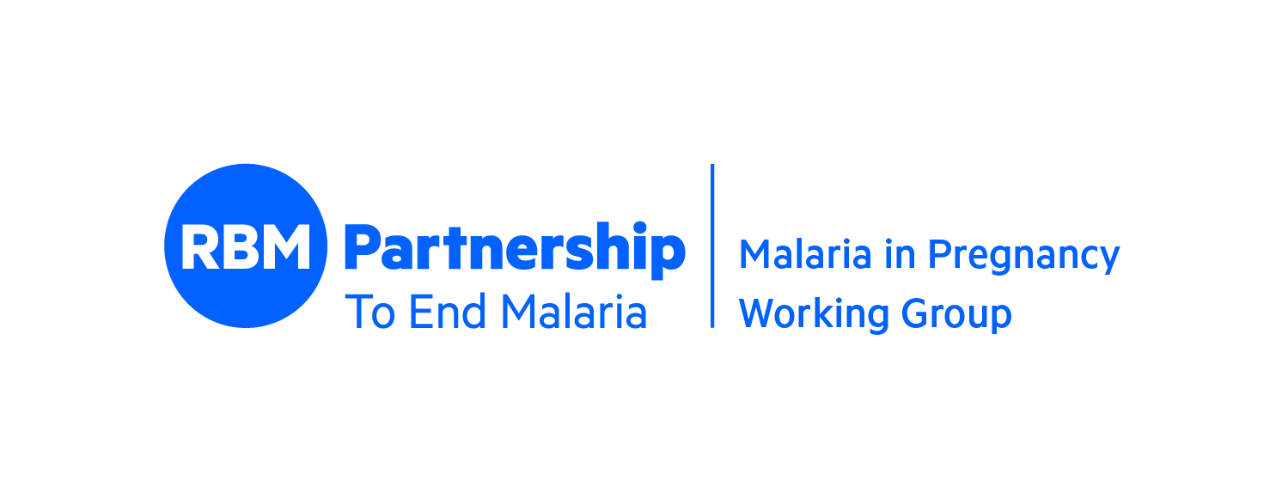

RBM Partnership
Malaria in Pregnancy Working Group
Twenty-third Annual Meeting
Geneva, Switzerland
September 12 & 13, 2023

Strengthening partnerships to close the gaps in MiP

Meeting Objectives:
- Discuss opportunities to prioritize MiP as part of the broader ANC platform
- Share, disseminate and discuss new MiP research and innovations with implications for MiP programming
- Disseminate learning from country experiences in improving coverage of MiP interventions
- Develop WG action plan for 2024

Tuesday, September 12th

Time | Session Description | Presenter/ Facilitator
8:00 – 8:30 | Arrival & Meeting Registration
8:30 – 9:00 | Welcome  Opening Remarks  Introduction of new co-Chair  Review of Agenda/Meeting Objectives | Michael Charles, CEO RBM Partnership  Daniel Ngamije, WHO GMP Director  Julie Gutman, CDC  Chonge Kitojo, PMI/USAID
9:00 – 10:45 | Broader support of the ANC platform  Presentation: Gender/Youth & MiP  1. Accelerating a Gender-Transformative Approach to Malaria in Pregnancy Advocacy  2. Listening to Women’s Voices: A client-centered approach to preventing MiP through ANC  3. PMI-S Gender Rapid Assessment, Strategy Development and Implementation  4. Maternal Health & Malaria: Opportunities for Collaboration and Integration | Facilitator: Mercedes Bonet, WHO  1. Deborah Atobrah, CEGENSA, University of Ghana  2. Elizabeth Arlotti Parish, Jhpiego  3. IniAbasi Nglass, MSH  4. Meredith Mikulich, Office of Maternal and Child Health and Nutrition, USAID
10:45 – 11:15 | Break/Networking
11:15 - 12:30 | ANC policy & practice  1. Optimizing scaleup of Group ANC as a strategic tool in improving standard and coverage of care in 104 facilities on MiP and ANC retention in Nasarawa State, Nigeria  2. Group ANC Results from Benin  3. Multi-country analysis of WHO Antenatal Care Policy on the Prevention of Malaria in Pregnancy  4. Equity of Antenatal Care Services, Atlantique, Benin & Geita, Tanzania, 2021-2022 | Facilitator: Dale Halliday, Unitaid  1. Eberechukwu Eke, Jhpiego, Nigeria  2. Julie Gutman, CDC  3. Bolanle Olapeju, Uniformed Services University  4. Anna Munsey, CDC
12:30 – 13:30 | LUNCH
13:30 – 15:30 | A Deeper Dive into C-IPTp Programming: Learning from countries & partners | Facilitator: Elaine Roman, Jhpiego  Silvia Schwarte, WHO  Moussa Dadjoari, NMCP Burkina Faso  Emmanuel Shekerau, NMCP Nigeria  Camille Houetohoussu, NMCP Benin  Brune Estelle Ramiranirina, NMCP Madagascar  Maud Majeres-Lugand, MMV  Susan Youll, PMI  Anne-Sophie Briand, Global Fund
15:30 – 16:00 | Break/Networking
16:00 – 17:25 | Research Symposia: What’s new in MiP  1. Protection from malaria after pre-conception PfSPZ Vaccine  2. The development of PfPSZ vaccines for the prevention of pregnancy malaria  3. Quantifying the impact of malaria in pregnancy on maternal anemia  4. Intermittent preventive treatment with dihydroartemisinin-piperaquine for malaria in pregnancy in women living with HIV  5. PBPK modelling to support the clinical development of antimalarials in pregnant women | Facilitator: Prudence Hamade, Malaria Consortium  1. Halimatou Diawara, MRTC, U of Bamako and Sara Healy, LMIV, NIH - virtual  2. Thomas L. Richie and Stephen L. Hoffman, Sanaria  3. Sequoia Leuba, Imperial College London  4. Hellen Barsosio, KEMRI - virtual  5. Nada Abla Geiser, MMV
17:25 – 17:30 | Looking ahead to Day 2 | Chonge Kitojo, co-Chair

Wednesday, September 13th

Time | Session Description | Presenter/Facilitator
8:30 – 8:45 | Report out: MiP WG Country Advisory Board | Nnenna Ogbulafor, NMEP Nigeria
8:45 – 9:00 | Speed Up IPTp Scale Up campaign update | Abena Poku-Awuku, MMV
9:00 – 11:00 | Using data for MiP programming decisions  1. SME & MiP  2. WHO ANC SMART Guideline to advance guideline implementation and data use  3. Utility of ANC Attendees as a Sentinel Surveillance Population in Geita, Tanzania & Rarieda, Kenya  4. Using ANC-based malaria screening to reconstruct transmission and burden trends within the community | Facilitator: Peter Olumese, WHO  1. Molly Robertson, Global Fund, SMERG - virtual  2. María Barreix, WHO  3. Anna Munsey, CDC  4. Joseph Hicks, Imperial College London
11:00 – 11:30 | Break/Networking
11:30 – 12:30 | Engaging innovatively private sector opportunities to increase access to MiP commodities – examples of digital health initiatives  1. Increasing Malaria in Pregnancy Services in Kenya through Private Sector Engagement  2. Maisha Meds: digital infrastructure to support malaria care in the private sector | Facilitator: Maud Majeres Lugand, MMV  1. Edna Anab & Samuel Nderi, Kasha - virtual  2. Victoria Goodfellow, Maisha Meds
12:30 – 13:30 | LUNCH | Pause café
13:30 – 14:45 | Inform, sensitize and advocate to improve access to MiP services  - Antenatal Care Within Primary Health Care  - Multisectoral Mass Action Against Malaria (MAAM) for a Malaria Free Pregnancy  - SBC for Early ANC Initiation | Facilitator: Abena Poku-Awuku, MMV  1. Ashley Malpass, USAID/PMI  2. Peter Mbabazi, MOH Uganda, MSWG -virtual  3. Angela Acosta, JHU CCP, SBC WG
14:45 - 15:15 | Break/Networking
15:15 – 17:20 | Action planning: Where do we go from here? | Facilitators: Julie Gutman & Chonge Kitojo, co-Chairs
17:20 – 17:30 | Meeting Close | Julie Gutman, co-Chair

