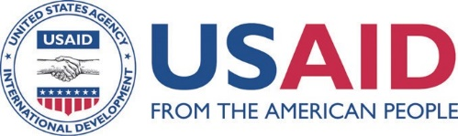

Prevention and Control of Malaria in Pregnancy
Reference Manual

Fourth Edition, 2021

Jhpiego is an international, nonprofit health organization affiliated with Johns Hopkins University. For more than 40 years, Jhpiego has empowered frontline health workers by designing and implementing effective, low-cost, hands-on solutions to strengthen the delivery of health care services for women and their families. By putting evidence-based health innovations into everyday practice, Jhpiego works to break down barriers to high-quality health care for the world’s most vulnerable populations.
Published by:
Jhpiego Brown’ Wharf
1615 Thames Street
Baltimore, Maryland 21231-3492, USA
www.jhpiego.org
© Jhpiego Corporation, 2021. All rights reserved.
First edition published in 2003, second edition in 2008, third edition in 2015, and fourth edition in 2021.
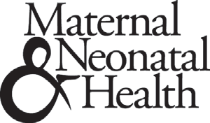
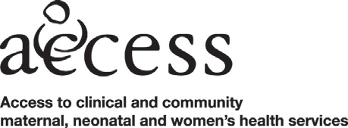

This publication is adapted from the Prevention and Control of Malaria in Pregnancy Learning Resource Package made possible through support by United States Agency for International Development (USAID) under terms of Award No. HRN-A-00-98-00043-00/Maternal and Neonatal Health Program, and by the Maternal and Child Health Division, Office of Health, Infectious Diseases and Nutrition, Bureau for Global Health, under the terms of the Leader with Associates Cooperative Agreement GHS-A-00-04-00002-00/ACCESS Program. The opinions expressed herein are those of the authors and do not necessarily reflect the views of USAID or the United States Government.
USAID did not contribute to the information in or funding of the 2015 edition, 2017 update, or 2021 edition.
Trademarks: All brand and product names are trademarks or registered trademarks of their respective companies.

Table of Contents
List of Figures v
List of Tables v
Acknowledgments. vii
Abbreviations viii
Introduction 1
Scope of the Problem 1
Global Response to Malaria Control 3
Purpose of This Manual 4
Module One: Antenatal Care 6
Background 6
Goal of ANC 8
Male Involvement in ANC 13
Scheduling and Timing of Antenatal Contacts 14
Timing of IPTp-SP 14
Malaria in Pregnancy in the Context of COVID-19 19
Recordkeeping for Antenatal Contacts and Malaria Prevention Activities 23
Respectful Maternity Care 24
Case Study: Always on Duty in the Fight against Malaria 25
Module Two: Malaria Transmission 27
Background 27
How Malaria Is Transmitted 28
Populations Most Affected by Malaria 30
Impact of Malaria Transmission Levels on Effects of MIP 32
Integration of MIP and Other Common Conditions 35
Malaria’s Effects on the Fetus 37
Malaria’s Effects on Communities 38
Module Three: Malaria Prevention 39
Malaria Prevention Strategy 39
Insecticide-Treated Nets 40
Indoor Residual Spraying 43
IPTp-SP 44
Other Ways to Prevent Malaria 48
Module Four: Diagnosis and Treatment of Malaria 50
Malaria Diagnosis 50
Fever during Pregnancy 56
Case Management of Malaria during Pregnancy 57
Recommendations for Treatment of Uncomplicated MIP 60
Severe Malaria 61
Recognizing and Reporting Potential Adverse Effects 64
Appendix A: Summary List of WHO Recommendations on Antenatal Care for a Positive Pregnancy Experience 67
Appendix B: Job Aid: Prevention of Malaria during Pregnancy: Administer IPTp-SP Starting at 13 Weeks 74
Appendix C: Technical Brief: Implementing Malaria in Pregnancy Programs in the Context of WHO Recommendations on Antenatal Care for a Positive Pregnancy Experience 75
Appendix D: RBM Call to Action Infographic, 2019 82
References 83

List of Figures
Figure 1. Comparison of antenatal care 8
Figure 2. Difference between Anopheles mosquitoes and other mosquitoes 28
Figure 3. How malaria is transmitted 28
Figure 4. The malaria cycle of infection 29
Figure 5. Endemicity: Plasmodium falciparum: global map (2010) 31
Figure 6. Possible outcomes of malaria infection with immune status 31
Figure 7. Malaria in pregnancy in areas of stable transmission 33
Figure 8. Insecticide-treated net bed and mat 40
Figure 9. Thick and thin film blood smears 52
Figure 10. Sample decision chart for treatment of malaria in remote areas 55
Figure 11. Treatment of uncomplicated malaria 65

List of Tables
Table 1. 2016 ANC contact schedule with proposed timelines for implementation of malaria in pregnancy interventions (MCSP 2018) 15
Table 2: Components of antenatal care contacts 17
Table 3. WHO strategy for malaria in pregnancy, by level of transmission 34
Table 4. Comparison of untreated nets and insecticide-treated nets 41
Table 5. Comparison of microscopy and rapid diagnostic testing 54
Table 6. Signs and symptoms of uncomplicated and severe malaria 57
Table 7. Treatment for uncomplicated malaria 60
Table 8. Determining the cause of convulsions in pregnancy 61
Table 9. Stabilization and prereferral treatment for severe malaria 63
Table 10. Potential adverse effects of malaria treatment drugs 64
Table 11. Nutritional interventions 67
Table 12. Supplements 68
Table 13. B.1: Maternal assessment 68
Table 14. Other WHO recommendations 69
Table 15. B.2: Fetal assessment 70
Table 16. Ultrasound 70
Table 17. Preventive Measures 71
Table 18. Interventions for Common Physiological Symptoms 72
Table 19: Health System Interventions to improve ANC 72
Table 20: Task Shifting 73

Acknowledgments
This reference manual is an update of Prevention and Control of Malaria during Pregnancy: Reference Manual for Health Care Providers, second edition, published by Jhpiego in 2015. The technical editors of the third edition, Patricia Gomez and Judith Kanne, would like to acknowledge the significant contributions of Emmanuel Otolorin to the first edition and Frances Ganges to the first and second editions.
They would also like to thank the following individuals for their contributions to the third edition (2015):
William Brieger, Jhpiego Baltimore
Bright Orji Clement, Jhpiego Nigeria Blami Dao, Jhpiego Baltimore Aimee Dickerson, Jhpiego Baltimore Augustine Ngindu, Jhpiego Kenya Elaine Roman, Jhpiego Baltimore
Lisa Noguchi, Jhpiego Baltimore
The technical editors for the 2021 edition include:
Bill Brieger, Jhpiego Baltimore
Patricia Gomez, Jhpiego Baltimore
Elaine Roman, Jhpiego Baltimore
Stacie Stender, Jhpiego Baltimore
Gladys Tetteh, Jhpiego Baltimore
Katherine Wolf, Jhpiego Baltimore
The authors would also like to acknowledge the efforts of the President’s Malaria Initiative and USAID’s Maternal and Child Survival Program for the development of the job aids and technical brief included as resources at the end of this document.

Abbreviations
ACT artemisinin-based combination therapy
ANC antenatal care
COVID-19 coronavirus disease, the illness caused by SARS-CoV-2
DOT directly observed therapy
GDM gestational diabetes mellitus
IPT intermittent preventive treatment
IPTp intermittent preventive treatment in pregnancy
IPV intimate partner violence
IRS indoor residual spraying
ITN insecticide-treated net
LLIN long-lasting insecticide-treated net
MCHIP Maternal and Child Health Integrated Program
MCSP Maternal and Child Survival Program
MIP malaria in pregnancy
PITC provider-initiated testing and counseling
PMI President’s Malaria Initiative
PrEP pre-exposure prophylaxis
QA quality-assured
RBM Roll Back Malaria
RDT rapid diagnostic test
RMC respectful maternity care
SARS-CoV-2 virus that causes COVID-19
SFH symphysis-fundal height
SP sulfadoxine-pyrimethamine
SSA sub-Saharan Africa
TT tetanus toxoid
USAID United States Agency for International Development
WHO World Health Organization

Introduction

Scope of the Problem
Malaria in pregnancy (MIP) is a major public health problem, affecting the pregnant woman, fetus, and newborn. Sub-Saharan Africa (SSA) continues to bear the highest burden, with more than 25 to 30 million pregnant women at risk of contracting malaria every year (Falade et al. 2010; Dellicour et al. 2010). Outside of SSA, the consequences of MIP can also be dire for women and their infants (Desai et al. 2007).
Malaria increasingly is a disease of poverty and inequity, with the most vulnerable at greatest risk of dying from a mosquito bite. According to the World Malaria Report 2020 (WHO 2020a), malaria deaths and cases are declining at a slowed rate, and malaria still strikes hardest against pregnant women and children in Africa. Reducing malaria cases and deaths among these populations offers one of the most significant opportunities to improve maternal health and child survival. Malaria disproportionately impacts pregnant women and children under age 5 years in SSA, with pregnancy reducing a woman’s immunity to malaria, making her more susceptible to malaria infection and increasing the risk of illness, severe anemia, and death. Malaria infection during pregnancy carries substantial risks for the pregnant woman, fetus, and newborn. According to the World Malaria Report 2020:
- In 2019, in 33 moderate- to high-transmission countries in the World Health Organization (WHO) African Region, there were an estimated 33 million pregnancies; in 35% (12 million) of these pregnancies, the woman was exposed to malaria infection during pregnancy.
- Malaria infection during pregnancy in these 33 countries resulted in an estimated 822,000 children with low birthweight.
- Despite a slight increase in coverage of three doses of intermittent preventive treatment in pregnancy (IPTp3) coverage, from 31% in 2018 to 34% in 2019, coverage remains well below the global target of at least 80% and underscores the substantial number of missed opportunities, given that 62% of women receive IPTp1.
- Manufacturers delivered about 253 million insecticide-treated bednets (ITN) to malaria-endemic countries in 2019, an increase of 56 million ITNs compared with 2018. About 84% of these ITNs were delivered to countries in SSA. The percentage of the population sleeping under an ITN also increased considerably between 2000 and 2019, for the whole population (from 2% to 46%), for children under age 5 years (from 3% to 52%), and for pregnant women (from 3% to 52%).
- Although progress is being made, more needs to be done to meet the WHO target of 80% coverage of pregnant women with ITNs and IPT, and the President’s Malaria Initiative (PMI) target of 85% uptake of ITNs and IPTp (PMI 2019).
Worldwide, in 2019 there were about 229 million malaria cases in 87 malaria-endemic countries, a decrease from 238 million in 2000. When the World Health Assembly adopted the Global Technical Strategy for Malaria 2016–2030 (WHO 2015a) in 2015, there were 218 million estimated malaria cases. The proportion of malaria cases caused by Plasmodium vivax decreased from about 7% in 2000 to 3% in 2019. Malaria case incidence (cases per 1,000 population at risk) decreased from 80 in 2000 to 57 in 2019 globally. Between 2000 and 2015, global malaria case incidence declined by 27%, and between 2015 and 2019 it declined by less than 2%, indicating a slowing in the rate of decline since 2015 (WMR 2020). Between 2000 and 2019, in the six countries of the Greater Mekong subregion (GMS)—Cambodia, China (Yunnan Province), Lao People’s Democratic Republic, Myanmar, Thailand and Viet Nam—P. falciparum malaria cases fell by 97%, while all malaria cases fell by 90%. Of the 239,000 malaria cases reported in 2019, 65,000 were P. falciparum cases (WMR 2020).
Pregnant women are particularly vulnerable because pregnancy reduces a woman’s immunity to malaria, making her more susceptible to malaria infection and increasing the risk of illness, severe anemia, and death. For the developing fetus maternal malaria infection increases the risk of spontaneous abortion, stillbirth, premature delivery, and low birthweight. Approximately 100,000 newborn deaths in malaria-endemic countries in Africa are caused by low birthweight due to P. falciparum infections in pregnancy (Desai et al. 2007). It is estimated that 217,026 stillbirths are attributable to P. falciparum malaria, or up to 20% of stillbirths in malaria-endemic areas of SSA (Lawn et al. 2016; Moore et al. 2017).
The following statistics highlight the burden of malaria for women during pregnancy:
- Ten thousand maternal deaths occur annually from malaria-related anemia, and many more are likely to be directly or indirectly due to malaria infections (Dellicour et al. 2010).
- A study in Mozambique based on autopsy data suggests malaria as a nonobstetric cause in 10% of maternal deaths (Sicuri et al. 2010).
- HIV increases the risk of malaria and its adverse effects:
  - The proportional increases in malaria are estimated to be 5.5% and 18.8% in areas with an HIV prevalence of 10% and 40%, respectively (ter Kuile et al. 2004).
  - Some studies suggest that HIV and malaria act synergistically, since HIV aggravates malaria- associated anemia (ter Kuile et al. 2004).
  - Women living with HIV are at greater risk of severe anemia and death (Schantz-Dunn and Nour 2009).
Information Box 1
Each year, in SSA malaria accounts for approximately:
- 20% of all stillbirths
- 20% of all low-birthweight deliveries
- 35% of preventable low-birthweight births
- 200,000 infant deaths
- 100,000 newborn deaths due to low birthweight

At the Abuja Summit on Roll Back Malaria (RBM) in April 2000, regional leaders outlined their commitment to reduce the incidence of malaria, especially among those most at risk: children, pregnant women, and people living with HIV/AIDS. Since that time, significant research, political commitment, and programmatic efforts—including country surveys—have produced promising strategies and tools to address this major public health problem.
As an example, 45 of the 47 countries surveyed (96%) had a policy for distributing ITNs to pregnant women. The estimated coverage in 2007 was about 4.7 million (or 17%) of the 27.7 million pregnant women who were at risk in the 32 countries with current information.
In addition, 39 of the 47 countries surveyed (83%) had an IPTp policy. In 2007, an estimated 6.4 million (25%) of the 25.6 million pregnant women in those countries received at least one dose of quality-assured (QA) sulfadoxine-pyrimethamine (SP) as preventive treatment, and 19.8 million people in 31 countries had an opportunity to visit an antenatal clinic (van Eijk et al. 2011). However, it is estimated that only 34% of eligible pregnant women in SSA received three or more doses of IPTp-SP in 2019 (WMR 2020).

Global Response to Malaria Control
The RBM Partnership comprises more than 500 national and global partners who are collaborating to avoid duplication of efforts and maximize resource use. Country-level scale-up of malaria control efforts remains critical to Africa’s growth and development. The international community has committed to reduce malaria’s burden.
Specific examples include:
- President’s Malaria Initiative. PMI was launched in June 2005 to reduce the burden of malaria and poverty in Africa. Funded by the U.S. Government, it aims to reduce malaria-related deaths by 50% in 19 high-burden countries by expanding malaria prevention and treatment measures to the most vulnerable populations—pregnant women and children under 5 years old. The initiative set its target for use of ITNs and IPTp at 85%.
- RBM Partnership. Progress toward the Abuja targets was assessed at the 2005 RBM Partnership summit in Yaoundé, Cameroon. The leaders at Yaoundé acknowledged that many countries had not met the objectives set in 2000 and were alarmed to realize that global spending on malaria was only about 20% of projected need. The RBM Partnership to End Malaria Strategic Plan 2021–2025 focuses on convening and coordinating an inclusive, multisectoral response to control, eliminate, and ultimately eradicate malaria, reducing malaria incidence and mortality rates globally by at least 90% compared with 2015 levels and eliminating malaria in a further 35 countries compared to 2015 (RBM 2020).
- Global Malaria Action Plan for a Malaria-Free World 2008–2015. Developed by the RBM Partnership, the first action plan was endorsed by world leaders and the malaria community during the 2008 Millennium Development Goals Malaria Summit in New York. The plan became a valuable advocacy tool that provided the malaria community with a road map for progress and an evidence-based strategy for delivering effective prevention and treatment.
- Action and Investment to Defeat Malaria 2016–2030 (AIM). AIM builds on the success of the first Global Malaria Action Plan, serving as both a clarion call and a guide for collective action for all those engaged in the fight against malaria. The result of an extensive consultative process, AIM complements the WHO Global Technical Strategy for Malaria 2016–2030 by positioning malaria in the wider development agenda. AIM illustrates how reducing and eliminating malaria creates healthier, more equitable, and prosperous societies, and promotes a broadly inclusive and multisectoral response (RBMP 2015a).
- Global Technical Strategy for Malaria 2016–2030. The World Health Assembly adopted the strategy in May 2015, and set the target for reducing global malaria incidence and mortality rates by at least 90% by 2030. The strategy emphasizes the need for universal coverage of core malaria interventions for all populations at risk and highlights the importance of using high-quality surveillance data for decision-making (WHO 2015a).
- Global Call to Action to Increase National Coverage of IPTp for Immediate Impact, and to Prioritize and Scale Up Use of IPTp. In April 2015, the RBM Partnership issued the call to increase and scale up the use of IPTp. It also exhorted national health entities in malaria- endemic countries, the donor and research communities, the pharmaceutical industry, and civil society to achieve, by 2030, the target of at least 90% coverage, with women receiving three or more doses of IPTp in areas of stable malaria transmission within all malaria-endemic countries (RBMP 2015b). The RBM Partnership issued a new call to action in 2020 (see infographic in Appendix D)
- Transforming IPT for Optimal Pregnancy (TIPTOP), funded by Unitaid, 2017–2022. The introduction of IPTp in the early 2000s increased opportunities for pregnant women to protect themselves and their unborn babies from the detrimental consequences of MIP. Unfortunately, IPTp uptake has fallen short of set targets in most SSA countries. In 2014, a global call to action to increase IPTp uptake was launched (see above) and engendered great momentum at global and country levels to reprioritize MIP programming and address shortfalls in IPTp uptake. This project is introducing community IPTp with QA SP, complementing delivery of IPTp at antenatal care (ANC) and affording eligible pregnant women additional opportunities to prevent malaria. Working in four countries, TIPTOP is helping to generate the evidence for WHO to review and potentially update their IPTp policy.
Purpose of This Manual
This updated reference manual, like the previous editions, is one component of a learning package that teaches health care providers that evidence-based interventions can help them prevent, recognize, and treat malaria during pregnancy, resulting in improved outcomes for women and their newborns.
Information Box 2
This updated edition presents WHO’s current evidence-based information and three-pronged approach to preventing and treating MIP:
- Use of ITNs for all pregnant women
- IPTp-SP beginning as early as possible in the second trimester of pregnancy for women in areas of moderate to high malaria transmission
- Early diagnosis and prompt and effective case management

The manual is based on the WHO strategic framework for MIP (WHO 2004c; WHO 2010a); the October 2012 updated WHO policy recommendation on IPTp using SP; the third edition of the WHO Guidelines for the Treatment of Malaria (WHO 2015b); and the IMPAC manual Managing Complications in Pregnancy and Childbirth, 2nd edition (WHO 2017).
Because the goal is to deliver these services on the platform of routine ANC, this manual uses the WHO Recommendations on Antenatal Care for a Positive Pregnancy Experience (WHO 2016c) to guide integration of WHO’s three-pronged approach to MIP and to integrate services targeting other infectious diseases, such as HIV and TB. Although many of the 2016 WHO recommendations have been incorporated into this learning resource package, a full discussion of them is beyond the scope of this manual. The reader is encouraged to access the recommendations at http://www.who.int/reproductivehealth/publications/maternal_perinatal_health/anc-positive-pregnancy-experience/en/.
Globally, 85% of women have at least one ANC contact with a skilled health worker (UNICEF 2017). This high level of attendance provides a unique opportunity to deliver effective interventions and promote continued ANC contacts, in addition to rapid diagnosis and treatment, to protect the millions of women and their babies at risk of malaria. Malaria prevention and treatment are integrated as part of other interventions carried out during ANC.
This reference manual also provides updated information on malaria transmission, prevention, and treatment. Because new information unfolds constantly, Internet resources are highlighted to help providers stay current on new research and global recommendations. In addition, because many treatment regimens are country or region specific, providers are urged to comply with local policies and guidelines.
Throughout the document, the following symbols are used to draw the reader’s attention to important information.
Indicates the learning objectives for each module.
Alerts the learner to important information.
Suggests Internet resources for important information and updates.

Module One: Antenatal Care
LEARNING OBJECTIVES

Globally, about 85% of pregnant women have at least one least one ANC contact (UNICEF 2017). However, sociodemographic data indicate that women from poorer backgrounds, those living in rural areas, and those with lower levels of education are less likely to access ANC services, even where they exist. Other recognized barriers to ANC include lack of access to transport and cultural norms (Finlayson and Downe 2013).

While countries work to increase access to care for all women, ANC presents a unique opportunity to integrate services aimed at prevention and treatment of MIP, such as IPTp-SP. This module describes the components of ANC and outlines how it can be organized and delivered most effectively for women in regions of moderate to high malaria transmission. After completing this module, learners will be able to:
- Define ANC and list the main goals of ANC.
- Describe WHO’s three-pronged approach to prevention and control of MIP.
- Discuss the timing of ANC contacts and their content.
- Discuss modifications to ANC necessitated by the COVID-19 pandemic.
- Describe the essential elements of a birth preparedness/complication readiness plan.
- Describe health system factors to support recordkeeping for ANC.

Background
Information Box 3
Women want a positive pregnancy experience.
A positive pregnancy experience is defined as maintaining physical and sociocultural normality, maintaining a healthy pregnancy for the woman and baby (including preventing or treating risks, illness, and death), having an effective transition to positive labor and birth, and achieving positive motherhood, including maternal self-esteem, competence, and autonomy (WHO 2016c).

The care a woman receives throughout her pregnancy helps ensure that she, the fetus, and the newborn survive pregnancy, childbirth, and the postpartum/postnatal periods in good health. ANC relies on evidence-based interventions that are focused on the individual woman (i.e., her needs and concerns) and appropriate to gestational age. WHO released new recommendations on ANC in 2016, with the purpose of:
- Placing the woman at the center of care
- Promoting innovative, evidence-based approaches to ANC
- Enhancing the woman’s experience of pregnancy and ensuring that babies have the best possible start in life
- Aligning with the Sustainable Development Goals to expand care beyond survival, prioritizing person-centered health and well-being, not only the prevention of death and morbidity
The new recommendations complement existing WHO guidelines on the management of specific pregnancy complications, including the WHO Integrated Management of Pregnancy and Childbirth manual Managing Complications in Pregnancy and Childbirth (WHO 2017).

The recommendations are divided into five categories: nutrition, maternal and fetal assessment, preventive measures, interventions for common physiological symptoms, and health systems interventions to improve the use and quality of ANC. Specific recommendations will be cited in this manual as they pertain to routine ANC and to prevention and treatment of MIP.
Until the release of the 2016 WHO recommendations for ANC, the most commonly used approach was focused ANC, which was also centered on the woman’s needs but relied on fewer contacts. The new recommendations call for a minimum of eight contacts during pregnancy to improve perinatal outcomes and maternal satisfaction. This approach is aligned with WHO’s 2012 policy recommendation for IPTp-SP (see Figure 1).

Important Maternal Health Resources
Maternal health and malaria in pregnancy:
World Health Organization. Fact sheet on the World Malaria Report 2014. http://www.who.int/malaria/media/world_malaria_report_2014/en/
World Health Organization. World Malaria Report 2014. http://www.who.int/malaria/publications/world_malaria_report_2014/en/
International Confederation of Midwives 30th Triennial Congress. http://www.who.int/maternal_child_adolescent/topics/maternal/en/
World Health Organization. 2013. WHO policy brief for the implementation of intermittent preventive treatment of malaria in pregnancy using sulfadoxine-pyrimethamine (IPT-p-SP).
http://www.who.int/malaria/publications/atoz/policy_brief_iptp_sp_policy_recommendation/en/
World Health Organization. 2016. WHO recommendations on antenatal care for a positive pregnancy experience. http://www.who.int/reproductivehealth/publications/maternal_perinatal_health/anc-positive-pregnancy-experience/en/
World Health Organization 2017. Managing Complications in Pregnancy and Childbirth: a guide for midwives and doctors, 2nd edition. http://www.who.int/maternal_child_adolescent/documents/managing-complications-pregnancy-childbirth/en/.

The updated guidelines explicitly replace the word “visit” with “contact” to imply active engagement between the pregnant woman and her health provider. This term has been adopted in this learning resource package. A contact can also take place in the community through outreach activities and by a lay provider, depending on the local context. The first ANC contact should take place in the first trimester, two in the second trimester, and five in the third trimester. This WHO ANC model, which aims to reduce the incidence of stillbirths (Vogel et al. 2013) and increase the woman’s satisfaction with her care, is meant to be instituted in a framework of quality services and positive experience of care for the woman and her family.
Figure 1. Comparison of World Health Organization (WHO) focused antenatal care and 2016 WHO antenatal care schedule of contacts (MCSP 2017)
Comparing ANC Schedules
WHO FANC Model | 2016 WHO ANC Model
First Trimester
Visit 1: 8–12 weeks | Contact 1: up to 12 weeks
Second trimester
Visit 2: 24–26 weeks | Contact 2: 20 weeks
 | Contact 3: 26 weeks
Third Trimester
Visit 3: 32 weeks | Contact 4: 30 weeks
 | Contact 5: 34 weeks
Visit 4: 36–38 weeks | Contact 6: 36 weeks
 | Contact 7: 38 weeks
 | Contact 8: 40 weeks
Return for delivery at 41 weeks if not given birth

Currently, most women in Africa and Asia attend ANC at least once, which creates an opportunity for health care providers to address not only issues affecting maternal and perinatal health, but also other health care needs. ANC is designed as a platform for the delivery of integrated services appropriate to the needs of the woman. It can also be an effective link to interventions such as IPTp-SP and obtaining an ITN. Women can receive information about malaria and learn about evidence-based care for malaria prevention and treatment. Integrating malaria prevention and treatment into ANC is key to improved outcomes for women and newborns in malaria-endemic areas.
An important component of ANC is care from a skilled health care provider. Each contact should be conducted by a midwife, doctor, nurse, or other qualified health care provider—one who has the knowledge, skills, and attitudes required to work effectively toward accomplishing the goals of ANC, as described below.

Goal of ANC
The goal of ANC is to ensure a normal pregnancy resulting in a healthy outcome for the woman and baby. It is the reason many women seek ANC. WHO defines ANC as the care provided by skilled health care professionals to pregnant women and adolescent girls in order to ensure the best health conditions for both mother and baby during pregnancy. The components of ANC include risk identification; prevention and management of pregnancy-related or concurrent diseases; and health education and health promotion.

Risk Identification
An important goal of ANC is identifying women at risk for problems that can complicate their pregnancy and endanger their health. ANC promotes targeted assessment, during which the provider interviews, examines, and tests the woman to determine her risk of developing pregnancy- related complications and conditions that are common in the population being served.
One example of establishing risk relates to MIP, since malaria’s effects on pregnant women differ according to levels of transmission and immunity. For example, where malaria is most prevalent, pregnant women not using preventive measures regularly are largely assumed to be infected but asymptomatic. However, where transmission levels are low, women develop clinical illness and are more likely to have severe malaria.
It is crucial for providers to recognize that the different levels of transmission occur on a continuum and that diverse conditions can occur within a country or region. Since the women attending ANC may come from different settings, care and counseling to decrease the effects of MIP must be individualized accordingly.

Prevention and Management of Pregnancy-Related or Concurrent Diseases
Information Box 4
The following antenatal complications are major causes of maternal and newborn mortality:
- Hemorrhage
- Fetal malposition/malpresentation
- Pre-eclampsia/eclampsia
- Sepsis/infection
- Malaria and HIV/AIDS

Targeted assessment includes detection of signs and symptoms of pregnancy-related complications (such as placental abruption) and/or pre-existing diseases (such as diabetes). The provider also manages these complications or provides initial management and stabilization, including lifesaving measures as needed.
Facilitating management or referral to a higher level of care is an important role of the ANC provider.

Health Education and Health Promotion
ANC promotes setting aside time during each contact to discuss important health issues. The provider should ensure that the woman and her family have the information they need to make healthy decisions during pregnancy, childbirth, and the postpartum/newborn period, and sufficient guidance in applying that information in their particular situation. Important aspects to include in each ANC contact are:
- Healthy eating
- Care for common discomforts
- Avoiding use of potentially harmful substances (alcohol and tobacco, and drugs not prescribed by the provider)
- Handwashing and personal hygiene
- Physical activity and rest
- Sexual relations and safer sex
- Early and exclusive breastfeeding
- Family planning/healthy timing and spacing of pregnancies
Birth Preparedness and Complication Readiness is an intervention included by WHO as an essential element of the ANC package (WHO 2015d). If a woman is well prepared for normal childbirth and possible complications, she is more likely to receive the timely care from a provider that is needed to protect her overall health, and possibly save her life and the life of her newborn. As part of ANC, the provider assists the woman and her family in developing her birth plan. The birth plan helps to ensure that necessary preparations for normal childbirth are made well in advance of the estimated delivery date. Since every woman and her family must be prepared to respond appropriately in an emergency, the birth plan should also address complication readiness. The main components of a birth plan and how to help women implement them include:

Health Care Provider
Assist the woman in arranging for a provider to attend the birth. The provider should be trained in supporting normal labor and childbirth, and managing complications if they arise. Make sure the woman knows how to contact the provider or health care facility at the appropriate time. Record relevant phone numbers on her clinic card and give her a contact number for the health facility.

Place of Birth
Support the woman in arranging the place of birth, whether it is the district hospital, primary health care center, community health post, or home. Depending on her individual needs, you may need to recommend a specific level of health care facility as the place of birth or simply support the woman in her choice of where to give birth.

Transportation/Emergency Transportation
Make sure that she knows the transportation systems and that she has made specific arrangements for:
- Transportation to the place of birth
- Emergency transportation to an appropriate health care facility if she experiences danger signs
- If applicable, discuss emergency means of transportation available through national, district, community, and/or facility programs.

Funds/Emergency Funds
Ensure that she has personal savings or other funds that she can access when needed to pay for care during normal birth and/or an emergency.
If relevant, discuss emergency funds that are available through the community and/or facility.

Decision-Making
Discuss who usually makes decisions in her family and decide:
- How decisions will be made when labor begins or if danger signs arise (who is the key decision- maker?)
- Who else can make decisions if that person is not present

Support
Assist the woman in deciding on and arranging necessary support, including:
- A companion of her choice to stay with her during labor and childbirth, and accompany her during transport, if needed
- Someone to care for her house and children during her absence

Blood Donor
In areas where adequate blood transfusion services are not available, ensure that the woman has identified an appropriate blood donor and that this person will be accessible in case of an emergency.

Items Needed for a Clean and Safe Birth and the Newborn
Make sure the woman has gathered necessary items for a clean and safe birth. Discuss the importance of keeping items together for easy retrieval when needed.
- Though the woman should check with her provider about what she will need to bring to the facility, the following are often necessary:
- Soap
- Plastic cloth or sheet
- New, unused razor blade
- Cord ties
- Clean bedclothes
- Clean clothes
- Placenta receptacle if she wants to keep the placenta
- Perineal pads/cloths
- For the newborn, the following are often necessary:
- Blankets
- Cloths/nappies
- Hat
- Clothes
Note: Items needed depend on the individual requirements of the intended place of birth, whether in a facility or in the home.

Danger Signs and Signs of Labor
Ensure that the woman knows the danger signs indicating that the complication readiness plan must be put into action:
- Vaginal bleeding
- Difficulty breathing
- Fever
- Severe abdominal pain
- Severe vomiting
- Severe headache/blurred vision
- Convulsions/loss of consciousness
- Persistent cough
- Night sweats
- Blood-tinged sputum
- Labor pains or leaking fluid before 37 weeks
Fever can be a sign of uncomplicated malaria. Fever, respiratory distress, severe anemia, hemoglobin in the urine, low blood pressure, headache, convulsions, mental confusion, abnormalities in blood coagulation, and loss of consciousness can also be signs (among others) of severe malaria.
Finally, ensure that the woman knows the following signs of labor, as well as when and how to contact the provider:
- Regular, progressively painful contractions
- Lower back pain radiating from the fundus
- Bloody show (passage of blood with cervical mucus)
- Rupture of membranes
Health promotion messages specific to MIP are summarized in Information Box 5 below, and more information on prevention of malaria can be found in Module 3.
Information Box 5
In areas with a malaria risk, pregnant women and their families should receive the following health care, messages, and counseling:
- IPTp-SP (in areas of moderate to high transmission): Works to protect against malaria and its complications. Women should be counseled about the importance of returning for continued ANC contacts.
- The 2012–2013 WHO recommendations for pregnant women, including the following:
- As early as possible during the second trimester (13 weeks and after), give IPTp-SP, three tablets at one time (each tablet contains sulfadoxine 500 mg/pyrimethamine 25 mg), using directly observed therapy (DOT).
- IPTp-SP should be given at each scheduled ANC contact, at least one month apart.
- The last dose of IPTp-SP can be administered until the time of delivery without safety concerns.
- SP can be given on an empty stomach or with food.
- Folic acid at a daily dose equal to or above 5 mg should not be given with SP because it counteracts SP’s efficacy as an antimalarial.
- A daily dose of iron and folic acid supplementation in pregnant women at the dose of 30–60 mg of elemental iron and 0.4 mg of folic acid is recommended. Combined, the two will help reduce the risk of low-birthweight infants, maternal anemia, and iron deficiency at term.
- SP should not be administered to women living with HIV who are receiving co-trimoxazole prophylaxis.
- ITNs: Where to find them and how to use them effectively, how they work, and their benefits and safety for the pregnant woman and fetus in malaria risk areas. ITNs should be provided to women as early in the pregnancy as possible. (Ideally, all women should sleep under ITNs so they are protected even before they become pregnant.)
- The importance of early diagnosis of malaria and prompt treatment: Women with suspected malaria must go immediately to a health facility, and compliance with the treatment regime must be ensured (see Appendix B for WHO/USAID/MCSP Implementing Malaria in Pregnancy Programs in the Context of WHO Recommendations on Antenatal Care for a Positive Pregnancy Experience).
- Malaria prevention: What the woman and her family can do to minimize mosquito bites.

Key interventions that have proven effective in reducing maternal and newborn morbidity and mortality include the following:

Prevention of Tetanus and Anemia
- Tetanus toxoid (TT) immunization
- Daily oral iron and folic acid supplementation with 30–60 mg of elemental iron and 400 mcg (0.4 mg) of folic acid
- Preventive treatment for hookworm infection in endemic areas, after the first trimester

Prevention of Mother-to-Child Transmission of HIV
In high-prevalence settings (less than 5% HIV prevalence in the population that is being tested), provider-initiated testing and counseling (PITC) for HIV should be done routinely in all ANC settings. In low-prevalence settings, PITC can be considered for pregnant women in ANC settings as a key component in the effort to eliminate mother-to-child transmission of HIV; integrate HIV testing with syphilis, as relevant to the setting; and strengthen the underlying maternal and child health systems.

Male Involvement in ANC
Many men are uncertain about how they can contribute to a healthy outcome for their partners and their babies. Depending on the woman’s preference and cultural norms, a man can be encouraged to do the following:
- Support and encourage the woman throughout pregnancy.
- Ensure adequate rest and healthy eating.
- Provide financial support for normal birth, complications, and care of the newborn.
- Help the woman make a birth and complication readiness plan.
- Encourage the woman to attend the antenatal clinic as early as possible in pregnancy and then as recommended thereafter.
- Encourage the woman to take her SP under provider supervision.
- Make sure the woman has an ITN and sleeps under it every night before, during, and after pregnancy.
- Use condoms consistently and correctly to prevent sexually transmitted infections/HIV.
- Accompany his partner to the health facility and during childbirth.

Scheduling and Timing of Antenatal Contacts
Appropriate scheduling depends on the woman’s gestational age and individual needs. For women whose pregnancies are progressing normally, WHO now recommends the following schedule of a minimum of eight ANC contacts (WHO 2016c). These contacts may take place at or around the times listed:
- First contact: Ideally, this contact should take place in the first trimester (by 12 weeks).
- Second and third contacts: Two contacts should take place in the second trimester, ideally at 20 and 26 weeks.
- Fourth through eighth contacts: These should take place at about 30, 34, 36, 38, and 40 weeks.
- If the woman has not given birth by 41 weeks, she should be referred for delivery.

Timing of IPTp-SP
The new ANC recommendations need to be adapted to each country’s context. The ANC contact schedule should be applied flexibly so that pregnant women always receive IPTp-SP when eligible, in addition to ITNs and effective case management, starting as early as possible during the second trimester of pregnancy. Table 1 highlights the WHO ANC recommended schedule and corresponding MIP interventions.

Table 1. 2016 ANC contact schedule with proposed timelines for implementation of malaria in pregnancy interventions (MCSP 2018)
ANC Contact Schedule and Proposed Time of IPTp-SP Administration  (To be adapted to country context, also considering disease burden and health needs) |  | MIP-related Interventions and Considerations during ANC Contacts
Contact 1: Up to 12 weeks |  | - Register pregnant women, provide ITNs, and counsel on their use. Screen for HIV.  - Administer 30 to 60 mg of elemental iron and 400 μg  (0.4 mg) of folic acid daily. These supplements should be given as early as possible in pregnancy and continue throughout pregnancy.  - Counsel to return for a visit at 13 to 16 weeks (see contact 1a below) to receive the first dose of IPTp-SP (as directed by national guidelines).*  - Counsel on prompt diagnosis and effective treatment/malaria case management during pregnancy.
Additional contact (1a): In moderate to high malaria transmission areas in Africa where IPTp-SP is policy, a contact should be made early in the second trimester (13 to 16 weeks) to administer SP as early as possible. | IPTp-SP dose 1 | Remember:  - Do not administer IPTp-SP before week 13 of pregnancy.  - Administer the first IPTp-SP dose as early as possible in the second trimester to fully benefit from the protective capacity in this critical period of pregnancy.†  - Administer the second dose of IPTp- SP one month later.  - Administer the following doses of IPTp-SP starting from the scheduled contact at 20 weeks, observing at least one-month intervals between SP doses.  - SP can be safely administered from the beginning of the second trimester until the time of delivery.  - One full dose of IPTp-SP consists of 1,500 mg/75 mg SP (i.e., three tablets of 500 mg/25 mg SP).  - Provide IPTp-SP by directly observed treatment.  - Pregnant women on co-trimoxazole should not receive IPTp-SP due to an increased risk of adverse events when both drugs are given in parallel.  - Continue to administer 30 to 60 mg of elemental iron and 400 mcg (0.4 mg) of folic acid.  - Continue counseling as above.
Contact 2: 20 weeks | IPTp-SP dose 2
Contact 3: 26 weeks | IPTp-SP dose 3
Contact 4: 30 weeks | IPTp-SP dose 4
Contact 5: 34 weeks | IPTp-SP dose 5
Contact 6: 36 weeks | No SP administration if last dose was received at contact 5 in week 34
Contact 7: 38 weeks | IPTp-SP dose 6 (if no dose was received at contact 6 in week 36)
Contact 8: 40 weeks

ANC Contact Schedule and Proposed Time of IPTp-SP Administration  (To be adapted to country context, also considering disease  burden and health needs) | MIP-related Interventions and Considerations during ANC Contacts
Pregnant women should receive MIP interventions as appropriate,
even when they come at weeks not designated in the contact schedule.

Despite the known side effects associated with sulfonamides, SP for IPTp is generally very well tolerated. Mild and transient side effects including nausea, vomiting, weakness and dizziness have been reported by some women, particularly with the first dose of SP. Studies have demonstrated that side effects tend to decrease with the administration of further doses (§,‡). Side effects should be discussed openly and managed in the ANC.
# This schedule is a suggested adaptation of the WHO ANC schedule for countries implementing IPTp; training should highlight that women attending off-schedule should be attended to appropriately, and that it is the interval, rather than the specific weeks, which are most critical
* It is recommended that the first dose of IPTp-SP be given as early as possible in the second trimester of pregnancy to ensure optimal protection from malaria for the mother and her baby. However, pregnant women who come later in pregnancy can and should receive their first dose anytime (as long as it is not in the first trimester), with following doses being given at least one month apart. When malaria-endemic countries are planning their ANC programming, they may wish to add another contact to allow for monthly dosing of IPTp-SP.
† Pregnant women should receive their first dose of IPTp-SP as early as possible at the beginning of the second trimester, defined as 13 weeks gestation (i.e., 12 completed weeks or 13 weeks and zero days).
§ Clerk CA et al. A randomized, controlled trial of intermittent preventive treatment with sulfadoxine-pyrimethamine, amodiaquine, or the combination in pregnant women in Ghana. Journal of Infectious Diseases. 2008;198(8): 1202-11. http://www.ncbi.nlm.nih.gov/pubmed/18752443
‡ Tagbor H et al. Efficacy, safety, and tolerability of amodiaquine plus sulfadoxine-pyriméthamine used alone or in combination for malaria treatment in pregnancy: a randomised trial. Lancet. 2006;368(9544): 1349-56. http://www.ncbi.nlm.nih.gov/pubmed/17046467
- MCSP. 2018. Implementing Malaria in Pregnancy Programs in the Context of World Health Organization Recommendations on Antenatal Care for a Positive Pregnancy Experience. Washington, DC: MCSP.

The period between 13 and 20 weeks is a critical period for irreversible negative consequences of MIP, when parasite densities are highest, and major benefit can be achieved from malaria prevention. For effective MIP programming, a contact with the provider early during the second trimester (between 13 and 16 weeks) is critical to ensuring timely access to the first dose of IPTp-SP for maximal impact. While the standard practice in many countries is to give the first dose of IPTp-SP at quickening (woman’s first awareness of fetal movement), this can leave the pregnant woman and fetus unprotected for several weeks, depending on variations in women’s perception of quickening (WHO 2017).
A Toolkit to Improve Early and Sustained Intermittent Preventive Treatment in Pregnancy (IPTp) Uptake has been developed to assist providers in assessing gestational age in the second trimester (USAID and MCSP 2017). An important component of the toolkit is the job aid, Prevention of Malaria during Pregnancy: Administer Intermittent Preventive Treatment in Pregnancy Using Sulfadoxine-Pyrimethamine (IPTp-SP) Starting at 13 Weeks, which can be found in Appendix B. Women with danger signs, special needs, conditions that lie beyond the scope of basic care (such as antenatal bleeding, elevated blood pressure, or diabetes), or other problems may require additional contacts. In addition, women should always be encouraged to access the health care system between contacts if they have a problem or concern. (See Table 2 for the components of ANC contacts.)

Table 2: Components of antenatal care contacts (for pregnant women in moderate- to high-transmission areas)
Activity | First Contact* (in First Trimester†) | Second and Third Contacts (in Second Trimester, ideally at 20 and 26 Weeks) | Fourth–Eighth Contacts (in Third Trimester, ideally at 30, 34, 36, 38, and 40 Weeks)
Assessment (History, Physical Exam, Lab Tests) | In order to:  - Perform risk assessment and detect signs/symptoms of malaria and other complications or diseases.  - Calculate estimated delivery date/gestational age by last menstrual period and physical exam.  - Provide health education and health promotion.  Conduct a thorough assessment:  - Quick check: Ask about and manage problems/danger signs.  - History: Ask about general well-being, menstrual and contraceptive history; present pregnancy; obstetric history; medical, surgical, and social history; and TB screening.  - Physical examination: Check blood pressure; examine breasts, abdomen, uterine size, fetal heart rate, extremities, and genitals.  - Test hemoglobin level. Test and counsel for syphilis and HIV.  - Perform one obstetric ultrasound scan prior to 24 weeks to estimate gestational age and identify multiple pregnancies and fetal anomalies (if available).  - Offer appropriate care/referral for problems identified. | In order to:  - Perform risk assessment and detect signs/symptoms of malaria and other complications or diseases.  - Confirm estimated delivery date and progress.  - Provide health education and health promotion.  Conduct a targeted assessment:  - Quick check: Ask about and manage problems/danger signs.  - History: Ask about general well-being, problems/changes since last contact.  - Physical examination: Check blood pressure; examine abdomen (including uterine size and fetal heart rate), and other elements as indicated.  - Test hemoglobin level; test and counsel for syphilis and HIV (if not done in previous contact).  - Continue or revise (if appropriate) plan of care.  - Offer appropriate care/referral for problems identified. | In order to:  - Perform risk assessment and detect signs/symptoms of malaria and other complications or diseases.  - Confirm estimated delivery date and progress.  - Provide health education and health promotion.  Conduct a targeted assessment:  - Quick check: Ask about and manage problems/danger signs.  - History: Ask about general well-being, problems/changes since last contact.  - Physical examination: Check blood pressure; examine abdomen (including uterine size and fetal heart rate, and fetal presentation after 36 weeks), and other elements as indicated.  - Test hemoglobin level; test and counsel for syphilis and HIV (if not done in previous contact).  - Continue or revise (if appropriate) plan of care.  - Offer appropriate care/referral for problems identified.

Activity | First Contact* (in First Trimester†) | Second and Third Contacts (in Second Trimester, ideally at 20 and 26 Weeks) | Fourth–Eighth Contacts (in Third Trimester, ideally at 30, 34, 36, 38, and 40 Weeks)
Care Provision and Counseling | - Initiation of IPTp-SP (in areas of medium to high malaria transmission):  - Do not give IPTp-SP in first trimester. If this contact takes place after onset of second trimester, give first dose of IPTp-SP by directly observed therapy; can be given with or without food.  - Do not give SP to women receiving co- trimoxazole prophylaxis.  - Note: Folic acid at a daily dose of ≥ 5 mg should not be given together with SP, as this counteracts its efficacy as an antimalarial.  - WHO recommends daily iron and folic acid supplementation in pregnancy at the dose of 30–60 mg of elemental iron and 0.4 mg of folic acid.  - Give first dose of tetanus toxoid.  - Provide health education and health promotion on malaria prevention with IPTp-SP and insecticide-treated nets, healthy eating and physical activity, birth spacing, tobacco and substance use, and common discomforts.  - Provide insecticide-treated net (if possible). If not available, provide information on how it can be obtained.  - Develop birth and complication readiness plan (including review of danger signs).  - Provide date for next ANC contact. | Continuation of preventive measures:  - If no prior IPTp-SP and in areas of medium to high malaria transmission, give first dose; give second dose now by directly observed therapy if first dose was at least 1 month ago; can be given with or without food.  - Do not give SP to women receiving co-trimoxazole prophylaxis.  - Note: Folic acid at a daily dose of ≥ 5 mg should not be given together with SP, as this counteracts its efficacy as an antimalarial.  - WHO recommends daily iron and folic acid supplementation in pregnancy at the dose of 30–60 mg of elemental iron and 0.4 mg of folic acid.  - Give second dose of tetanus toxoid if at least 1 month since first dose. If no prior tetanus toxoid, give first dose.  - Give anthelmintic per local guidelines.  - Provide health education and health promotion as needed; further develop/review birth and complication readiness plan, and review danger signs.  - Ensure continued insecticide-treated net use.  - Provide date for next ANC contact. | Continuation of preventive measures:  - If no prior IPTp-SP and in areas of medium to high malaria transmission, give first dose by directly observed therapy; give subsequent dose now if last dose was at least 1 month ago; can be given with or without food.  - Do not give SP to women receiving co-trimoxazole prophylaxis.  - Note: Folic acid at a daily dose of ≥ 5 mg should not be given together with SP, as this counteracts its efficacy as an antimalarial.  - WHO recommends daily iron and folic acid supplementation in pregnancy at the dose of 30–60 mg of elemental iron and 0.4 mg of folic acid.  - If no tetanus toxoid this pregnancy, give first dose. Give second dose now if 1 month since first dose.  - Provide health education and health promotion as needed; further develop/review birth and complication readiness plan, and review danger signs.  - Ensure continued insecticide-treated net use.  - Provide date for next ANC contact. Refer for delivery at 41 weeks.
Recordkeeping | - Before each contact, review records from the last ANC contact, if available. During the contact, record findings, care provided, and date of next ANC contact on clinic registers and the ANC card.
- Or when the woman thinks she is pregnant.
† If seen in the first trimester, the woman should be given an ITN and counseled on its use, and an appointment to return at 13 weeks or as soon as possible thereafter for the first dose of IPTp-SP.

Malaria in Pregnancy in the Context of COVID-19
The impact of SARS-CoV-2, the new strain of coronavirus responsible for COVID-19, has led to the disruption of provision of health care services globally, resulting in an increase in the number of deaths from non-COVID-19 causes. Previous improvements in the areas of immunizations, child health, and HIV and tuberculosis services have been reversed, and equitable access to health services is threatened as clients fear use of or are barred from routine health services, and human resources and commodities are redirected to care for those affected with COVID-19 (WHO 2020d). In addition, public transportation may be disrupted, contributing to clients’ inability to seek care during the pandemic.
“A well organized and prepared health system has the capacity to maintain equitable access to high-quality essential health services throughout an emergency, limiting direct mortality and avoiding indirect mortality.”
–Maintaining essential health services: operational guidance for the COVID-19 context, interim guidance, World Health Organization, June 1, 2020.
In a multinational study of pregnant women in 18 countries, women with COVID-19 diagnosis were at increased risk of morbidity and mortality, including preterm birth, and newborns of women with COVID-19 had significantly higher severe morbidity and mortality compared with newborns of women without COVID-19 diagnosis (Villar 2021). Thus, care during pregnancy, labor, birth and the postpartum period must remain a priority of the health system.
The pandemic has not spared ANC services. In one study, ANC services in 53% of countries surveyed were partially disrupted (WHO 2020d), and in many countries, pregnant women are in a constant state of uncertainty about their continuous availability. Performance Monitoring for Action (PMA) has conducted surveys in several SSA countries and has found considerable disruption in many, especially in relation to maternal health services⁵. In addition, there are concerns about the safety of care in health facilities, including exposure to COVID-19. It is therefore vital to adapt ANC services to continue to serve and protect providers and clients. The following areas should be taken into consideration (WHO 2020b, TIPTOP 2020, RBM 2020a).

Infection Prevention and Control (IPC)
- To guarantee the safe delivery of services, health facilities and providers must adhere to the minimum requirements for IPC.
- Ensure adherence to standard precautions for all patients and all providers at all times, in particular:
  - Distancing of at least one meter, preferably two;
  - Hand hygiene, including handwashing stations and/or alcohol-based hand rub at the facility entrance for all clients and ensuring that health care workers perform hand hygiene after each client encounter;
  - Appropriate use of personal protective equipment (PPE), including cloth face coverings for clients, and gloves, masks, face shields, and gowns for providers, depending on the service provided; and
  - Surface and environmental cleaning and disinfection.
- Additional IPC measures will depend on the local COVID-19 transmission scenario and the type of contact required by the activity.
- It is crucial that health care providers and community health workers be trained on COVID-19 prevention and use of PPE based on their situation (Jhpiego 2020).

Establish Effective Patient Flow (Screening, Triage, and Targeted Referral) at All Levels
- Reorganize to include a screening area at the health facility entrance and put in place standard operating procedures to isolate staff and clients with suspected or confirmed COVID-19.
- Develop a system to direct clients with danger signs (obstetric and/or COVID-related) to appropriate services for management.
- Ensure adequate social distancing in in- and outpatient client areas.
- Strengthen use of PPE for health workers depending on type of exposure.
- Develop a patient flow system that minimizes contact between clients.
- Consider use of a booking system for appointments (clinical consultation, medication pickup, and laboratory work) to help minimize crowding and wait times.

Offsite Triage
Consider triage via phone if clients have access to one and are willing to communicate with health care providers in this manner. To support triage by phone, a specific format should be developed and followed for each call. During each call, the provider should ask about and provide counseling on the following subjects:
- Danger signs (if present, direct the client to the nearest service as necessary)
- Common discomforts of pregnancy and how the client is managing them
- Birth preparedness/complication readiness
- Fetal movement
- Nutrition, including importance and use of iron/folate tablets
- Activity/rest
- Hygiene
- Presence of depressive or anxiety symptoms
- Birth spacing
- Consistent use of ITNs
Before ending the phone call, providers should respond to the client’s questions and set a date for the next ANC contact to assess blood pressure and fetal growth, perform necessary laboratory tests, and provide iron/folate tablets, ITNs and IPTp-SP, as well as other routine care.

Onsite Triage and Screening
- Ensure hand hygiene at facility entrances (i.e., handwashing stations and/or alcohol-based hand rub) for all clients. Ask clients to wear cloth face coverings. Healthcare workers should wear face masks and perform hand hygiene after each client encounter.
- Identify clients with respiratory symptoms and/or respiratory distress and isolate them while immediately directing them to the appropriate service for clinical evaluation, and follow up with/refer and manage as needed.
- Perform temperature checks for clients and their companions at the facility entrance, isolating anyone with a temperature ≥38°C (using an infrared thermometer whenever possible) and assess clinical symptoms (especially respiratory distress), and/or contact with persons with suspected or confirmed COVID-19 using a simple checklist. Clients with suspected or confirmed COVID-19 should be isolated immediately. Note that because at least 30% of clients with COVID-19 do not have symptoms, use of masks and social distancing is imperative.
- In areas of malaria transmission, all clients with fevers should be screened for malaria using rapid diagnostic tests (RDTs), and clients with malaria should receive prompt case management. Clients may be infected with both COVID-19 and malaria, but until the diagnoses are established, providers should minimize exposure of clients diagnosed with malaria to COVID-19.
- Provide a comfortable, well-ventilated waiting area, ideally a separate waiting area for potentially ill clients, or at least an area where distancing can be ensured.
- Minimize involvement of nonclinical staff in triage, and provide training for them on COVID-19 triage, screening, standard precautious, and PPE, with direct communication and support to clinical backstop.
- Disinfect all surfaces and materials used during triage and exams.

Considerations Specific to ANC Services
The results of a living systematic review (as of October 6, 2020) show that pregnant and recently pregnant women with COVID-19 appear to be less likely to be symptomatic or manifest common symptoms such as fever, dyspnea, and myalgia, compared with nonpregnant women of reproductive age. Pregnant women in contact with confirmed cases of COVID-19 should remain in isolation to contain virus transmission and be monitored at home or a facility per country guidelines.
If moderate or severe symptoms of COVID-19 develop, pregnant women should receive immediate care, per recommendations for adults, as there is concern for rapid deterioration affecting maternal and fetal survival. Routine ANC visits in health facilities should be postponed, and delivery of ANC counseling and care should instead be conducted via home-based or mobile phone. If postponed, health visits should be rescheduled after the period of self-isolation following national guidelines and advice, and in consultation with the health care provider (WHO 2021).
- Deliver ANC according to national guidelines to the extent possible, making modifications as needed to protect clients and encourage ANC attendance.
- Where comprehensive facility-based services are disrupted, prioritize ANC contacts for low-risk pregnant women during the third trimester and for all pregnant women who are assessed as high risk, including women with comorbidities, women who are underweight or overweight, adolescent girls, women at risk of common maternal mental health conditions, and other vulnerable groups.
- Ensure that women adapt birth preparedness and complication readiness plans to consider changes to services, and that they are aware of danger signs signaling immediate need to contact a health provider: bleeding, respiratory difficulties, high fever, severe headache, etc.
- Discontinue group counseling and group ANC sessions until related restrictions are lifted or until appropriate PPE and distancing measures can be ensured. Prioritize ANC counseling messages to shorten sessions.
- During individual counseling, maintain a 1- to 2-meter distance between the health care worker and client (in the client’s home, community, or facility), and maintain this distance between clients in waiting areas and queues.
- Where possible, use a simple booking system for appointments, or increase frequency of ANC sessions, to decrease client volume per ANC session.
- Discuss the most common symptoms of COVID-19 infection (fever, fatigue, cough [with or without sputum production], and shortness of breath) with clients. Other symptoms may include loss of appetite, malaise, muscle pain, sore throat, nasal congestion, headache, diarrhea, nausea, and vomiting. Some people may not have signs or symptoms of COVID-19 infection, but can still pass the infection to others.
- To decrease the chance of spreading infection, counsel pregnant women to maintain a distance of 1 to 2 meters from everyone (except intimate household members without symptoms) or per other national guidance. Encourage use of face coverings at all times outside the home (WHO 2021).
- Perform physical exams respectfully and quickly to minimize close contact to the extent possible, using appropriate PPE.
- Offer ITNs at the first contact, and 2–3 months of recommended micronutrient supplements.
- Communicate specific dates for return to ANC to receive IPTp-SP by directly observed therapy monthly, if possible.
- Ensure supplies of clean drinking water and cups, or ask clients to bring their own water and cups.
- Ensure targeted outreach strategies are implemented where coverage and care seeking have declined.
- Plan for catch-up of missed ANC contacts, including delivery of tetanus toxoid vaccines and HIV and syphilis testing. Establish mechanisms for ensuring continued early delivery of missed contacts or content. Plan for catch-up of incomplete home-based records (WHO 2020c).
- Consider relocating ANC from hospital environments to the community and/or where possible, recommend a route to the ANC clinic that bypasses other areas of the facility that may expose the client to COVID-19.
- Provide a “one-stop” contact, that is, combine services such as ultrasound, laboratory tests, and medication administration at the same contact to reduce the number of visits women must make to the facility (UNFPA 2020).
- Follow country guidelines on vaccination of pregnant and breastfeeding women against COVID-19.

Recordkeeping for Antenatal Contacts and Malaria Prevention Activities
Recordkeeping is a critical tool in the provision of ANC. Accurate recordkeeping is necessary to adequately monitor the woman’s condition, provide continuity of care (over time and among health care providers), plan and evaluate care, and communicate effectively among providers and clinical sites. If a referral is necessary, the availability of clear and complete records will facilitate better care for the woman. A health care facility should establish and maintain a record for every woman and newborn receiving care. The provider gathers information, records it, refers to it, and updates it at the time of each contact. WHO now recommends that each pregnant woman carry her own case notes during pregnancy to improve continuity, quality of care her pregnancy experience.
Keep in mind that the information recorded does not have to be lengthy, but it must be accurate. It should also be written clearly enough so that other providers can easily understand what is documented. The following list outlines what should be included on the antenatal record.

First Contact
- History (including date of first day of last menstrual period, breastfeeding, and contraception)
- Physical examination (including uterine size to assess gestational age)
- Care provision, including provision of IPTp-SP by DOT and date given, if appropriate
- Other preventive treatment, such as TT and iron/folic acid
- Gestational age-appropriate health education and health promotion messages discussed, such as birth preparedness/complication readiness plan, healthy eating and physical activity, tobacco and substance use, birth spacing, and use of ITNs or long-lasting insecticide-treated nets (LLINs), if available, including where to access and how to use them; other malaria prevention measures and danger signs, including signs/symptoms of malaria; and appropriate response
- Malaria, hemoglobin, syphilis, and other testing as appropriate
- HIV testing and TB screening
- Obstetric ultrasound scan before 24 weeks to estimate gestational age and identify multiple pregnancies and fetal anomalies
- IPTp-SP doses (IPTp1, IPTp2, etc.), if the woman’s first contact is within the second or third trimester: Do not give IPTp-SP to a woman during her first trimester of pregnancy or if she is taking co-trimoxazole prophylaxis.
- Date of next ANC contact

Subsequent Contacts
- Interim history
- Targeted physical exam
- Care provision, including provision of IPTp-SP by DOT if more than one month has passed since the last dose: Do not give IPTp-SP during the first trimester of pregnancy if the woman is taking high-dose folic acid (5 mg or more) or if the woman is taking co-trimoxazole prophylaxis.
- Preventive treatment, such as TT and iron/folic acid as appropriate
- Preventive anthelmintic treatment after the first trimester in endemic areas
- Gestational age-appropriate health education and health promotion messages, including review or revision of birth preparation/complication readiness plan and use of ITNs (and relevant information on how client obtained, can obtain, or has used an ITN)
- Malaria, hemoglobin, syphilis, and other testing as appropriate, if not carried out during the previous contacts
- Counseling and testing for HIV, if not carried out in previous contacts or if the woman requests it
- Date of next ANC contact

Respectful Maternity Care
One of the major reasons that women do not attend ANC or give birth in facilities is the perceived lack of respectful treatment by providers. The White Ribbon Alliance worked with global organizations to formulate the Respectful Maternity Care: Universal Rights of Childbearing Women (2011) charter, which includes:
- Freedom from harm
- Right to information, informed consent and refusal, and respect for choices and preferences, including companionship during maternity care
- Confidentiality, privacy Dignity, respect
- Equality, freedom from discrimination, equitable care
- Right to timely health care and to the highest attainable level of health Liberty, autonomy, self-determination, and freedom from coercion

Definition of Respectful Maternity Care
Respectful maternity care (RMC) considers the woman to be an active participant in her health, with rights and values that must be respected. It applies to assistance by a provider throughout the continuum of care, from ANC to labor, birth, and postnatal care.
RMC includes the recognition of women’s preferences and needs. Active steps must be taken to ensure and monitor for RMC, prevent disrespect and abuse, and take action to address them if they occur, ideally through facility-based quality improvement approaches.
Part of RMC is the use of positive interpersonal communication skills during every encounter with clients, including:
- Ensuring auditory and visual privacy during the ANC contact
- Speaking in a quiet, gentle tone of voice, using easily understood terms and language
- Listening to the woman/family and responding appropriately (active listening)
- Encouraging them to ask questions and express concerns
- Allowing them to demonstrate understanding of information provided
- Observing for unusual signs
- Explaining all procedures/actions and obtaining permission before proceeding
- Showing respect for cultural beliefs and social norms
- Being empathetic and nonjudgmental
- Avoiding distractions while conducting the contact
- Thanking the client and reminding her when to come again
Respectful care is a lifesaving skill. Your treatment and care of each woman should result in their choosing to return to your facility for care on a regular basis.

IMPORTANT MATERNAL HEALTH RESOURCES
The respectful maternity care toolkit is available online at: https://www.k4health.org/toolkits/rmc.

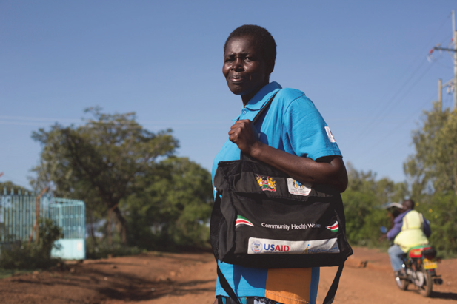
Case Study: Always on Duty in the Fight against Malaria
Photo by Jhpiego/Arete/Karel Prinslo
Francisca was worried. Catherine, a pregnant client at the Got Matar health clinic in Bondo, Kenya, had failed to show up for her antenatal contact the day before. Francisca, a community health worker, was determined to check on Catherine and ensure she received the antimalarial drugs needed to protect her and her baby from the killer disease.
Francisca persuaded a visitor to drive her to Catherine’s village, and within a half-hour, the community health worker was back at the Got Matar clinic, accompanied by Catherine. Catherine confirmed that she was too tired to walk to the clinic. She was pregnant with her fourth child, and this was the only pregnancy for which she had received ANC. She had lost two previous pregnancies to malaria.
“With my second miscarriage, I bled so much that they had to hospitalize me for a week,” Catherine said. “That is why I decided to come for [the] antenatal clinic with this pregnancy.”
During ANC contacts, a pregnant woman receives a complete package of care to keep her and her fetus healthy, including intermittent preventive treatment to combat malaria. The women are also given a mosquito net before and after delivery, and they receive health talks on malaria prevention and control for themselves and their families.
“My greatest joy is when I see a mother I have been monitoring throughout pregnancy safely deliver a healthy baby,” says Francisca, who lost a 2-month-old son to malaria. “That is what keeps me going.”
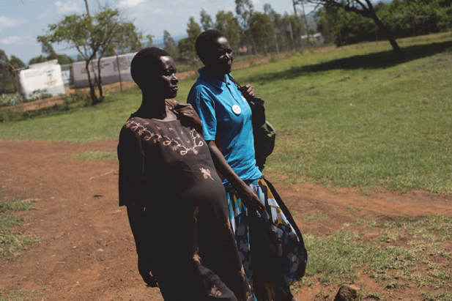
In just three years, the percentage of women making four ANC contacts in Bondo district grew from 19% to 50%. The lifesaving malaria drugs that women take during these contacts play an essential role in reducing the impact of malaria in Bondo. The district medical health officer cited a big reduction in the number of patients coming in for malaria treatment. With the strategic care provided during antenatal clinic contacts, the antimalarial tools used to keep her healthy, and the watchful eye of Francisca, Catherine is in good hands.
Photo by Jhpiego/Arete/Karel Prinslo

Module Two: Malaria Transmission
LEARNING OBJECTIVES
This module summarizes what malaria is, how it is transmitted, and what its effects are, especially on pregnant women and those living with HIV/AIDS. After completing this module, learners will be able to:
- Define malaria and how it is transmitted.
- Describe the extent of malaria in Africa and in learners’ respective countries.
- Compare the effects of malaria in areas of stable and unstable transmission.
- List the effects of malaria on a pregnant woman, her developing fetus, and the community.
- Describe the effects of malaria on women living with HIV.
- Discuss integration of MIP and prevention of mother-to-child transmission of HIV services into ANC.

Background
Malaria is a disease caused by a group of parasites called Plasmodium. A parasite is a very small organism that cannot be seen with the naked eye. It cannot live on its own; it has to feed off other organisms to reproduce and live. Many types of Plasmodium exist, and they cause malaria in animals as well as people. There are five types of Plasmodium parasites that affect humans:
- Plasmodium falciparum
- Plasmodium vivax
- Plasmodium ovale
- Plasmodium malariae
- Plasmodium knowlesi (occurs naturally in monkeys in Southeast Asia but now known to cause disease in humans)
Of these five types, Plasmodium falciparum (P. falciparum) is the most prevalent species in sub-Saharan Africa, is responsible for the majority of deaths globally, and causes the most severe malaria disease.
The remaining species are not typically as life threatening as P. falciparum. Plasmodium vivax is the second most significant species and is prevalent in Southeast Asia and Latin America. P. vivax and
P. ovale have dormant liver stages, which can be reactivated in the absence of further mosquito bites and lead to clinical symptoms.
Malaria is spread by mosquitoes that are infected with malaria parasites. The mosquito becomes infected with these parasites by biting an infected person. However, not all mosquitoes can transmit malaria. Only female mosquitoes from the Anopheles family spread the malaria parasite.
As shown in Figure 2, the female Anopheles mosquito is different from a mosquito that does not transmit malaria in the way it positions its body while sitting on any object.
Figure 2. Difference between Anopheles mosquitoes and other mosquitoes
Anopheles
Posture
Culex
Body in two axes
Body in one axis
Note: The body of the Anopheles points up in the air in one line, but in other mosquitoes, the body is bent and the rear end points down.
Source: WHO. 2004c

How Malaria Is Transmitted
A person becomes infected with malaria after being bitten by an infected female Anopheles mosquito. The mosquito feeds on blood to nourish its eggs. When the infected mosquito bites, it injects saliva that contains parasites into the person’s bloodstream. The parasites then travel quickly to the liver cells, where they hide from the immune system and begin to multiply.
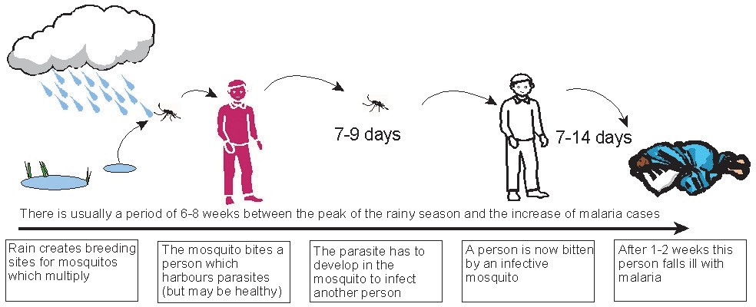
Figure 3. How malaria is transmitted
Source: WHO. 2004c

About one to two weeks after an infected mosquito bites the person, the multiplying parasites cause the infected liver cells to burst, and new parasites enter the bloodstream (Figure 3).
The parasites then attack red blood cells and begin consuming hemoglobin, the part of the blood that carries oxygen. While in the red blood cells, the parasites multiply and eventually cause the blood cells to burst, spilling parasites into the blood again. The loss of these red blood cells causes anemia. When this happens, the person usually begins to show signs of malaria. The most common symptom is fever and/or anemia.
The person may feel well briefly, until more red blood cells burst (about every two to three days) and s/he becomes sick again. This cycle continues repeatedly until the immune system or medicine stops the infection, or there are complications, which may lead to death.
Because Anopheles mosquitoes are active only at night, efforts to prevent malaria are most effective from dusk to dawn. However, because mosquitoes can transmit other diseases, it is best to prevent bites at all times. It is important to note that although mosquitoes can carry many other disease agents, they cannot transmit HIV.
As long as a person is exposed to Anopheles mosquitoes, the malaria cycle of infection can occur again, as illustrated in Figure 4. Sometimes, a few parasites remain in the liver and can be released even months or years later.
Figure 4. The malaria cycle of infection
Parasites in the blood of an infected person are drawn into the stomach of the mosquito as it feeds.
MOSQUITO BITES INFECTED PERSON
INFECTED MOSQUITO BITES PERSON
Parasites multiply in the human liver and blood, causing fever, chills, and other symptoms.

The following four factors affect malaria transmission and illness. The more of these factors there are in a community, the higher the malaria rate.
- Breeding sites: Anopheles mosquitoes need stagnant or slow-flowing bodies of non- contaminated water to use as breeding sites to lay their eggs. These sites, which may increase during the rainy season, include:
- Small ponds, ditches, pits, and canals
- Swamps, reservoirs, and rice fields
- Pools of water after rain
- Uncovered water tanks
- Along the banks of slow-flowing streams
- Water-filled animal hoof prints
- Objects that collect water, such as empty tins and containers
- Parasites: Enough parasites must exist in the human population to infect the mosquito.
- Climate: The temperature must be an average of at least 18–20C and the humidity above 60% for the mosquito to survive and for the parasite to develop and become infective. The warmer the weather, the faster the development of the parasite.
- Population: In Africa, Anopheles mosquitoes do not fly farther than about 1–2 kilometers from their breeding sites, unless aided by the wind. People must be near breeding sites in order to be bitten by an infected mosquito.

Populations Most Affected by Malaria
Information Box 6
Pregnant women are more likely to become infected than women who are not pregnant.
- Women in their first or second pregnancies are more at risk.
- Globally, about every 2 minutes, a child dies from malaria (WHO 2016d).
- An estimated 90% of all malaria deaths occur in Africa, and the majority are among children under 5 years old (WHO 2015c).

Malaria is a preventable and treatable disease, yet it remains a public health problem throughout the world, causing an estimated 429,000 deaths globally each year. Most of these deaths occur in the African region (92%), followed by the Southeast Asia region (6%) and the eastern Mediterranean region (2%) (WHO 2016d).
Of the estimated malaria cases, more than 90% occur in sub-Saharan Africa (see Figure 5). Pregnant women and young children are the two groups of people most at risk for infection. Pregnant women are three times more likely to develop severe disease than women who are not pregnant and acquire infections from the same area.
Millions of pregnancies occur among women living in malaria-endemic regions of Africa, yet only a fraction of these women have access to effective interventions.
Others who are at greater risk of malaria infection include people from areas with low or no malaria transmission, such as immigrants and refugees, who come to visit or live in high malaria transmission areas, and people living with HIV/AIDS.

Figure 5. Endemicity: Plasmodium falciparum: global map (2010) 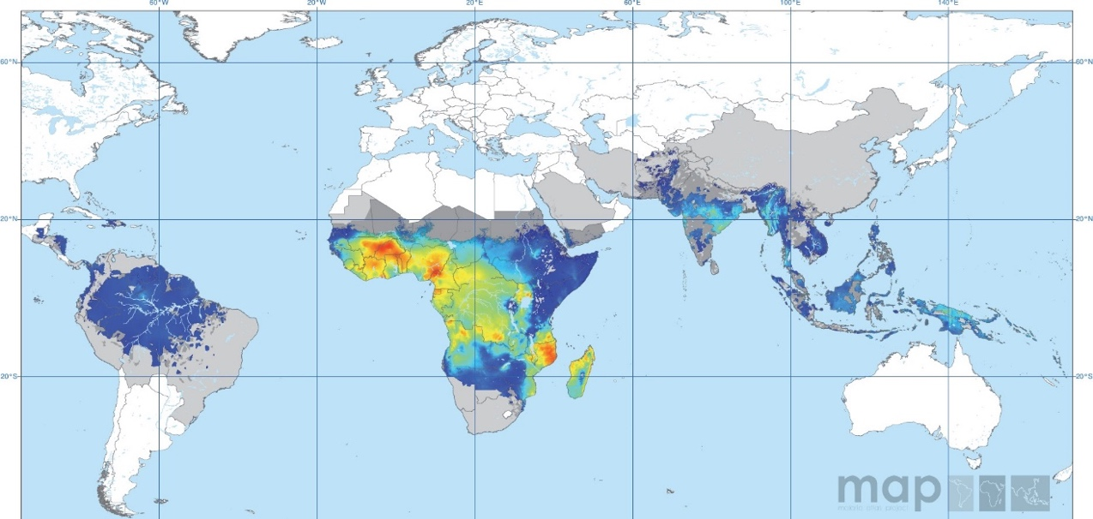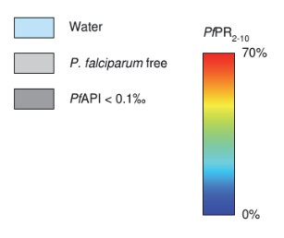
Source: Gething, P.W. et al. 2010

Transmission Levels
Areas of stable or moderate to high transmission are places where continuous exposure to malaria occurs at a constant rate. In these areas, immunity is developed during childhood. Episodes of clinical disease and risk of death from malaria decrease as immunity increases with repeated exposure to malaria infections. Adolescents and adults are partially immune, although they may have a few parasites in their blood, but adolescents have a higher risk of malaria infection due to immunologic and hormonal factors (Lalloo et al. 2006).
Immunity is reduced in pregnancy and can be lost when individuals move out of a high-transmission area for a long time. Pregnant women and children in areas of stable transmission have the highest risk of becoming ill from malaria.
Figure 6. Possible outcomes of malaria infection with increasing immune status*
Infection
Infection
Infection
Infection
Severe disease
Death
Moderate to severe disease
Disease
Disease
Disease
Possible Outcomes

Outcomes as Immunity Increases
*Adapted from WHO 2013a.
In areas of unstable or low transmission, the population is not exposed to malaria very often. Malaria can be seasonal in these areas (e.g., it may occur mostly in the rainy season). Due to these low levels of malaria infection, the population develops little or no immunity. As a result, children, adolescents, adults, and pregnant women are equally susceptible to malaria infections. Therefore, in unstable transmission areas, malaria can be very serious during pregnancy, and complications may occur in a short time (see Figure 7).
Often, different levels of transmission can occur within a country or region. Within a malaria region, such as in Southern Africa, there can also be malaria-free areas. Factors that affect transmission include temperature, humidity, and altitude. For example, the life of a mosquito extends due to high humidity, while cold weather (below 16°C) slows parasite development in the mosquito.

Impact of Malaria Transmission Levels on Effects of MIP
The effects of malaria infection on the pregnant woman can range from mild to severe, depending on the level of malaria transmission in a particular setting and the pregnant woman’s level of immunity (WHO 2004c). The level of immunity depends on several factors:
- Intensity of malaria transmission
- Number of previous pregnancies
- Presence of other conditions, such as HIV, which can lower immune response during pregnancy

Pregnancy in Areas of Stable Transmission
Even though there are more malaria infections in these areas, many pregnant women with malaria parasites do not have symptoms, meaning no fever or clinical signs of illness. This is because women in stable areas (see Figure 7) have some immunity, which decreases the chance of clinical disease.
However, the lack of clinical symptoms does not mean that the woman’s health is not affected. The major complication of malaria among pregnant women in stable areas is anemia, which can cause death in severe cases. Women who are pregnant for the first or second time are most at risk of such complications.
Figure 7. Malaria in pregnancy in areas of stable transmission*
Possible Outcomes of a Malaria Infection
Disease with signs and symptoms
Severe disease
Spontaneous abortion
A small proportion develop signs and symptoms.
Maternal and fetal death
Asymptomatic infection
Placental sequestration
Altered placental integrity
Less nutrient transport
Low birthweight
Higher infant mortality
A large proportion are immune and have no signs
and symptoms.
Anemia
Maternal morbidity
*Adapted from WHO 2004c.

Transmission Level Effects
The problems that malaria infection causes differ somewhat by the type of malaria transmission area: stable (high) or unstable (low) transmission (CDC 2012). In areas where malaria incidence is episodic rather than endemic, patients may have more severe forms of the disease, as their “learned immunity” fades. Malaria-naive and immunocompromised patients are prone to severe infections (Schantz-Dunn and Nour 2009).
Information Box 7
In areas of unstable transmission, these populations have a higher risk of malaria infection:
- Adolescents
- Women in their first or second pregnancy
- Immigrants/visitors from areas of low malaria transmission
- Women infected with HIV/AIDS
- Women with immunocompromised conditions

Adapted from WHO 2004c.
- In high-transmission areas, women have gained a level of immunity to malaria, which can wane during pregnancy. Malaria infection is likely to contribute to maternal anemia and delivery of low-birthweight infants (<2,500 g or 5.5 pounds); 11% of newborn deaths can be attributed to low birthweight caused by P. falciparum infection during pregnancy. It is a particular problem for adolescents, women in their first and second pregnancies, and women living with HIV/AIDS (Lalloo et al. 2006; CDC 2012).
- In low-transmission areas, women generally have developed no immunity to malaria. Malaria infection is more likely to result in severe malaria disease, maternal anemia, premature delivery, or fetal loss (CDC 2012).
- All pregnant women can be at similar risk for malaria infection in places where transmission is low or unstable.
Table 3 summarizes the current WHO strategy for MIP by level of transmission.
Table 3. WHO strategy for malaria in pregnancy, by level of transmission (2010)
Transmission Levels | Case Management (Diagnosis and Treatment) | Intermittent Preventive Treatment | Insecticide-Treated Nets (ITNS)
High/medium transmission—perennial (stable); high/medium transmission—seasonal (stable)a | There is limited risk of febrile illness and severe malaria.  Screen for and treat anemia with iron and folic acid supplement.  Promptly diagnose and treat all potential malaria illness with an effective drug. | Provide pregnant women with a standard IPTp-SP dose by directly observed therapy as early as possible in the second trimester.b  At each scheduled antenatal contact after first trimester, provide IPTp-SP at not less than 1-month intervals.c  Folic acid at a daily dose equal to or above 5 mg should not be given together with SP, as this counteracts the efficacy of SP as an antimalarial.  Do not give IPTp-SP if the woman is receiving  co-trimoxazole prophylaxis. | Begin use of ITNs early in pregnancy and continue postpartum.  Emphasize the importance of newborns and young children sleeping under ITNs.
Low transmission (unstable)e | Risk of severe malaria illness is high.  Promptly diagnose and treat all malaria illness with an effective drug.c  Screen and treat anemia with recommended antimalarial drug and iron supplement.  Consider P. vivax  infection in East Africa.d | Based on present evidence, IPTp-SP is not recommended in these areas. | Begin use of ITNs early in pregnancy and continue postpartum.  Emphasize the importance of newborns and young children sleeping under ITNs.
- Adult women have a high level of acquired antimalarial immunity; first and second pregnancies are at higher risk of adverse consequences of malaria.
- Currently the most effective drug for IPTp is sulfadoxine-pyrimethamine (SP).
- WHO recommends an ideal schedule of one ANC contact in the first trimester (or when the woman suspects she is pregnant) and seven ANC contacts thereafter.
- Chloroquine chemoprophylaxis to decrease the burden of P. vivax in pregnancy may be considered, but no evidence on the effectiveness of this strategy is available at this time.
- Adult women have very low or no acquired antimalarial immunity; all pregnancies are at risk of adverse consequences of malaria.
Source: Adapted from WHO 2004c and WHO 2013f.

Integration of MIP and Other Common Conditions

HIV/AIDS and Malaria
According to UNAIDS 2010, there are more than 22.9 million people living with HIV/AIDS in Africa alone. Malaria and HIV/AIDS overlap geographically and target the same vulnerable populations in this region. The presence of HIV results in a poorer response to both prevention and treatment of MIP (WHO 2004b; RBM Partnership 2008; WHO 2010a). HIV in pregnancy can:
- Reduce a woman’s resistance to malaria.
- Increase the likelihood of developing clinical malaria and malaria-related mortality.
- Cause malaria treatment to be less effective.
- Cause increased risk of malaria-related problems in pregnancy.
- Increase the risk of intrauterine growth restriction, leading to low birthweight.
- Increase the risk of preterm birth.
- Increase the risk of maternal anemia.
Pregnant women who are co-infected with HIV and malaria are at higher risk of anemia and malaria infection of the placenta. Among the 50 million women who are pregnant in malaria-endemic regions, at any given time, approximately 1 million women have both malaria and HIV/AIDS (Schantz-Dunn and Nour 2009).
Newborns of women living with HIV/AIDS therefore are more likely to have low birthweight and die during infancy (WHO 2004a; WHO 2010b). Research is ongoing about the relationship between MIP and mother-to-child transmission of HIV (WHO 2010b).
Since 2006, studies have shown that provision of antiretroviral (ARV) drugs to women living with HIV/AIDS during pregnancy, birth, and the postpartum periods, and to HIV-exposed infants, can significantly reduce the risk of perinatal transmission of HIV, which includes the breastfeeding period.

WHO Recommendations for Integrating Malaria and HIV Services (WHO 2004ª)
- Because people living with HIV/AIDS in areas of malaria transmission are particularly vulnerable to malaria, their protection by ITNs is of the highest priority.
- In addition to using bed nets, pregnant women living with HIV/AIDS in areas of moderate to high transmission should receive either IPTp-SP, beginning as early as possible in the second trimester at each scheduled ANC contact (but not more often than monthly), or daily co-trimoxazole prophylaxis. Do not give IPTp-SP to clients on daily co-trimoxazole prophylaxis.
- Collaboration between reproductive health programs and HIV and malaria control programs should occur to ensure integrated service delivery. This should include the necessary harmonization of national policies, guidelines, and training materials to avoid confusion among providers and ensure integrated implementation of services.
- During every ANC contact, women should receive counseling and care directed at preventing and treating both malaria and HIV. Appropriate diagnostic tools for HIV, malaria, and ARV and antimalarial drugs should be available at all levels of the health care system. ANC is the ideal time to counsel women on HIV and infant feeding (please see next section).
- Additional research on interactions between ARV and antimalarial drugs is urgently needed.
Information Box 8
Malaria and HIV
There is some evidence that the HIV/malaria relationship is not just an additive one—these infections may act synergistically, meaning the two infections do not just coexist but exacerbate one another. This is because HIV aggravates malaria-associated anemia, and women living with HIV are therefore at greater risk of severe anemia and death.

Co-Trimoxazole and Its Effects on Malaria
In adults living with HIV/AIDS, daily prophylaxis with co-trimoxazole has shown promise in preventing some infections, including malaria (Anglar et al. 1999; Suthar et al. 2012). Some programs are already using this approach.

HIV/AIDS and Infant Feeding
Recent studies have found persuasive evidence that the use of ARV drugs during pregnancy, childbirth, and while breastfeeding greatly reduces the risk of mother-to-child transmission of HIV. For example, if a woman living with HIV/AIDS breastfeeds her infant while taking ARV drugs herself or giving ARV drugs to her infant each day, the risk of transmission during 6 months of breastfeeding is reduced to 2%. If the woman living with HIV/AIDS breastfeeds for 12 months while taking ARV drugs or giving them to the infant, then the risk of transmission is about 4%.
Without such interventions, approximately 14–17% of breastfed infants of women living with HIV/AIDS would become infected with HIV by the age of 18 months (WHO 2012b).
Information Box 9
Counseling Women about Infant Feeding
In 2016, WHO released Guideline: Updates on HIV and Infant Feeding: The Duration of Breastfeeding and Support from Health Services to Improve Feeding Practices among Mothers Living with HIV (WHO 2016b), which includes the following recommendations:
- Women living with HIV/AIDS should breastfeed for at least 12 months and may continue breastfeeding for up to 24 months or longer (similar to the general population) while being fully supported for antiretroviral therapy (ART) adherence (see the WHO consolidated guidelines on ARV drugs for interventions to optimize adherence [WHO 2016a]).
- In settings where health services provide and support lifelong ART, including adherence counseling, and promote and support breastfeeding among women living with HIV/AIDS, the duration of breastfeeding should not be restricted. Women known to be living with HIV/AIDS (and whose infants are HIV uninfected or of unknown HIV status) should exclusively breastfeed their infants for the first 6 months of life, introducing appropriate complementary foods thereafter and continue breastfeeding. Breastfeeding should then only stop once a nutritionally adequate and safe diet without breast milk can be provided.
- National and local health authorities should actively coordinate and implement services in health facilities and activities in workplaces, communities, and homes to protect, promote, and support breastfeeding among women living with HIV/AIDS. Health care workers and women living with HIV can be reassured that ART reduces the risk of postnatal HIV transmission in the context of mixed feeding. Although exclusive breastfeeding is recommended, practicing mixed feeding is not a reason to stop breastfeeding in the presence of ARV drugs.

Health care workers and women living with HIV/AIDS can be reassured that shorter durations of breastfeeding of less than 12 months are better than never initiating breastfeeding at all
Source: WHO 2010a.

Sickle Cell Trait, Sickle Cell Disease, and Malaria
Sickle cell trait is a genetic condition resulting from a hemoglobin disorder. It is particularly common among people of African, Mediterranean, Saudi Arabian, and Indian ancestry. People with sickle cell trait carry one sickle hemoglobin-producing gene inherited from a parent and one normal hemoglobin gene. Those with the trait, often called carriers, do not have symptoms of sickle cell disease and live a normal life.
Only in some individuals in the general population do malaria episodes progress to severe, life- threatening disease; in the majority, the episodes are self-limiting (CDC 2012). Carriers have some protection against malaria. As a result, the population of sickle cell carriers is higher in malaria- endemic areas.
According to CDC’s birth cohort studies, sickle cell trait provides 60% protection against overall mortality from malaria. Most of this protection occurs between the ages of 2 months and 16 months, before the onset of clinical immunity in areas with intense transmission of malaria.
It is not known exactly why those with sickle cell trait have some resistance to P. falciparum malaria, especially in early childhood. Despite the fact that they have protection, it is still important that those with sickle cell trait take IPTp-SP and use ITNs and other preventive measures, such as indoor residual spraying (IRS), for malaria transmission control (World Health Assembly 2006).
People with sickle cell disease have two abnormal hemoglobin genes in their red blood cells. In general, women with sickle cell disease are at higher risk of pregnancy complications. Pregnancy can worsen sickle cell disease, and sickle cell disease can worsen pregnancy outcomes. Daily folic acid supplementation (with 1 mg or 5 mg orally) is often prescribed for women with sickle cell disease before and during pregnancy to help them replenish stores lost due to the hemolysis (destruction of red blood cells) caused by sickle cell disease.
Malaria prevention is very important for people living with sickle cell disease, as malaria can trigger sickle cell crisis. However, folic acid regimens higher than 0.4 mg daily may decrease effectiveness of IPTp-SP. Unfortunately, global consensus does not exist regarding the optimal regimen for malaria prophylaxis or folic acid supplementation for pregnant women living with sickle cell disease in areas with moderate to high malaria transmission due to a lack of research evidence. However, women with sickle cell disease must be encouraged to sleep under an LLIN every night. As these women are at higher risk of pregnancy complications, efforts should be made to help them access specialty care in both obstetrics and hematology, as available, so that specialists can make clinical decisions that consider the individual woman’s risks and clinical care needs (CDC 2015).
Information Box 10
Babies born to women with malaria are more likely to have low birthweight—the single greatest risk factor for death during the first month of life.

Malaria’s Effects on the Fetus
During pregnancy, malaria parasites hide (sequester) in the placenta and interfere with the transfer of oxygen and nutrients from the woman to the fetus. Combined with anemia, this increases the risk of spontaneous abortion and stillbirth. In the second half of pregnancy, malaria can hinder fetal weight gain, causing low birthweight and preterm births. About 5–14% of all low-birthweight babies are born to women infected with malaria, and an estimated 3–5% of all infant deaths can be traced to malaria infection in women. In some cases, malaria parasites can cross from the placenta into the baby’s blood and cause anemia in the baby.

Malaria’s Effects on Communities
Malaria may have multiple negative effects on the communities in which families live and work, including:
- Causing sick individuals to miss work (and wages)
- Causing sick children to miss school
- Possibly causing chronic anemia in children, inhibiting growth and intellectual development, and affecting future productivity in the community
- Using scarce resources (during treatment and to prevent morbidity and mortality death)
- Being too expensive (treatment is more costly than prevention)
- Requiring drugs for treatment
- Requiring staff time
- Causing preventable deaths, especially among children and pregnant women
Information Box 11
Health Education and Counseling Points
- Malaria is transmitted through female Anopheles mosquito bites.
- Pregnant women and children are particularly at risk of malaria.
- Adolescents are at higher risk of MIP.
- Pregnant women in malaria-endemic areas infected with malaria may have no symptoms.
- Women living with HIV have a higher risk of malaria infection.
- Malaria can lead to severe anemia, spontaneous abortion, and low-birthweight newborns.
- Malaria is preventable.
- Malaria is treatable.
General Malaria Information, Facts, and FAQs
CDC: http://www.cdc.gov/malaria
WHO: http://www.who.int/topics/malaria/en/
UNICEF: http://www.unicef.org/health/index_malaria.html

Module Three: Malaria Prevention
LEARNING OBJECTIVES
This module describes the 2010 WHO strategy for malaria prevention and control. It also includes counseling points about malaria prevention for pregnant women and their families. After completing this module, learners will be able to:
- Describe the three-pronged approach to malaria prevention and control according to WHO’s current MIP strategy.
- List the elements of counseling women about the use of ITNs—more specifically, LLINs—for IPTp and other means of malaria prevention.
- Describe the use of SP for IPTp, including dosage, timing, and contraindications.
- Discuss IRS and other ways to prevent malaria.
- Assist the pregnant woman with preparing a birth preparedness and complication readiness plan.

Malaria Prevention Strategy
The WHO Global Malaria Programme recommends the following three primary interventions for effective malaria control, which must continue to be scaled up if countries are to move toward achieving the United Nations Sustainable Development Goals by 2030:
- Diagnosis of malaria cases and treatment with effective medicines
- Distribution of ITNs—more specifically, LLINs—to achieve full coverage of populations at risk of malaria
- IRS to reduce malaria transmission
A meta-analysis of national survey data sets showed that under routine program conditions, exposure to IPTp-SP and ITNs was associated with reductions in neonatal mortality and low birthweight (Eisele et al. 2012). Furthermore, the protective role of IPTp-SP in reducing neonatal mortality under trial conditions and cost-effectiveness of IPTp-SP during routine ANC services have been demonstrated (Menendez et al. 2010; Sicuri et al. 2010). These studies highlight the critical importance of continuing IPTp-SP and ITN use among pregnant women to prevent the adverse consequences of MIP.
Information Box 12
Considerations for Maternal and Newborn Health and Malaria Programs
- Not only is IPTp-SP lifesaving and straightforward to implement, it is also highly cost-effective for prevention of maternal malaria and reduction of neonatal mortality.
- IPTp-SP as a key intervention for pregnant women (combined with ITN use and effective case management) should remain a priority across stable malaria transmission countries.
- A recent study by Chico et al. found that pregnant women who received two or more doses of IPTp- SP were protected not only from adverse outcomes related to malaria but also some sexually transmitted/reproductive tract infections (2017).
- These data indicate that ministries of health should aim for full coverage and scale-up of these lifesaving interventions.

The Africa Regional Office of WHO developed an evidence-based strategy for the prevention and control of MIP in the region (WHO 2004c; WHO 2013f). The strategy was designed to be appropriate for most African settings, but it also includes guidance on adapting the content to local situations. Because most sub-Saharan Africans live in areas of stable (moderate to high) transmission, WHO’s three-pronged approach is the basis for this strategy:
Information Box 13
Note on Drug Information
At the time of publication of this manual, the drug of choice for IPTp is SP. However, research on alternative drugs is being conducted. Malaria prevention programs in Africa should be in regular contact with WHO for new information on recommendations for malaria prevention.

- Use of ITNs by all pregnant women
- IPTp-SP, beginning as early as possible in the second trimester of pregnancy, for women in areas of moderate to high malaria transmission
- Early diagnosis and prompt case management
It is crucial to provide a standard IPTp-SP dose by DOT to pregnant women as early as possible in the second trimester because the placenta becomes susceptible to infection by the end of the first trimester (Walker et al. 2014). Thereafter, IPTp-SP should be given at each scheduled ANC contact, at not less than 1-month intervals. The high level of at least one ANC contact in much of Africa affords an ideal platform to encourage ongoing contacts and thus implement each component of WHO’s 2012 strategy. Because each setting is different, national reproductive health and malaria control programs should collaborate to formulate and disseminate these new guidelines.
The health care system, community, private sector, and nongovernmental organizations should work together to ensure high-quality services with adequate drugs and supplies. For example, collaboration with community-based groups to make ITNs available at several locations will help increase ITN usage.
Figure 8. Insecticide-treated net tucked under a bed (a) and tucked under a mat (b)
a. | 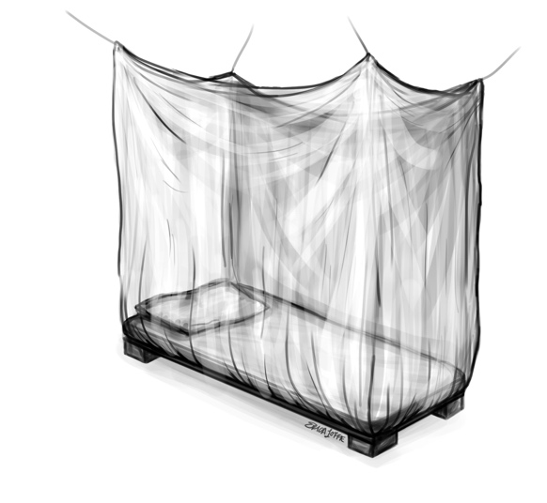 | b. | 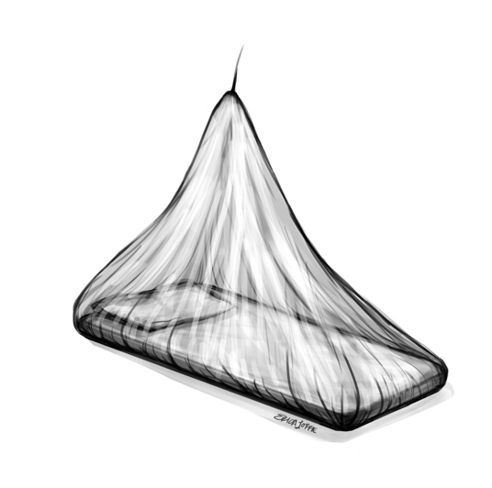

Insecticide-Treated Nets
There are two types of ITNs:
- Long-lasting: Effectiveness lasts the lifetime of the net (2 to 3 years).
- Retreatable: Effectiveness is limited to 6 months to 3 years, depending on the formulation of the chemical and the environment.
Of all the methods of preventing mosquito bites, sleeping indoors under an ITN (Figure 8) is probably the most effective, as mosquitoes bite at night, when people are asleep. ITNs reduce human contact with mosquitoes by acting as a barrier, killing them if they land on the net or by repelling them and driving them away from where people are sleeping.
Many studies have demonstrated the effectiveness of ITNs in reducing the risk of low birthweight and maternal anemia. Numerous programs have contributed to making ITNs accessible by reducing costs and increasing availability. Unfortunately, many women do not use ITNs, even when they can afford them. Some reasons for this may include:
- People are not in the habit of using nets, so they hesitate to buy them.
- People need to be convinced of their usefulness and safety.
- The need to retreat the nets periodically is inconvenient or not affordable, unless people have access to LLINs, which can retain their effectiveness for 2 to 3 years (depending on the manufacturer).
- Other family members might not like sleeping under nets, discouraging the pregnant woman from doing so. This often results from lack of knowledge about the benefits of ITNs for pregnant women and children.

Some Frequently Asked Questions and Facts about ITNs

Are untreated nets just as effective as ITNs
Although untreated mosquito nets can protect against mosquitoes, they are less effective than treated nets.
Table 4 compares nets that are not treated with an insecticide with those that are treated.
Table 4. Comparison of untreated nets and insecticide-treated nets
Untreated Nets | Insecticide-Treated Nets
Provide some protection as barriers against malaria. | Provide a high level of protection against malaria.
Do not kill or repel mosquitoes that touch the net. | Kill or repel mosquitoes that touch the net.
Do not reduce number of mosquitoes. | Reduce number of mosquitoes inside and outside the net.
Do not repel/kill other insects, like lice, ticks, and bedbugs. | Repel and/or kill other insects, like lice, ticks, and bedbugs (Lindsay et al. 1989).
Are safe for use by pregnant women, children, and infants. | Are safe for use by pregnant women, children, and infants.

What are the benefits of using ITNs?
For pregnant women, ITNs protect against malaria, reducing the risk of anemia, abortion, stillbirth, and maternal death.
For newborns, ITNs help by:
- Decreasing the incidence of low birthweight
- Lowering the incidence of newborn anemia
- Reducing the risk of newborn death
- Promoting growth and development during pregnancy and the first few weeks of life

How do ITNs help the community?
- They cost less than treating malaria infection.
- They reduce the number of people who get sick from malaria and the number of people who die from severe malaria.
- By reducing malaria illness in children, they promote growth and general health.
- By reducing malaria in adults, they enable adults to spend more time at work, thereby improving productivity and their economic status.

Are ITNs safe?
WHO recommends that certain insecticides be used to treat ITNs. These insecticides are safe for humans and are being used in many countries throughout the world. The insecticides used in ITNs are diluted, and the quantities are too small to have effects on humans, including newborns.

Where can ITNs be found?
- Antenatal clinics
- General merchandise shops
- Drug shops or pharmacies
- Markets
- Public and private health facilities
- Nongovernmental organizations and community-based groups, such as the African Medical Research Foundation
- Community health workers

How are ITNs used?
For an ITN to effectively reduce the number of mosquitoes in a house, it must be used and cared for correctly. Below are tips for using an ITN:
- Expose the net to air for a few hours after opening to enable free chemicals to escape.
- Hang the net so that it covers the entire bed or sleeping mat, and tuck it under the mattress or mat, as shown in Figure 8.
- Use the net every night and all year, not just when mosquitoes are bothering you.
- Handle the net gently so that it does not tear. During the day, tie it up and out of the way to avoid damage.
- Regularly inspect the net for holes and repair them (although treated nets that are torn still offer some protection).
- Refer to local guidelines for instructions on when to retreat nets.
- Do not smoke or use fire near the net; it may easily catch fire.

LLINs
An LLIN net is a pretreated, ready-to-use net that can last up to 2 to 3 years, depending on the type, and does not require retreatment during that time. LLINs have several advantages compared to retreatable ITNs. For example, LLINs:
- Usually have a one-time cost.
- Do not require additional treatments.
- Save money because there are no additional costs associated with retreatment or retreatment campaigns and additional insecticides.
Because some studies have shown that LLINs might not have the expected life of 2 to 3 years, WHO recommends that each country conduct its own study to assess net attrition and physical integrity to better plan campaigns to resupply nets.
Demand for LLINs has increased rapidly, from 5.6 million in 2004 to 145 million in 2010 in sub- Saharan Africa. Many government and nongovernmental programs prefer LLINs to conventional nets. The high demand may cause a delay in availability, but providers are encouraged to promote regular ITNs when LLINs are not available. Because of variations in quality, it is advised that only WHO- recommended LLINs be used until further testing is done. A list of WHO pesticide evaluation scheme recommended LLINs is available online at http://www.who.int/whopes/resources/en/.

Indoor Residual Spraying
The main purpose of IRS is to lower malaria transmission by reducing the survival of mosquitoes entering houses and sleeping areas. It is a national-level initiative, but it is implemented at the local level.
To be effective, IRS operations should be country-specific and must include:
- Adequate commitment and social acceptance
- Spraying of at least 80% of homes and barns in an area
- Enough health system capacity to deliver quality, well-timed, and high coverage
- Credible information about local vectors, especially their insecticide susceptibility, as well as indoor versus outdoor feeding and resting behaviors
According to WHO (2013c), IRS can be an effective intervention if these guidelines are followed:
- Use where the majority of the vector population feeds and rests inside houses.
- Use where the vectors are susceptible to the insecticide being used.
- Use in areas where people sleep indoors at night.
- Use where the malaria transmission is such that only one or two rounds per year are needed.
- Use where the majority of structures are suitable for spraying.
- Use when structures are in a confined area. If scattered over a wide area, the transportation costs will be high.
Currently, IRS is contributing to malaria prevention. Most IRS programs have specially trained staff to do the spraying. Providers should stay updated about any local IRS programs in their areas and educate clients accordingly.
A new approach to improve the effectiveness, efficiency, soundness, and sustainability of IRS is called integrated vector management (WHO 2013c). The approach encourages government and nongovernmental groups to plan IRS within the context of a comprehensive malaria control effort.
Information Box 14
WHO guidelines recommend that IRS should be used where:
- The majority of the vector population feeds and rests inside houses.
- The vectors are susceptible to the insecticide being used.
- People sleep indoors at night.
- Malaria transmission is such that only one or two rounds per year are needed.
- The majority of structures are suitable for spraying.
- Structures are in a confined area. If scattered over a wide area, the transportation costs will be high.

IPTp-SP
IPTp-SP is based on the assumption that every pregnant woman living in areas of moderate to high malaria transmission has malaria parasites in her blood or placenta, whether or not she has symptoms of malaria.
Therefore, WHO recommends that pregnant women in areas where the prevalence rate of malaria is 11–50% during most of the year (moderate) and over 50% during most of the year for children 2 to 9 years old (high) should receive their first dose of IPTp-SP as early as possible in the second trimester, and receive subsequent doses at each scheduled ANC contact thereafter, but not more often than monthly (every 4 weeks).
Information Box 15
WHO Policy Brief for the Implementation of IPTp-SP
- IPTp-SP prevents the adverse consequences of malaria on maternal and fetal outcomes, such as placental infection, clinical malaria, maternal anemia, fetal anemia, low birthweight, and neonatal mortality.
- IPTp-SP has recently been shown to be highly cost-effective for prevention of maternal malaria and reduction of neonatal mortality in areas with moderate or high malaria transmission
- Despite the spread of SP resistance, IPTp-SP continues to provide significant benefit, resulting in protection against neonatal mortality (protective efficacy 18%) and low birthweight (21% reduction in low birthweight) under routine program conditions (WHO 2013f).
Preventing parasites from attacking the placenta helps the fetus develop normally and avoid low birthweight. Note that there are two circumstances in which IPTp-SP should not be given:
- If pregnant women are receiving co-trimoxazole prophylaxis
- If pregnant women are receiving folic acid at a daily dose of ≥ 5 mg (this dose of folic acid counteracts SP’s efficacy as an antimalarial)
Information Box 16
Folate Supplementation Information
- Some evidence suggests that high doses (> 5 mg) of folate supplementation may reduce the effectiveness of SP for treatment of malaria (Ouma et al. 2006; WHO 2010a).
- Use of lower doses (0.4 mg) of folate does not seem to reduce SP effectiveness. For this reason, if higher doses are used, health care providers should instruct pregnant women not to take folate for at least 14 days after receiving SP.
- Providers should understand and follow local protocols.

IPTp-SP: Frequently Asked Questions and Answers

Who should receive IPTp-SP?
IPTp-SP should be given as early as possible in the second trimester to all pregnant women living in areas of stable transmission, whether or not they have symptoms of malaria, except for the two exceptions above. (See “When should you avoid giving SP?”)

What about resistance to SP in some countries?
Evidence shows that SP prevents consequences of malaria in pregnant women who have already had a number of malaria infections and thus have a certain level of immunity. It is thought that SP primarily works through a prophylactic effect. Recent evidence also demonstrates that SP is associated with higher mean birthweight and fewer low birthweights across a wide range of SP resistance levels. Even in areas where a high proportion of P. falciparum parasites carry quadruple mutations, IPTp-SP remains effective in preventing adverse maternal and fetal consequences of malaria (WHO 2013f).
Information Box 17
IPTp-SP is important because many pregnant women with malaria parasites have no symptoms.

How should IPTp-SP be given?
- A single dose is three tablets of sulfadoxine (500 mg and pyrimethamine 25 mg per tablet), under DOT. For women presenting in late pregnancy, even one dose of IPTp-SP is beneficial.
- IPTp-SP should be given to all pregnant women, but only after onset of the second trimester. Subsequent doses must be at least 4 weeks apart.
- To avoid accumulation of high levels of SP in the woman’s blood, do not give SP to a woman who has taken it within the last 4 weeks.
- To administer IPTp-SP through DOT, give the woman safe drinking water in a clean cup, and directly observe as she swallows the tablets. SP can be taken with or without food.
- Record the IPTp-SP dose (IPTp1, IPTp2, etc.) in the ANC register and clinic card.
- Tell the woman when to return for her next contact. Advise her to return sooner if signs of malaria or danger signs appear.
- Counsel on the use of ITNs.

Why should IPTp be given at a particular time?
Administration of SP, like many other drugs, should be avoided during the first trimester of fetal development.
Because the presence of parasites in the placenta interferes with the transfer of nutrients to the fetus, it is important to ensure that the placenta is free of malaria parasites when fetal growth is fastest.
The fetal growth rate is relatively slow in the first half of pregnancy, but it increases rapidly after the first 20 weeks. IPTp-SP is best given when the fetal growth rate is at its highest in order to reduce placental parasitemia and resulting fetal growth restriction. However, since the placenta becomes susceptible to infection around the end of the first trimester, starting IPTp-SP as early as possible in the second trimester can decrease maternal anemia and low birthweight (Walker et al. 2014).
information Box 18
Intermittent Preventive Treatment
Currently, the WHO recommendation is to give IPTp-SP by DOT at each scheduled ANC contact , not more often than monthly, with the first dose given as early in the second trimester as possible (at 13 weeks). The last dose can be administered up to the time of delivery without safety concerns.

What are the other important considerations about IPTp-SP?
- If a woman presents for her first antenatal contact in late pregnancy, she can still receive IPTp-SP, provided that the doses are taken 1 month apart.
- Provide iron and folic acid supplements to help prevent and treat severe anemia during pregnancy, and educate the woman about locally available foods that are rich in these nutrients.

What should you do if the client vomits after taking
- If vomiting occurs within 30 minutes of taking SP, the client should repeat the dose of SP because she may have vomited the drug before it could be absorbed.
- Advise the woman to drink plenty of fluids to avoid dehydration.

When should you avoid giving SP?
- Ask the woman about any allergies to sulfa drugs, including SP, before giving SP. If she is allergic to sulfa drugs, do not give SP; instead, emphasize ITNs and other preventive measures, and, as with other clients, make sure that the client knows the danger signs of pregnancy, the signs/symptoms of malaria, and the appropriate response to these signs and symptoms.
- SP should not be given to women in the first trimester of pregnancy.
- Do not administer SP to pregnant women who are receiving folic acid at a daily dose of ≥ 5 mg, as this dose of folic acid counteracts SP’s efficacy as an antimalarial. WHO recommends the provision of daily folic acid at a dose of 0.4 mg during pregnancy.
- Women who are taking co-trimoxazole to treat other infections (e.g., women living with HIVAIDS) should not take SP.
- Do not give SP if the woman has had a dose within the last 4 weeks.

Determining Early Gestational Age
The recent WHO policy on administration of IPTp-SP at 13 weeks of pregnancy may present a challenge to providers who are not accustomed to confirming early second-trimester gestation. The following information can serve as a review.
- Take a history.
  - Ask about regularity of menstrual periods, current breastfeeding, and current or past use of contraception.
  - Ask about the date of the first day of the last menstrual period and use a pregnancy wheel or calendar to determine weeks of pregnancy.
  - Ask whether quickening has occurred. If it has, the woman is probably in the second trimester; if she has not noted fetal movement she is still a candidate for IPTp-SP, if other findings confirm that she is at least 13 weeks pregnant.
  - Information obtained from the history must be correlated with findings from the physical exam.
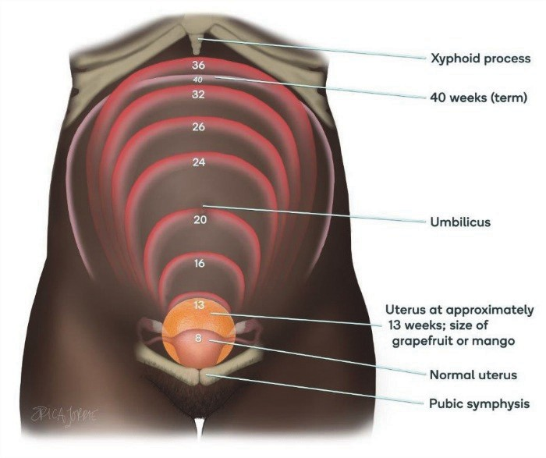
- Perform an abdominal exam.
  - In the first trimester, the uterus grows from the size of a lemon to the size of a large orange and cannot be palpated abdominally above the symphysis pubis.
  - In the second trimester, the uterus grows to the size of a large mango or grapefruit and can be palpated abdominally about three fingerbreadths above the symphysis pubis.
    - To palpate the uterus, make sure the woman has emptied her bladder.
    - Explain what will be done (and why) before conducting the exam.
    - Ask her to lie on her back with support under her head, bend her knees, and keep her feet flat on the bed or exam table.
    - Using a firm but gentle touch, place fingers on the pubic bone and walk them up the center of the abdomen until the top of her uterus (fundus) is palpated; it will feel like a hard ball.
    - A uterine fundus palpated about three fingerbreadths above the pubic bone is compatible with pregnancy in the second trimester.
Information Box 19
Internal Exam
Internal exams are not necessary to determine if a woman has reached the second trimester. In the majority of women, the uterus is palpable abdominally at 13 weeks and beyond.

- Use other means of determining gestational age early in pregnancy.
  - Pregnancy tests, if available and affordable, can confirm pregnancy and be correlated with information from the history and physical exam.
  - Ultrasound can be superior to dating by last menstrual period or physical examination, depending on clinical circumstances, but dating precision decreases with gestational age. WHO now recommends one obstetric ultrasound scan before 24 weeks gestation to estimate gestational age and to identify multiple pregnancies and fetal anomalies.

Other Ways to Prevent Malaria
Pregnant women are far more vulnerable to malaria than other adults: They are four times more likely than other adults to contract malaria and twice as likely to die from it. This is due to the typical immunosuppression associated with pregnancy, increased levels of the hormones cortisol and estrogen, and perhaps because the abdominal skin of pregnant women is slightly warmer than that of women who are not pregnant. Although ITNs and IPTp-SP are the most effective ways to prevent malaria in pregnant women, other means of preventing infection are also available.
Information Box 20
Health Education and Counseling Points
- There are many ways to prevent bites and reduce mosquito-breeding sites.
- Sleep under ITNs. Where available, LLINs are preferred because they last longer and do not require retreatment.
- Use of IPTp-SP prevents parasites from attacking the placenta.
- IPTp-SP helps prevent malaria and, in turn, reduces the incidence of maternal anemia, spontaneous abortions, preterm birth, stillbirth, and low birthweight.
- IRS programs (where applicable) can be effective in reducing the number of mosquitoes that transmit malaria. They are not a replacement for ITNs and IPTp-SP, but they can be used to support and enhance these efforts.

It is important to educate pregnant women to prevent malaria by taking the following additional actions, as appropriate, to minimize contact with mosquitoes:
- Cover doors and windows with wire or nylon mesh/nets to prevent mosquitoes from entering the house.
- Avoid going outside after dark, and when going out in the evening:
  - Wear protective clothing that covers the arms and legs.
  - Apply chemical mosquito repellent cream on exposed skin surfaces.
  - Use mosquito coils (particularly when sitting outdoors) that release smoke. The smoke keeps mosquitoes away or kills them when they fly through it. According to the United Nations Environment Programme, skin repellents and mosquito coils can give worthwhile additional protection before bedtime when used in conjunction with other preventive methods.
  - Spray rooms with insecticide before going to bed every evening. Because the sprays are effective for only a few hours, this method should be used in combination with other measures, such as putting screens on doors and windows.
- Physically kill mosquitoes in the house by swatting them.

Module Four: Diagnosis and Treatment of Malaria
LEARNING OBJECTIVES
This module outlines how to recognize uncomplicated and severe malaria, how to treat uncomplicated malaria, and how to refer severe malaria cases. After completing this module, learners will be able to:
- Explain why self-diagnosis/treatment may lead to treatment failure or recurring infection.
- Describe the types of diagnostic tests available for malaria, including their advantages and disadvantages.
- Identify other causes of fever during pregnancy.
- List the signs and symptoms of uncomplicated and severe MIP.
- Describe the treatment for uncomplicated MIP.
- Explain the steps to appropriately refer a pregnant woman who has severe malaria.

Malaria Diagnosis
A diagnosis of malaria is usually based on the patient’s signs and symptoms, clinical history, and physical examination. If available, laboratory confirmation of the malaria parasite is recommended. Prompt and accurate assessment will lead to improved differential diagnosis of fever during pregnancy, improved management of non-malarial illness, and effective case management of malaria.

Self-Diagnosis
In malaria-endemic countries, where there is often limited access to health care, clients who experience symptoms that are usually associated with the disease often rely on self-diagnosis and treatment. However, because the symptoms are similar to those of several other common ailments, misdiagnosis is possible, so the client may not take the appropriate drug to address the cause of her illness. Alternatively, she may take the right drugs but not in the correct dosage or for the recommended duration.
Any of these scenarios could result in partially treated malaria; continuation of symptoms; development of severe malaria, which could prove fatal; and/or relapse. Correct diagnosis and proper treatment with appropriate drugs, dosage, and duration will help prevent treatment failures, while the use of ITNs will reduce the chance for a recurrent infection. When a client who has self- treated presents with symptoms of malaria or reports that symptoms have worsened or recurred, it is possible that she:
- Has self-treated with the wrong drug or dosage.
- Has not completed the treatment.
- Might have been given incorrect treatment instructions (or might not have understood the instructions).
- Has received a poor-quality or counterfeit drug (this can happen even at health facilities).
- Does not have malaria.
Often, clients can purchase drugs without a prescription or verification of diagnosis at pharmacies, local shops, roadside kiosks, and other easily accessible locations. Some clients might present for care before they start treatment. Examples include:
- A pregnant woman who has questions or concerns about self-treatment or how it affects her developing fetus
- A client who wants to be sure of the diagnosis before beginning treatment because of the unpleasant side effects and/or cost of some antimalarial drugs
Providers have an important role in recognizing the need for malaria detection and/or treatment regardless of the reason the client seeks care. Health messages to emphasize the dangers of incorrect or inadequate treatment for malaria will help to educate the community.
Finally, encouraging all clients to seek care from a skilled health provider whenever they suspect malaria or experience any danger signs can help prevent problems from self-treatment.

Diagnostic Testing
The introduction of artemisinin-based combination therapy (ACT) for malaria treatment has made it important to ensure the correct diagnosis of malaria, given that these drugs are expensive and, if used inappropriately, can lead to resistance to antimalarial drugs.
Two methods routinely used for parasitological diagnosis are light microscopy and RDTs (WHO 2010a). However, only the routine types of parasitological diagnosis are discussed in this reference manual. Once the woman presents with malaria symptoms and is tested, the results should be available within a short time (less than 2 hours). When this is not possible, she must be treated on the basis of clinical diagnosis (WHO 2010a).
Parasitological diagnosis has several major advantages, including:
- Prevents wastage of drugs through unnecessary treatment, resulting in cost savings.
- Improves care in parasite-positive patients due to greater certainty of malaria diagnosis.
- Prevents unnecessary exposure to malaria drugs.
- Confirms treatment failure.

Microscopy
Malaria infection can be detected by microscope examination of the client’s blood, which is spread out as a thick or thin blood smear on a microscopic slide. This blood test, if available, will confirm the presence of the malaria parasite and therefore the diagnosis of malaria. It is also useful when a client has vague symptoms. Microscopic examination remains the gold standard for laboratory confirmation of malaria. However, where resources are limited, laboratory services might not always be available for microscopic diagnosis due to lack of laboratory personnel, proper equipment, or reagents.
- The thin blood film is often preferred for routine identification of the parasite because the organisms are easier to identify. However, the process and the small quantity of blood needed for this type of film make it inadequate when the parasite density is low.
- The thick blood film concentrates the layers of red blood cells on the slide, using about two to three times more blood than the thin film. It is better than the thin film in detecting low levels of parasites and estimating parasite density and reappearance of circulating parasites during infection relapses. However, the process of scanning for parasites among white blood cells and platelets can be difficult, so an experienced technician is needed to perform the examination.
Figure 9. Thick and thin film blood smears
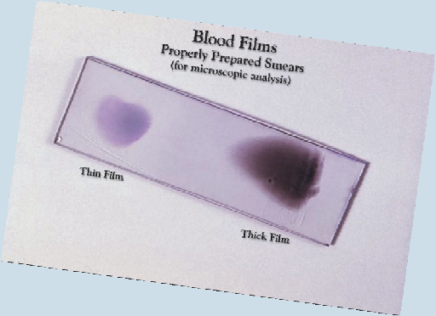

This Giemsa stained slide depicts an example of properly prepared thick and thin film blood smears to be examined.

Gustav Giemsa (1867–1948) was by trade both a chemist and a pharmacist. In 1902, he developed a staining technique that was useful in the identification of malarial parasites, such as P. falciparum.
Source: Courtesy of CDC Public Health Image Library: http://phil.cdc.gov/phil/home.asp

Because the signs and symptoms of malaria are nonspecific, malaria should be suspected based on a fever or a history of fever. However, making a judgment or diagnosis based on clinical features alone has very low specificity, and the result is generally overtreatment. Other possible causes of fever and the need for alternative or additional treatment must always be carefully considered.
WHO’s 2010 recommendations for clinical diagnosis/suspicion of uncomplicated malaria in different epidemiological settings are as follows:
- In settings where the risk of malaria is low, clinical diagnosis of uncomplicated malaria should be based on the possibility of exposure to malaria and a history of fever in the previous 3 days with no features of other severe diseases.
- In settings where the risk of malaria is high, clinical diagnosis should be based on a history of fever in the previous 24 hours and/or the presence of anemia, for which pallor of the palms appears to be the most reliable sign in young children.
In all settings, clinical suspicion of malaria should be confirmed with a parasitological diagnosis. However, in settings where parasitological diagnosis is not possible, the decision to provide antimalarial treatment must be based on the probability of the illness being malaria. Other possible causes of fever and need for alternative treatment must always be carefully considered.

RDTs
Misdiagnosis of malaria can be a problem when lab testing is not available, and it can result in complications, incorrect treatment, or even death. RDTs have been developed to provide quick, accurate, and accessible malaria diagnoses without the need for laboratory facilities.
RDTs exist in different formats, including dipsticks, cassettes, and cards. Many providers prefer the dipstick, which is less costly than the other formats and is easy to use. In countries where ACTs have been introduced as the first-line treatment for malaria, the use of RDTs can reduce the cost of treatment by eliminating treatment that is unnecessary. However, in some situations, the cost-
effectiveness of treatment still needs to be evaluated, especially in areas of high malaria transmission. Successful RDT programs also require a cool chain for transport and storage, training for providers, and a clear policy on actions required based on results (WPRO 2005; UNICEF 2007).

When Is RDT Useful?
When used correctly, malaria RDTs can provide a helpful guide to the presence of clinically significant malaria infection, particularly when good-quality, microscopy-based diagnosis is unavailable. However, management decisions should not be based on RDT results alone.
Assessment of the woman’s status should include obtaining a history, performing a targeted physical exam, and carrying out other laboratory tests as dictated by the woman’s condition. In the presence of fever in high-transmission areas, an RDT should be performed to rule out malaria comorbidity.
RDTs should not be used to confirm clearance of parasites soon after treatment because the circulating antigens may take up to 10 days to clear from the system.

Maintaining a Cool Chain
Generally, storage between 2°C and 30°C is recommended by RDT manufacturers, but the specific instructions of each type of RDT should be followed. Expiration dates are generally set according to these conditions. If storage temperatures exceed the recommended limits, it is likely that the shelf life of the RDTs will be reduced and sensitivity lost before the expiration date. Exposure to high temperatures can be a major contributor to poor performance (WHO 2011b).
The development of a cool chain starts before shipping from the manufacturer:
- The shipper or air carrier is notified of temperature storage requirements by the manufacturer in writing. These requirements are clearly marked on cartons and documents.
- The manufacturer initiates shipment only after the consignee confirms that the shipping notice is received.
- Consignees then must arrange to have someone receive the materials so that shipments can be moved immediately to temperature storage of less than 30°C. Personnel should also ensure that shipments are not left on airport tarmacs, in customs sheds, or in vehicles.
- Ground transportation, at any stage during delivery, should be carried out with attention to outside temperatures while the vehicle is moving and parked. Avoid leaving RDTs in vehicles parked in the sun.
- Storage:
  - Storage of RDTs at any stage before the final destination is reached should conform to manufacturers’ specifications, which is usually less than 30°C.
  - Maximize the time RDTs are stored in centralized controlled conditions. Minimize uncontrolled storage in remote areas.
  - Select a cool, peripheral storage location; thatch roofing may be cooler than iron. Maximize shade.

Indications for Diagnostic Testing
- For pregnant women, a parasitological diagnosis is recommended before treatment starts.
- Women who live in or have come from areas of unstable transmission are the most likely candidates for severe malaria, which can be life threatening.
- An RDT can be used as a test of a cure in clients who have been treated for malaria but still have symptoms. (Microscopy should be used as a test of cure up to 10 days after treatment.)
  - If treatment was adequate, clients may have been reinfected or have another problem causing similar symptoms (see section on fever during pregnancy below). Counterfeit or poor-quality drugs can also be a cause of treatment failure.

Choosing between Microscopy and RDTs
In the event that both RDTs and microscopy are available in a health facility, the decision to use one or the other depends on factors such as the client caseload, availability of skilled lab and clinical personnel, and the need to use microscopy services for other diseases in the local population. Other considerations are outlined in Table 5.
Table 5. Comparison of microscopy and rapid diagnostic testing
Diagnostic Tool | Sensitivity/  Specificity | Cost | Advantages | Disadvantages
Microscopy | High (when used by well-trained staff) | Low (especially when caseload of febrile patients is high) | - Can specify and quantify parasites.  - Can identify other causes of fever.  - Prevents unnecessary exposure to antimalarial drugs.  - Can be used to confirm treatment success and failure. | - Is generally not available outside health facilities.  - Requires skilled personnel.  - Requires lab supplies.
Rapid Diagnostic Test | Variable, depending on:  - Species of parasite  - Number of parasites  - Condition of test  - Correct technique  - Correct interpretation by reader  Test sensitivity is highest at the first antenatal care contact but low thereafter (Kyabayinze et al. 2016; Williams et al. 2016). | Variable; depends on type of test | - Can be used in remote settings, communities, and homes, making malaria diagnosis more accessible.  - Can be used by trained individuals or groups.  - Prevents unnecessary exposure to antimalarial drugs.  - Is easy to use. | - Vulnerable to high temperatures and humidity.  - Requires special handling and storage (cool chain).  - Can be expensive compared to microscopy.  - Not yet available in some areas.  - Practical experience and implementation limited, compared with microscopy.  - Cost can be high due to transport, storage, training, and quality control.

Clinical Diagnosis
Clinical diagnosis is based on the patient’s symptoms and on clinical findings at examination. The first symptoms of uncomplicated malaria (most often fever or history of fever) and clinical findings often are not specific and are common to other diseases. Thus, the early symptoms and clinical findings must be confirmed by a laboratory test.
In severe malaria (caused by P. falciparum), clinical findings of uncomplicated malaria with one or more signs of severe malaria—organ involvement leading to impaired consciousness/coma, prostration/generalized weakness, multiple convulsions, severe anemia, respiratory difficulties, and shock—are more striking and may increase the suspicion index for malaria.
According to current WHO recommendations for clinical diagnosis, the signs and symptoms of malaria are nonspecific. Malaria is suspected clinically primarily on the basis of fever or a history of fever. There is no combination of signs or symptoms that reliably distinguishes malaria from other causes of fever. Diagnosis based only on clinical features has very low specificity and results in overtreatment. In malaria-endemic areas, malaria should be suspected in any patient presenting with a history of fever or temperature less than or equal to 37.5°C and no other obvious cause (WHO 2015b). In low-transmission areas, malaria should be suspected in any patient presenting with fever and a history of travel to a malaria-stable area.
Figure 10 shows a decision chart for treating malaria based on results of malaria RDT or microscopy.
Figure 10. Sample decision chart for treatment of malaria in remote areas, based on the results of malaria rapid diagnostic test or microscopy

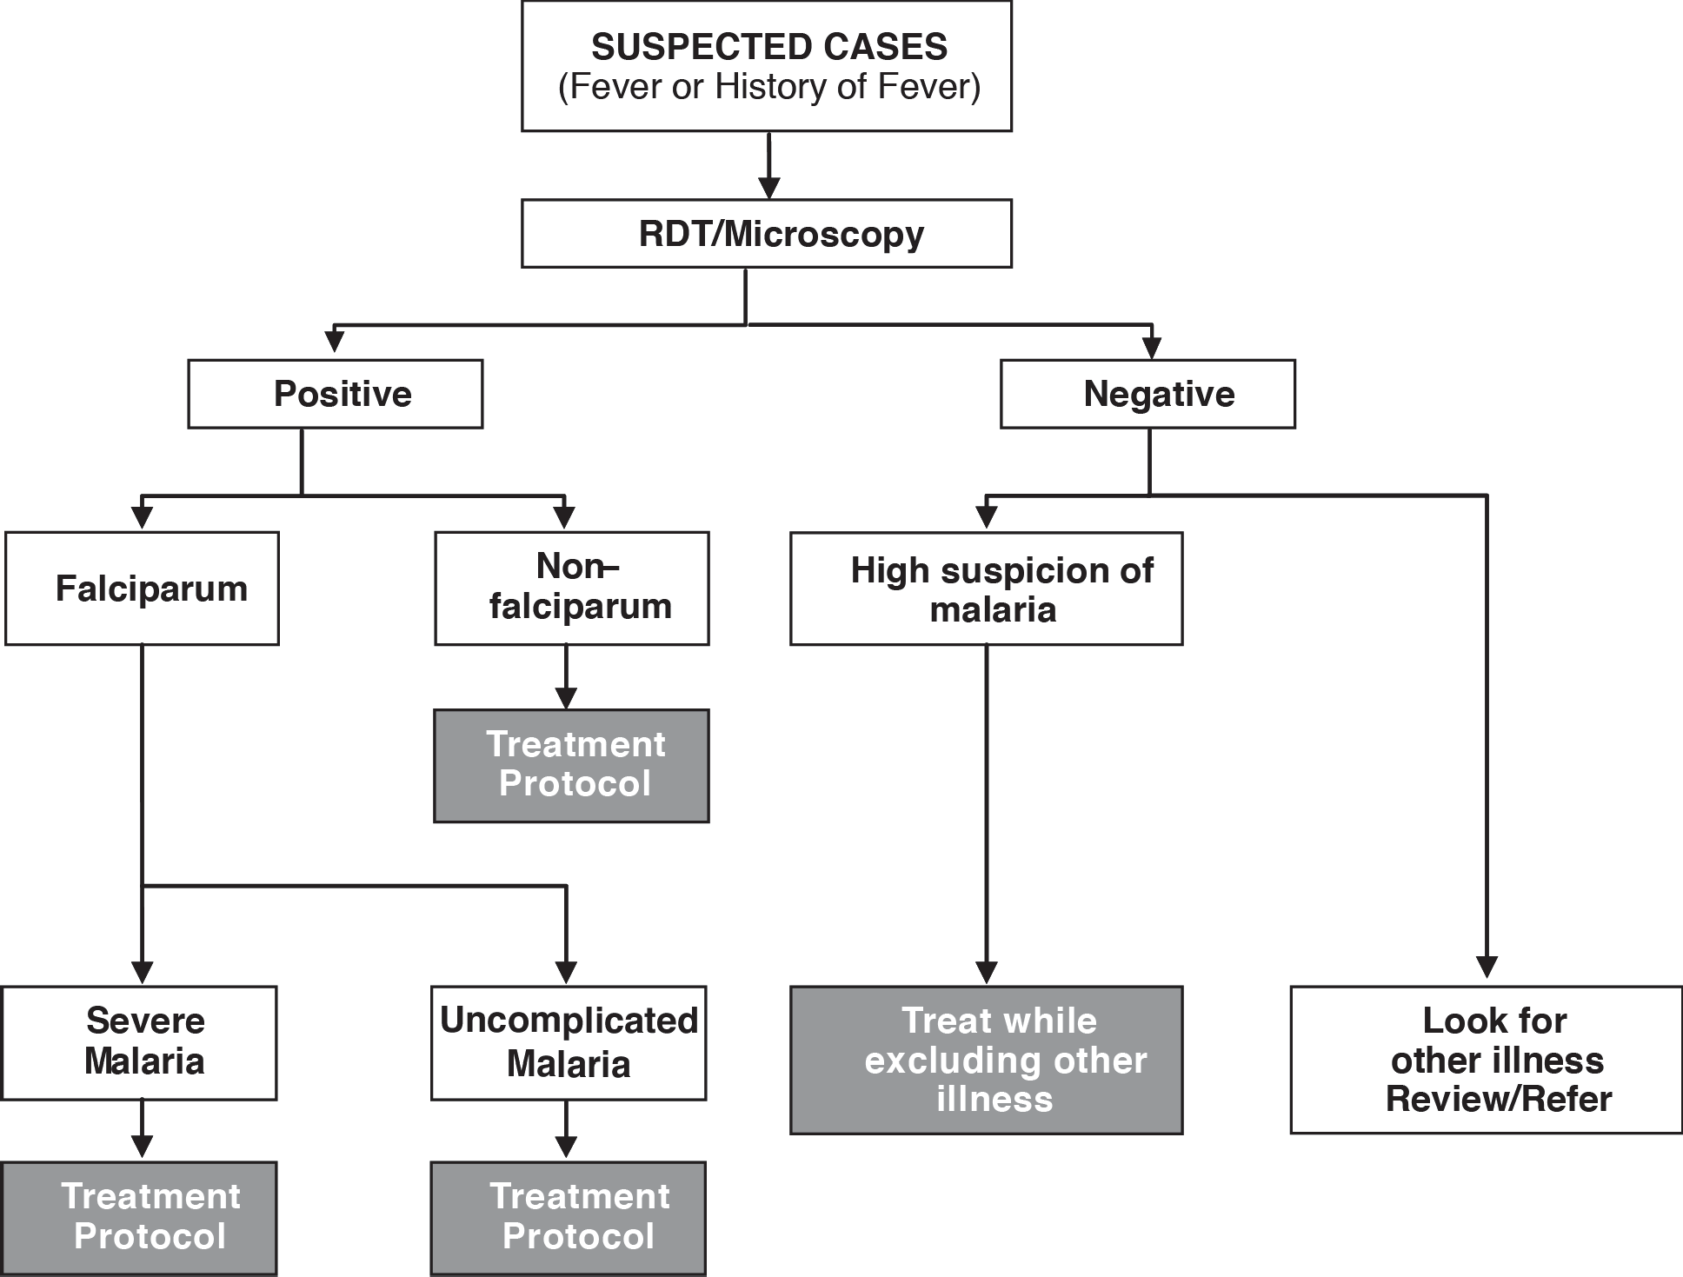
Source: Reprinted from WHO 2004b.

Fever during Pregnancy
Fever during pregnancy (an axillary temperature of 37.5°C or above) is a common symptom of malaria, especially in areas of unstable transmission, if there has been exposure to mosquito bites. Other conditions, however, including bladder or kidney infections, pneumonia, and uterine infections, can also cause fever during pregnancy. Tropical diseases, such as typhoid, dengue, and yellow fever, all of which have fever as a primary symptom, should also be ruled out. However, in areas of high transmission, always treat for malaria if malaria cannot be ruled out, even though there might be another cause of fever.
Before malaria can be diagnosed, it is essential that, in addition to finding out whether the woman has a fever, the provider gather as much information as possible from the woman and/or her family to rule out other causes. Ask her about or examine her for:
- Use of any drugs for fever or malaria
- Any fluid leaking from the vagina/rupture of membranes
- Foul-smelling, watery discharge from the vagina
- Tender or painful uterus or abdomen
- Headache
- Muscle/joint pain
- Dry or productive cough
- Chest pain and/or difficulty breathing
- Pain or burning when passing urine; urinary frequency, urgency, or flank pain
- Other danger signs
Always listen carefully to the client’s complaints and concerns. It is also important to remember that the client’s history is not limited to her complaints. Additional symptoms may be revealed when the health care provider asks specific questions. Once the history has been obtained, other information is gathered via physical examination and, sometimes, lab tests. If an initial diagnostic test for malaria is negative but suspicion of malaria remains, repeat the test in six hours (WHO 2017).

Recognizing Malaria in Pregnant Women
Malaria may be uncomplicated or severe. Although uncomplicated malaria is easily treated, severe malaria may be life threatening and therefore must be promptly recognized and treated. Table 6 summarizes the signs and symptoms of uncomplicated and severe malaria (WHO 2015b).
(If a health care provider suspects severe malaria and is in a facility without admission services, health care provider should give prereferral treatment/management and refer the woman immediately [see prereferral and referral guidelines on the next page]).
Table 6. Signs and symptoms of uncomplicated and severe malaria
Uncomplicated Malaria:  One or more of the following clinical features in the presence of malaria parasitemia or positive rapid diagnostic test:  Axillary temperature  ≥37.5°C, and/or history of recent fever, and/or presence of anemia | Severe Malaria: One or more of the following clinical features or laboratory findings in the presence of malaria parasitemia or positive rapid diagnostic test:
 | Clinical Features:  - Impaired consciousness/coma  - Prostration/generalized weakness  - Multiple convulsions (>two within 24 hours)  - Deep breathing/respiratory distress  - Acute pulmonary edema  - Circulatory collapse/shock (systolic blood pressure < 80 millimeters of mercury)  - Acute kidney injury  - Clinical jaundice and evidence of other vital organ dysfunction  - Significant bleeding | Laboratory Findings:  - Hypoglycemia (blood glucose  < 2.2 millimoles per L or < 40 mg per deciliter)  - Metabolic acidosis (plasma bicarbonate < 15 millimoles per L); hyperlactatemia (lactate > 5 millimoles per L)  - Severe normocytic anemia (hemoglobin < 7 g per deciliter, packed cell volume < 20%)  - Hemoglobinuria  - Hyperparasitemia*  - Renal impairment (serum creatinine  > 265 micromoles per L)  - Pulmonary edema (radiologic)  - Plasma or serum bilirubin > 50 micromoles per L (3 mg per deciliter) with a parasite count > 100,000 per microliter)
Please note: Uterine cramping or contractions can occur in pregnant women with both severe and uncomplicated malaria, and should be managed per reproductive health guidelines.
*Hyperparasitemia is defined as parasite densities >100,000 per microliter (or >2.5% of red blood cells parasitized) in low-transmission areas or 250,000 per microliter (or >5% of red blood cells parasitized) in areas of high stable malaria transmission (WHO 2013d).
Source: PMI 2017.

Case Management of Malaria during Pregnancy
Despite preventive measures, some pregnant women will still become infected with malaria, so case management is an essential part of malaria control (WHO 2009).
The goal of malaria treatment in pregnancy is to completely eliminate the infection, as any amount of parasites in the blood can affect the woman or cause placental infection, affecting the fetus. After first determining whether the infection is severe or uncomplicated, the provider selects treatment based on the trimester of pregnancy and available drugs (i.e., drugs approved for malaria treatment in accordance with national guidelines) (WHO 2009).
Although uncomplicated malaria can easily be treated, severe malaria is more difficult to manage, requiring immediate admission or referral. Women may be referred to a higher level of care within the facility or to the nearest location where they can receive appropriate care as quickly as possible.
The antimalarial drugs considered safe in the first trimester of pregnancy are quinine, chloroquine, clindamycin, mefloquine, and proguanil. Drugs contraindicated in all trimesters of pregnancy include primaquine, tetracycline, doxycycline, and halofantrine.

ACT
In many parts of Africa and worldwide, P. falciparum malaria has become resistant to single-drug therapy, resulting in ineffective treatment and increased morbidity and mortality. For this reason, WHO now recommends the use of a combination of drugs to fight malaria. A major advantage of combination therapy is that drug resistance with combination therapy is far less likely than it is with single-drug treatments.
The simultaneous use of drugs, including a derivative of artemisinin (from a plant called Artemisia annua), along with another antimalarial drug is referred to as ACT. ACT currently is the most effective treatment for malaria. The objective is to cure the infection as rapidly as possible (WHO 2010a).
Overall, ACTs are more than 95% effective in curing malaria and are well tolerated by most patients. There is also evidence that ACTs reduce the transmission of P. falciparum. For these reasons, nearly 60 countries (half of them in Africa) have changed national policy and adopted ACTs as their first line of treatment, although many have not yet implemented the new policy. One barrier may be the cost of ACTs, which is higher than that of conventional malaria drugs.
Despite the promising news about ACTs, more research is needed on safety in pregnancy (especially the first trimester), drug interactions, and strategies for treatment. Some governments want to use combination therapy before malaria becomes resistant to traditional drugs like SP. Then, SP would still be effective and reserved for use in IPTp. Other countries are dealing with patient compliance, drug intolerance in some clients, and a general lack of clinical experience with combination therapy.
It is important to follow country or regional guidelines regarding which combination therapies to use and how to use them. According to WHO’s Managing Complications in Pregnancy and Childbirth: A Guide for Midwives and Doctors (WHO 2017), treat uncomplicated MIP as follows:
Treatment of Acute, Uncomplicated P. Falciparum Malaria in the First Trimester
- Quinine salt (dihydrochloride or sulfate) 10 mg per kilogram of body weight by mouth every 8 hours plus clindamycin 300 mg every 6 hours, both given for 7 days.
- If clindamycin is not available, treat with quinine monotherapy: quinine salt (dihydrochloride or sulfate) 10 mg per kilogram of body weight by mouth every 8 hours for 7 days.
- ACT can be used if quinine is not available, if quinine and clindamycin fail, or if adherence to 7-day treatment with quinine cannot be guaranteed.

Treatment of Acute, Uncomplicated P. Falciparum Malaria in the Second and Third Trimesters
- Treat based on national policy with any of the ACTs (assuming a body weight of 50 kilograms or more).
- Treatment of uncomplicated P. falciparum malaria: Treat children and adults with uncomplicated
- P. falciparum malaria (except pregnant women in their first trimester) with one of the following recommended ACTs:
  - Artemether (80 mg) and lumefantrine (480 mg) orally twice daily for 3 days
  - Artesunate (200 mg) and amodiaquine (540 mg) orally once daily for 3 days
  - Artesunate (200 mg) and mefloquine (440 mg) orally once daily for 3 days
  - Dihydroartemisinin (160 mg) and piperaquine (1,280 mg) orally once daily for 3 days
  - Artesunate (200 mg) and SP (1,500 mg/75 mg) single dose orally only on day 1
- Country programs must inform frontline providers of the ACTs known to be effective in the country at any given time, and distribute guidelines about their dosage and use.
- Note: Quinine is associated with an increased risk of hypoglycemia in late pregnancy. It should be used in combination with clindamycin only if effective alternatives are not available.
People living with HIV/AIDS who have uncomplicated P. falciparum malaria should avoid artesunate and SP if they are also receiving co-trimoxazole, and avoid artesunate and amodiaquine if they are also receiving efavirenz or zidovudine.
Inormation Box 21
Drugs that should never be given in pregnancy include tetracycline, doxycycline, primaquine, and halofantrine.

There have been few major side effects associated with combined malaria drugs. Reported side effects are usually minor or not sufficient to cause withdrawal of treatment or medical intervention (Denis et al. 2006; Jima et al. 2005; Mohamed et al. 2006; Tagbor et al. 2006).
Pruritus and fatigue, for example, were frequent side effects of amodiaquine in one study (Fanello et al. 2006). Because these are new drug combinations in most settings, possible side effects may not yet be fully known. It is important, therefore, to carefully monitor patients for any side effects or problems and report them to appropriate authorities in your country. Remember also to counsel women to report any of these problems promptly.

Treatment of P. Vivax, Ovale, Malariae, and Knowlesi Malaria in the First Trimester
- In areas with chloroquine-sensitive P. vivax parasites: Chloroquine is the treatment of choice in areas with chloroquine-sensitive vivax malaria. Give chloroquine 10 mg per kilogram of body weight orally once daily for 2 days followed by 5 mg per kilogram of body weight orally on day 3.
- In areas with chloroquine-resistant P. vivax parasites: Chloroquine-resistant P. vivax has been reported in several countries. Before considering second-line drugs for treatment failure with chloroquine, clinicians should exclude poor patient compliance and a new infection with
- P. falciparum. If diagnostic testing is not available, treat as for P. falciparum malaria. The treatment option for confirmed chloroquine-resistant vivax malaria is quinine salt (dihydrochloride or sulfate) 10 mg per kilogram of body weight orally three times a day for 7 days. Note: The dose of quinine is the same for all species of malaria.

Treatment of P. Vivax, Ovale, Malariae, and Knowlesi Malaria in the Second and Third Trimesters
- In areas with chloroquine-sensitive P. vivax parasites: ACT and chloroquine alone are the two treatment options in areas with chloroquine-sensitive vivax malaria (see dosage under first, second, and third trimesters in acute, uncomplicated P. falciparum malaria).
- In areas with chloroquine-resistant P. vivax parasites: Treat with ACT (see dosage under second and third trimesters in acute, uncomplicated P. falciparum malaria).

Antirelapse Treatment
Primaquine is contraindicated in pregnant women and women who are breastfeeding an infant less than 6 months of age. To prevent relapse in P. vivax or P. ovale malaria, consider weekly chemoprophylaxis with chloroquine until childbirth and breastfeeding are completed. Then, on the basis of glucose-6-phosphate dehydrogenase status, treat with primaquine to prevent future relapse.

Treatment of Liver States of P. Vivax and Ovale Malaria
P. Vivax and P. ovale malaria may remain dormant in the liver. From time to time, these dormant stages are released into the blood, causing a new, symptomatic vivax or ovale infection. A 14-day course of primaquine (0.25–0.5 mg per kilogram of body weight daily orally) should be used to clear the liver stages, but primaquine should not be given to pregnant women or women breastfeeding an infant less than 6 months of age.

Recommendations for Treatment of Uncomplicated MIP
WHO recommends the following for treatment of uncomplicated MIP (WHO 2015b). Refer to your country-specific guidelines for what is approved for use in your setting and obtain specific instructions on usage.
Table 7. Treatment for uncomplicated malariaa
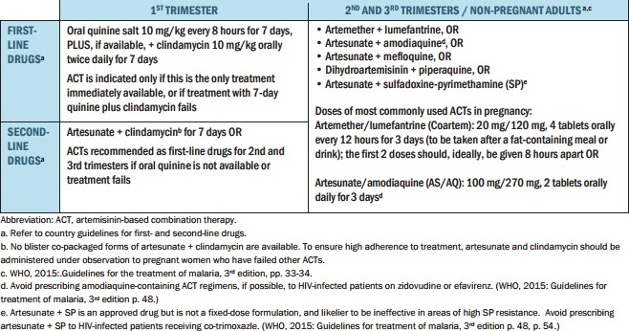
Information Box 22
Malaria Is Not the Only Cause of Fever
If a woman’s condition does not improve within 48 hours after starting treatment and/or after starting the second-line drug therapy, suspect other causes of fever during pregnancy.

Management of Elevated Body Temperature
Teach the woman and her caregivers how to control her body temperature by sponging her body with lukewarm water. Also, if temperature is ≥ 38°C axillary, give paracetamol 500 mg two tablets every 6 hours until her body temperature has returned to normal.

Follow-Up after Treatment of Uncomplicated Malaria
Ask the woman to return within 2 to 3 days or if her condition worsens. If possible, arrange for a health care provider or community health worker to visit the client’s home 2 to 3 days after treatment has started to check on her progress. Ensure that the client continues to take her drugs even if fever is no longer present. She must complete the dosage once treatment is started and make certain she knows about danger signs and when to return to the facility.
Most clients will respond to malaria treatment and begin to feel better within 1 or 2 days after starting treatment with quinine plus clindamycin or an ACT. If treatment failure is suspected based on no improvement or if her condition worsens, she should be referred for microscopy and appropriate treatment.

Severe Malaria
In the case of antimalarial treatment for severe malaria, the main objective is to prevent death (WHO 2015b). Stabilize and refer the woman immediately to an appropriate level of care if she has any symptoms that suggest severe malaria. Although the scope of this learning resource package is treatment of uncomplicated malaria and identification of severe malaria, provision of a loading dose artesunate, and immediate referral, basic information is provided here about considerations in ongoing care for women with severe malaria. For further information, please see WHO 2015b and WHO 2017.
To assist in determining the cause of convulsions, use the information in Table 8. However, women in the second and third trimesters of pregnancy are more likely to have severe malaria than other adults. Severe MIP may be misdiagnosed as eclampsia. If a pregnant woman living in a malarial area has fever, headaches, or convulsions, and malaria cannot be excluded, treat the woman for both malaria and eclampsia (WHO 2017).
Table 8. Determining the cause of convulsions in pregnancy
Signs/Symptoms | Severe Malaria | Eclampsia
Recent history of fever, chills (from patient or family) | Yes | No
Temperature | ≥ 37.5°C axillary | < 38°C
Blood pressure | Systolic < 140 mmHg; Diastolic  <90 mmHg | Systolic ≥ 160 mmHg; Diastolic  ≥110 mmHg
Proteinuria | No | Yes
Enlarged spleen | Yes | No
Jaundice | Yes | No

Treatment of Convulsions Associated with Severe Malaria
- If convulsions occur, maintain airway, place patient on her side, and give diazepam 10 mg IV slowly over 2 minutes.
- If eclampsia is diagnosed in addition to malaria, prevent subsequent convulsions with magnesium sulfate.
- If eclampsia is excluded, prevent subsequent convulsions with phenytoin.
Patients who have severe disease should be treated with parenteral antimalarial therapy regardless of the species of malaria seen on the blood smear. Oral antimalarial drugs are not recommended for the initial treatment of severe malaria. If severe malaria is strongly suspected but a laboratory diagnosis cannot be made, blood should be collected for diagnostic testing as soon as it is available, and parenteral antimalarial drugs may be started (CDC 2013).
Hypoglycemia in severe malaria is common and can occur at any time during the illness, especially after initiation of quinine therapy. There sometimes are no symptoms.
- Monitor blood glucose levels using a stick test every 4 hours. Note: If the woman is receiving quinine IV, monitor blood glucose levels every hour.
- If hypoglycemia is detected, give 50% dextrose 50 mL IV followed by dextrose (5% or 10%) 500 mL infused over 8 hours. Note: Monitor blood glucose levels and adjust infusion accordingly.
- Monitor fluid balance carefully.
Women with severe malaria require intensive nursing care, preferably in an intensive care unit. Clinical observations should be made as frequently as possible and include monitoring of vital signs, coma score, urine output, and fetal well-being. Blood glucose should be monitored every 4 hours, if possible, particularly in unconscious patients.
Note: The antipyretic of choice, if body temperature is higher than 38°C, is paracetamol. Aspirin or ibuprofen should not be given because of the risks of gastrointestinal bleeding and renal impairment.

Prereferral Treatment for Severe Malaria (WHO 2015b)
Parenteral antimalarial drugs should be given to pregnant women with severe malaria in full doses without delay, as the risk of death from severe malaria is greatest in the first 24 hours. Mortality from untreated severe malaria (particularly cerebral malaria) approaches 100%. With prompt, effective antimalarial treatment and supportive care, the rate falls to 10–20% overall. Treatment should therefore be started immediately, and pregnant women should be given the full dose of parenteral antimalarial drugs before referral. Parenteral artesunate is the drug of choice in all trimesters when the patient has severe P. falciparum malaria.
Begin treatment with IV or IM route for at least 24 hours and until the woman can tolerate oral drugs. Then, give a complete oral treatment with ACT for three days.
Rectal administration of artesunate or artemether may be done if injections are not possible. If these are not available, parenteral quinine may be given in all trimesters.

Parenteral Artesunate
Parenteral artesunate is the treatment of choice for severe malaria in all trimesters. Begin treatment with IV or IM route for at least 24 hours and until the woman can tolerate oral drugs. Then, give a complete oral treatment with ACT for three days.

Loading Dose
Give artesunate 2.4 mg per kilogram of body weight IV every 12 hours for at least 24 hours, until the woman can tolerate oral drugs.

Maintenance Dose
Give artesunate 1.2 mg per kilogram of body weight IV as a single bolus once daily beginning on the second day of treatment. Continue the maintenance dosing schedule until the woman is conscious and able to swallow, then give artesunate 2 mg per kilogram of body weight once daily to complete 7 days of treatment.

Parenteral Artemether
If artesunate is not available, give intramuscular artemether as follows:

Loading Dose of Artemether
Give artemether 3.2 mg per kilogram of body weight IM as a single dose on the first day of treatment.

Maintenance Dose of Artemether
Give artemether 1.6 mg per kilogram of body weight IM once daily beginning on the second day of treatment. Continue the maintenance dosing schedule until the woman is conscious and able to tolerate oral drugs. Then, give a complete dose of ACT. If artemether is unavailable, parenteral quinine should be started immediately and continued until artemether is obtained.

Parenteral Quinine Dihydrochloride
If neither parenteral artesunate nor artemether are available, treat with parenteral quinine dihydrochloride.

Loading Dose of Quinine Dihydrochloride
Infuse quinine dihydrochloride 20 mg per kilogram of body weight in IV fluids (5% dextrose) over 4 hours.
- Never give an IV bolus injection of quinine.
- If it is definitely known that the woman has taken an adequate dose of quinine (1.2 g) within the preceding 12 hours, do not give the loading dose. Proceed with the maintenance dose (see below).
- If the history of treatment is not known or is unclear, give the loading dose of quinine.
- Use 100–500 mL 5% dextrose, depending on the woman’s fluid balance state. Wait 4 hours (8 hours from the start of the first dose) before giving the maintenance dose.

Maintenance Dose of Quinine Dihydrochloride
Infuse quinine dihydrochloride 10 mg per kilogram of body weight over 4 hours. Repeat every 8 hours from the start of the last dose (i.e., quinine infusion for 4 hours, no quinine for 4 hours,
quinine infusion for 4 hours, etc.). Note: Monitor blood glucose levels for hypoglycemia every hour while the woman is receiving quinine IV.
Continue the maintenance dosing schedule until the woman is conscious and able to tolerate oral drugs. Then, give quinine dihydrochloride or quinine sulfate 10 mg per kilogram of body weight by mouth every 8 hours to complete 7 days of treatment or ACT.
Table 9. Stabilizationa and prereferral treatment for severe malariab
 | All Trimester/Nonpregnant Adults
First-Line Drug | Parenteral artesunate 2.4 mg per kilogram IV bolus (“push”) injection or IM injection as loading dose.
Second-Line Drug | If artesunate is unavailable, intramuscular artemether should be given, and if this is unavailable, then parenteral quinine should be started immediately until artesunate is obtained.c
ª Treat shock: Ensure airway. Position on side with legs elevated. Ensure warmth. Start IV infusion. Perform relevant laboratory tests. Treat convulsions and fever (refer to WHO 2017).
^{b} WHO recommends artesunate as first-line drug to treat severe malaria in all trimesters. A job aid on administering IV artesunate is available at https://www.mmv.org/sites/default/files/uploads/docs/access/Injectable_Artesunate_Tool_Kit/InjectableArtesunate_posterEN.pdf c WHO 2015b, p. 87. Source: PMI 2017.
If referral is necessary, follow these steps:
- Explain the situation to the client and her family.
- Give prereferral treatment according to local protocols.
- Help arrange transport to the other facility, if possible.
- Include the following information in your referral note:
  - Brief history of client’s condition
  - Details of any treatment provided
  - Reason for referral
  - Any significant findings from history, physical exam, or laboratory tests
  - Highlights of any important details of current pregnancy
  - Copy of client’s ANC record, if possible
  - Contact information in case the referral facility or provider has any questions
- Accompany the woman during transport, if possible, and be sure to have sufficient drugs available.
- Record information on the ANC card and clinic record.
- Case management of malaria during pregnancy is summarized in Figure 11.

Recognizing and Reporting Potential Adverse Effects
Health care providers should understand the potential adverse effects of all drugs they administer. This includes drugs used to treat MIP, although these drugs are generally well tolerated and have mild side effects if used as directed. Women need to know about any adverse effects they might experience and what to do if they occur. Note that all drugs have the potential to cause allergic reactions, so clients should be asked about history of allergies. Potential adverse effects are summarized in Table 10.
Table 10. Potential adverse effects of malaria treatment drugs (WHO 2015b)
Artemether/Lumefantrine | Artesunate/Amodiaquine | Quinine | Artemisinin
- Mild weakness or dizziness  - Fatigue  - Chills  - Mild headache  - Joint/muscle pain  - Cough  - Anorexia  - Nausea/vomiting  - Sleep disorder | - Loss of appetite  - Difficulty sleeping  - Sleepiness  - Cough  - Nausea  - Abdominal pain  - Weakness (mild or severe)  - Fatigue  - Headache  - Dizziness | - Buzzing/ringing in ears  - Headache  - Nausea  - Dizziness  - Vomiting  - Hypoglycemia (when given parenterally) | - Dizziness  - Nausea/vomiting  - Anorexia  - Bitter taste

Providers should be aware of the pharmacovigilance system in their countries to which they can report adverse effects or other concerns about the drugs they administer.
Figure 11. Treatment of uncomplicated malaria among women of reproductive age
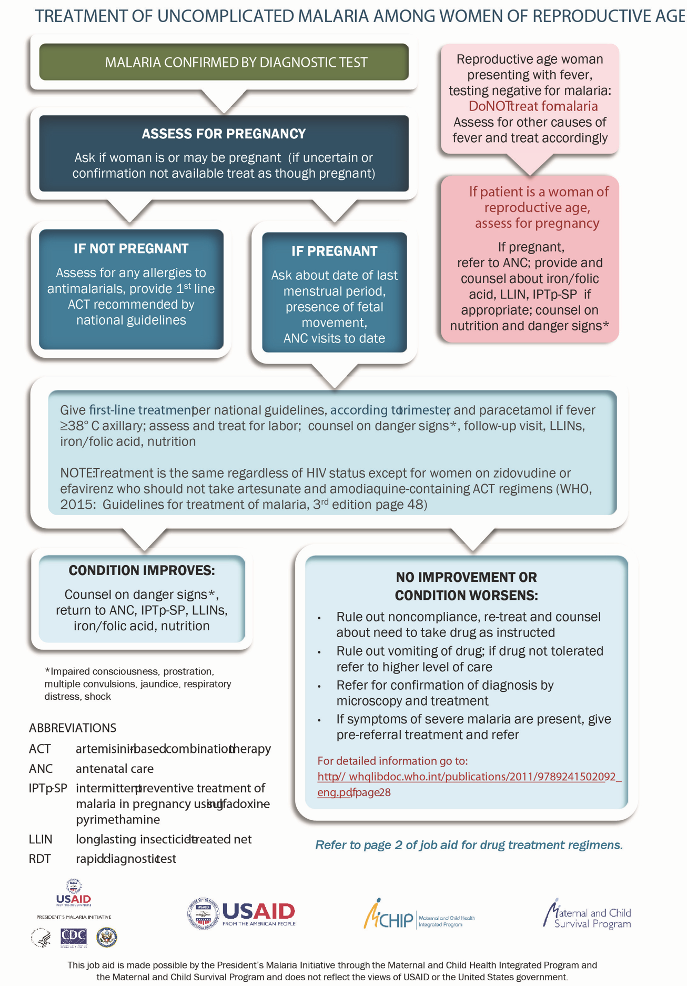
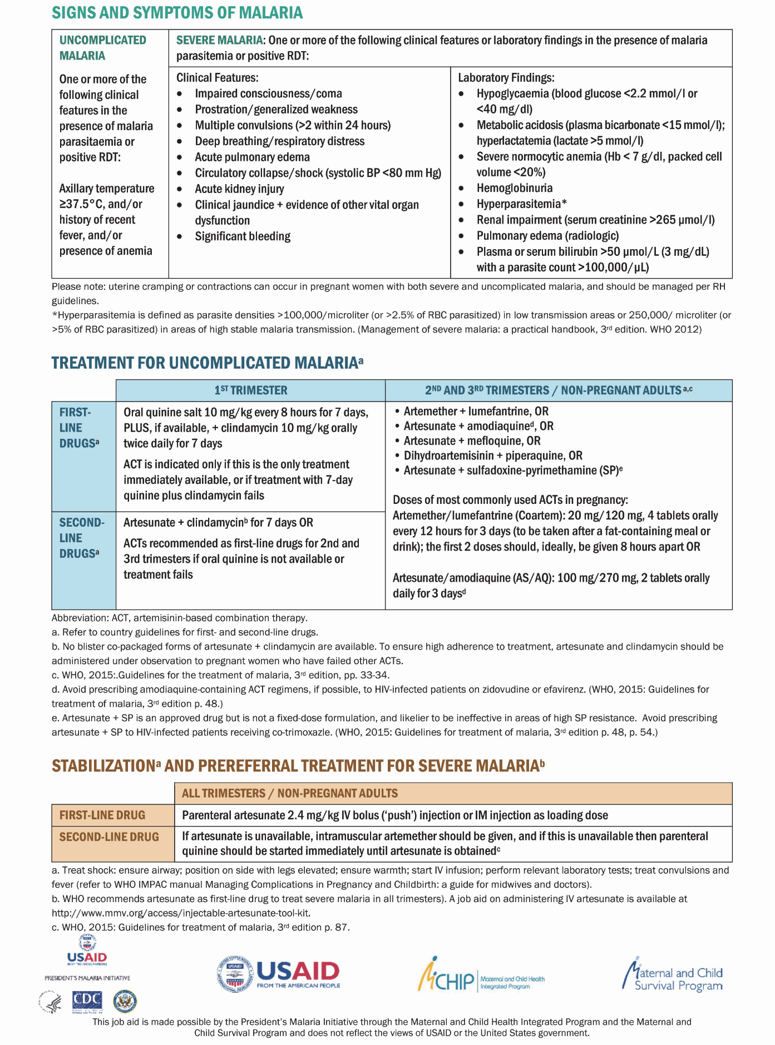
Source: PMI 2017

Appendix A: Summary List of WHO Recommendations on Antenatal Care for a Positive Pregnancy Experience
Table 11. Nutritional Interventions
 | Recommendation | Type of Recommendation
Dietary interventions | A.1.1: Counseling about healthy eating and keeping physically active during pregnancy is recommended for pregnant women to stay healthy and prevent excessive  weight gain during pregnancy.ª | Recommended
 | A.1.2: In undernourished populations, nutrition education on increasing daily energy and protein intake is recommended for pregnant women to reduce the risk of low-birthweight newborns. | Context-specific recommendation
 | A.1.3: In undernourished populations, balanced energy and protein dietary supplementation is recommended for pregnant women to reduce the risk of stillbirths and small- for-gestational-age newborns. | Context-specific recommendation
 | A.1.4: In undernourished populations, high-protein supplementation is not recommended for pregnant women to improve maternal and perinatal outcomes. | Not recommended
Iron and folic acid supplements | A.2.1: Daily oral iron and folic acid supplementation with 30–60 mg of elemental ironb and 400 micrograms (0.4 mg) of folic acidc is recommended for pregnant women to prevent maternal anemia, puerperal sepsis, low birthweight, and preterm birth.d | Recommended
 | A.2.2: Intermittent oral iron and folic acid supplementation  with 120 mg of elemental iron^{e} and 2,800 micrograms (2.8 mg) of folic acid once weekly is recommended for pregnant women to improve maternal and neonatal outcomes if daily iron is not acceptable due to side effects and in populations with an anemia prevalence among  pregnant women of less than 20%.^{f} | Context-specific recommendation
Calcium supplements | A.3: In populations with low dietary calcium intake, daily calcium supplementation (1.5–2 g oral elemental calcium) is recommended for pregnant women to reduce the risk of  pre-eclampsia.^{g} | Context-specific recommendation
Vitamin A supplements | A.4: Vitamin A supplementation is only recommended for pregnant women in areas where vitamin A deficiency is a  severe public health problem^{h} to prevent night blindness.^{i} | Context-specific recommendation

These recommendations apply to pregnant women and adolescent girls within the context of routine antenatal care.
ª Healthy diet contains adequate energy, protein, vitamins, and minerals obtained through the consumption of a variety of foods, including green and orange vegetables, meat, fish, beans, nuts, whole grains, and fruit.
^{b} The equivalent of 60 mg of elemental iron is 300 mg of ferrous sulfate heptahydrate, 180 mg of ferrous fumarate, or 500 mg of ferrous gluconate.
^{c} Folic acid should be started as early as possible (ideally before conception) to prevent neural tube defects.
^{d} This recommendation supersedes the previous recommendation found in WHO’s Guideline: Daily Iron and Folic Acid Supplementation in Pregnant Women (2012).
^{e} The equivalent of 120 mg of elemental iron equals 600 mg of ferrous sulfate heptahydrate, 360 mg of ferrous fumarate, or 1,000 mg of ferrous gluconate.
^{f} This recommendation supersedes the previous recommendation in WHO’s Guideline: Intermittent Iron and Folic Acid Supplementation in Non-Anaemic Pregnant Women (2012).
^{g} This recommendation is consistent with the WHO Recommendations for Prevention and Treatment of Pre-Eclampsia and Eclampsia (2011) and supersedes the previous recommendation found in WHO’s Guideline: Calcium Supplementation in Pregnant Women (2013).
^{h} Vitamin A deficiency is a severe public health problem if > 5% of women in a population have a history of night blindness in their most recent pregnancy in the previous 3–5 years that ended in a live birth or if > 20% of pregnant women have a serum retinol level < 0.7 moles per L. Determination of vitamin A deficiency as a public health problem involves estimating the prevalence of deficiency in a population by using specific biochemical and clinical indicators of vitamin A status.
^{i} This recommendation supersedes the previous recommendation found in WHO’s Guideline: Vitamin A Supplementation in Pregnant Women (2011).

Table 12. Supplements
Zinc supplements | A.5: Zinc supplementation for pregnant women is only recommended in the context of rigorous research. | Context-specific recommendation (research)
Multiple micronutrient supplements | A.6: Multiple micronutrient supplementation is not recommended for pregnant women to improve maternal and perinatal outcomes. | Not recommended
Vitamin B6 (pyridoxine) supplements | A.7: Vitamin B6 (pyridoxine) supplementation is not recommended for pregnant women to improve maternal and perinatal outcomes. | Not recommended
Vitamin E and C supplements | A.8: Vitamin E and C supplementation is not recommended for pregnant women to improve maternal and perinatal outcomes. | Not recommended
Vitamin D supplements | A.9: Vitamin D supplementation is not recommended for pregnant women to improve maternal and perinatal outcomes.j | Not recommended
Restricting caffeine intake | A.10: For pregnant women with high daily caffeine intake (more than 300 mg per day),k lowering daily caffeine intake | Context-specific recommendation

Table 13. B.1: Maternal Assessment
B. Maternal and Fetal Assessment l
Recommendation |  | Type of Recommendation
Anemia | B.1.1: Full blood count testing is the recommended method for diagnosing anemia in pregnancy. In settings where full blood count testing is not available, onsite hemoglobin testing with a hemoglobinometer is recommended over the use of the hemoglobin color scale as the method for diagnosing anemia in pregnancy. | Context-specific recommendation
Asymptomatic bacteriuria (ASB) | B.1.2: Midstream urine culture is the recommended method for diagnosing ASB in pregnancy. In settings where urine culture is not available, onsite midstream urine Gram staining is recommended over the use of dipstick tests as the method for diagnosing ASB in pregnancy. | Context-specific recommendation
Intimate partner violence (IPV) | B.1.3: Clinical inquiry about the possibility of IPV should be strongly considered at antenatal care (ANC) contacts when assessing conditions that may be caused or complicated by IPV to improve clinical diagnosis and subsequent care, where there is the capacity to provide a supportive response (including referral where appropriate) and where the WHO minimum requirements are met.m,n | Context-specific recommendation
^{j} This recommendation supersedes the previous recommendation found in WHO’s Guideline: Vitamin D Supplementation in Pregnant Women (2012).
^{k} This includes any product, beverage, or food containing caffeine (i.e., brewed coffee, tea, cola-type soft drinks, caffeinated energy drinks, chocolate, and caffeine tablets).
^{l} Evidence on essential antenatal care activities, such as measuring maternal blood pressure, proteinuria, and weight, and checking for fetal heart sounds, was not assessed by the WHO Guideline Development Group (GDG), as these activities are considered to be part of good clinical practice.
^{m} Minimum requirements are a protocol/standard operating procedure, training on how to ask about IPV and how to provide the minimum response or beyond, private setting, confidentiality ensured, system for referral in place, and time to allow for appropriate disclosure.
^{n} This recommendation is consistent with Responding to Intimate Partner Violence and Sexual Violence against Women: WHO Clinical and Policy Guidelines (2013).

Table 14. Other WHO Recommendations
Recommendations Integrated from Other WHO Guidelines That Are Relevant to Antenatal Care (ANC) Maternal Assessment
Gestational diabetes mellitus (GDM) | B.1.4: Hyperglycemia first detected at any time during pregnancy should be classified as either GDM or diabetes  mellitus in pregnancy, according to WHO criteria.º | Recommended
Tobacco use | B.1.5: Health care providers should ask all pregnant women about their tobacco use (past and present) and exposure to secondhand smoke as early as possible in the pregnancy  and at every ANC contact.^{p} | Recommended
Substance use | B.1.6: Health care providers should ask all pregnant women about their use of alcohol and other substances (past and present) as early as possible in the pregnancy and at every  ANC contact.^{q} | Recommended
HIV and syphilis | B.1.7: In high-prevalence settings,^{r} provider-initiated testing and counseling (PITC) for HIV should be considered a routine component of the package of care for pregnant women in all ANC settings. In low-prevalence settings, PITC can be considered for pregnant women in ANC settings as a key component of the effort to eliminate mother-to-child transmission of HIV; integrate HIV testing with syphilis, viral, or other key tests, as relevant to the setting; and strengthen the  underlying maternal and child health systems.^{s} | Recommended
TB | B.1.8: In settings where the TB prevalence in the general population is 100/100,000 people or higher, systematic screening for active TB should be considered for pregnant  women as part of ANC.^{t} | Context-specific recommendation

Table 15. B.2: Fetal Assessment
Daily fetal movement counting | B.2.1: Daily fetal movement counting, such as with “count to 10” kick charts, is only recommended in the context of rigorous research. | Context-specific recommendation (research)
Symphysis-fundal height (SFH) measurement | B.2.2: Replacing abdominal palpation with SFH measurement for the assessment of fetal growth is not recommended to improve perinatal outcomes. A change from what is usually practiced (abdominal palpation or SFH measurement) in a particular setting is not recommended. | Context-specific recommendation
Antenatal cardiotocography | B.2.3: Routine antenatal cardiotocography is not recommended for pregnant women to improve maternal and perinatal outcomes. | Not recommended
º This is not a recommendation on routine screening for hyperglycemia in pregnancy. It has been adapted and integrated from WHO’s Diagnostic Criteria and Classification of Hyperglycaemia First Detected in Pregnancy (2013), which states that GDM should be diagnosed at any time in pregnancy if one or more of the following criteria are met:
- Fasting plasma glucose 5.1–6.9 millimoles/L (92–125 mg/deciliter)
- 1-hour plasma glucose > 10 millimoles/L (180 mg/deciliter) following a 75 g oral glucose load
2-hour plasma glucose 8.5–11.0 millimoles/L (153–199 mg/deciliter) following a 75 g oral glucose load
Diabetes mellitus in pregnancy should be diagnosed if one or more of the following criteria are met:
- Fasting plasma glucose > 7.0 millimoles/L (126 mg/deciliter)
- 2-hour plasma glucose > 11.1 millimoles/L (200 mg/deciliter) following a 75 g oral glucose load
- Random plasma glucose > 11.1 millimoles/L (200 mg/deciliter) in the presence of diabetes symptoms
^{p} Integrated from WHO Recommendations for the Prevention and Management of Tobacco Use and Second-Hand Smoke Exposure in Pregnancy (2013).
^{q} Integrated from WHO’s Guidelines for the Identification and Management of Substance Use and Substance Use Disorders in Pregnancy (2014).
^{r} High-prevalence settings are defined in the 2015 WHO publication Consolidated Guidelines on HIV Testing Services as settings with greater than 5% HIV prevalence in the population being tested. Low-prevalence settings are those with less than 5% HIV prevalence in the population being tested. In settings with a generalized or concentrated HIV epidemic, retesting of HIV-negative women should be performed in the third trimester because of the high risk of acquiring HIV infection during pregnancy; please refer to Recommendation B.1.7 for details.
^{s} Adapted and integrated from WHO’s Consolidated Guidelines on HIV Testing Services (2015).
^{t} Adapted and integrated from WHO’s Systematic Screening for Active Tuberculosis: Principles and Recommendations
(2013).
^{u} Cardiotocography is a continuous recording of the fetal heart rate and uterine contractions obtained via an ultrasound transducer placed on the woman’s abdomen.

Table 16. Ultrasound
Ultrasound scan | B.2.4: One ultrasound scan before 24 weeks gestation (early ultrasound) is recommended for pregnant women to estimate gestational age, improve detection of fetal anomalies and multiple pregnancies, reduce induction of labor for post-term pregnancy, and improve a woman’s pregnancy experience. | Recommended
Doppler  ultrasound of  fetal blood  vessels | B.2.5: Routine Doppler ultrasound examination is not recommended for pregnant women to improve maternal and perinatal outcomes.^{v} | Not recommended

Table 17. Preventive Measures
C. Preventive Measures
Recommendation |  | Type of Recommendation
Antibiotics for ASB | C.1: A 7-day antibiotic regimen is recommended for all pregnant women with ASB to prevent persistent bacteriuria, preterm birth, and low birthweight. | Recommended
Antibiotic prophylaxis to prevent recurrent urinary tract infections | C.2: Antibiotic prophylaxis is only recommended to prevent recurrent urinary tract infections in pregnant women in the context of rigorous research. | Context-specific recommendation (research)
Antenatal anti-D immunoglobulin administration | C.3: Antenatal prophylaxis with anti-D immunoglobulin in nonsensitized Rh-negative pregnant women at 28 and 34 weeks gestation to prevent Rhesus D alloimmunization is only recommended in the context of rigorous research. | Context-specific recommendation (research)
Preventive anthelminthic treatment | C.4: In endemic areas,^{w} preventive anthelmintic treatment is recommended for pregnant women after the first trimester as part of worm infection reduction programs.^{x} | Context-specific recommendation
Tetanus toxoid vaccination | C.5: Tetanus toxoid vaccination is recommended for all pregnant women, depending on previous tetanus vaccination exposure, to prevent neonatal mortality from tetanus.^{y} | Recommended
Recommendations Integrated from Other WHO Guidelines That Are Relevant to ANC
Malaria prevention: intermittent preventive treatment in pregnancy (IPTp) | C.6: In malaria-endemic areas in Africa, intermittent preventive treatment with sulfadoxine-pyrimethamine (IPTp- SP) is recommended for all pregnant women. Dosing should start in the second trimester, and doses should be given at least 1 month apart, with the objective of ensuring that at least three doses are received.z | Context-specific recommendation
Pre-exposure prophylaxis (PrEP) for HIV prevention | C.7: Oral PrEP containing tenofovir disoproxil fumarate should be offered as an additional prevention choice for pregnant women at substantial risk of HIV infection as part of combination prevention approaches.aa | Context-specific recommendation
^{v} Doppler ultrasound technology evaluates umbilical artery (and other fetal arteries) waveforms to assess fetal well- being in the third trimester of pregnancy.
^{w} Areas with greater than 20% prevalence of infection with any soil-transmitted helminths.
^{x} Consistent with WHO’s Guideline: Preventive Chemotherapy to Control Soil-Transmitted Helminth Infections in High-Risk Groups (2016, in press).
^{y} This recommendation is consistent with the WHO guideline on Maternal Immunization against Tetanus (2006). The dosing schedule depends on the previous tetanus vaccination exposure.
^{z} Integrated from WHO’s Guidelines for the Treatment of Malaria (2015), which also states: “WHO recommends that, in areas of moderate to high malaria transmission of Africa, IPTp-SP be given to all pregnant women at each scheduled ANC visit, starting as early as possible in the second trimester, provided that the doses of SP are given at least 1 month apart. WHO recommends a package of interventions for preventing and controlling malaria during pregnancy, which includes promotion and use of insecticide-treated nets, appropriate case management with prompt, effective treatment and, in areas with moderate to high transmission of P. falciparum, administration of IPTp-SP.” To ensure that pregnant women in endemic areas start IPTp-SP as early as possible in the second trimester, policymakers should ensure health system contact with women at 13 weeks gestation.
^{aa} Integrated from WHO’s Guideline on When to Start Antiretroviral Therapy and on Pre-Exposure Prophylaxis for HIV (2015). Substantial risk of HIV infection is defined by an incidence of HIV infection in the absence of PrEP that is sufficiently high (> 3% incidence) to make offering PrEP potentially cost saving (or cost-effective). Offering PrEP to people at substantial risk of HIV infection maximizes the benefits relative to the risks and costs.

Table 18. Interventions for Common Physiological Symptoms
D. Interventions for Common Physiological Symptoms
 | Recommendation | Type of Recommendation
Nausea and vomiting | D.1: Ginger, chamomile, vitamin B6, and/or acupuncture are recommended for the relief of nausea in early pregnancy, based on a woman’s preferences and available options. | Recommended
Heartburn | D.2: Advice on diet and lifestyle is recommended to prevent and relieve heartburn in pregnancy. Antacid preparations can be offered to women with troublesome symptoms that are not relieved by lifestyle modification. | Recommended
Leg cramps | D.3: Magnesium, calcium, or nonpharmacological treatment options can be used for the relief of leg cramps in pregnancy, based on a woman’s preferences and available options. | Recommended
Low back and pelvic pain | D.4: Regular exercise throughout pregnancy is recommended to prevent low back and pelvic pain. There are a number of different treatment options that can be used, such as physiotherapy, support belts, and acupuncture, based on a woman’s preferences and available options. | Recommended
Constipation | D.5: Wheat bran or other fiber supplements can be used to relieve constipation in pregnancy if the condition fails to respond to dietary modification, based on a woman’s preferences and available options. | Recommended
Varicose veins and edema | D.6: Nonpharmacological options, such as compression stockings, leg elevation, and water immersion, can be used for the management of varicose veins and edema in pregnancy, based on a woman’s preferences and available options. | Recommended

Table 19: Health System Interventions to improve ANC
E. Health System Interventions to Improve the Utilization and Quality of ANC
 | Recommendation | Type of Recommendation
Woman-held case notes | E.1: It is recommended that each pregnant woman carry her own case notes during pregnancy to improve continuity, quality of care, and her pregnancy experience. | Recommended
Midwife-led continuity of care | E.2: Midwife-led continuity-of-care models, in which a known midwife or small group of known midwives supports a woman throughout the antenatal, intrapartum, and postnatal continuum, are recommended for pregnant women in settings with well-functioning midwifery programs. | Context-specific recommendation
Group ANC | E.3: Group ANC provided by qualified health care professionals may be offered as an alternative to individual ANC for pregnant women in the context of rigorous research, depending on a woman’s preferences and provided that the infrastructure and resources for delivery of group ANC are available. | Context-specific recommendation (research)
Community-based interventions to improve communication and support | E.4.1: The implementation of community mobilization through facilitated participatory learning and action cycles with women’s groups is recommended to improve maternal and newborn health, particularly in rural settings with low access to health services.ab Participatory women’s groups represent an opportunity for women to discuss their needs during pregnancy, including barriers to reaching care, and to increase support to pregnant women. | Context-specific recommendation
 | E.4.2: Packages of interventions that include household and community mobilization and antenatal home visits are recommended to improve ANC utilization and perinatal health outcomes, particularly in rural settings with low access to health services. | Context-specific recommendation
^{ab} Integrated from WHO Recommendations on Community Mobilization through Facilitated Participatory Learning and Action Cycles with Women’s Groups for Maternal and Newborn Health (2014).

Table 20: Task Shifting
 | E.5.1: Task shifting the promotion of health-related behaviors for
Task- shifting components of antenatal care deliveryac | maternal and newborn healthad to a broad range of cadres, including lay health workers, auxiliary nurses, nurses, midwives, and doctors, is recommended. | Recommended
 | E.5.2: Task shifting the distribution of recommended nutritional supplements and IPTp for malaria prevention to a broad range of cadres, including auxiliary nurses, nurses, midwives, | Recommended
 | and doctors, is recommended.
Recruitment and | E.6: Policymakers should consider educational, regulatory, financial, and personal and professional support interventions to recruit and retain qualified health workers in rural and remote areas. | Context-specific recommendation
retention of staff
in rural and
remote areas^{ae}
ANC contact schedules | E.7: ANC models with a minimum of eight contacts are recommended to reduce perinatal mortality and improve women’s experience of care. | Recommended
Recommendations adapted and integrated from the WHO guideline on Optimizing Health Worker Roles to Improve Access to Key Maternal and

^{ac} Newborn Health Interventions through Task Shifting (2012).
^{ad} Including promotion of the following: care-seeking behavior and ANC utilization, birth preparedness and complication readiness, sleeping under ITNs, skilled care for childbirth, companionship in labor and childbirth, nutritional advice, nutritional supplements, other context-specific supplements and interventions, HIV testing during pregnancy, exclusive breastfeeding, postnatal care and family planning, and immunization according to national guidelines.
^{ae} Recommendation adapted and integrated from WHO’s Increasing Access to Health Workers in Remote and Rural Areas through Improved Retention: Global Policy Recommendations (2010).
Appendix B: Job Aid: Prevention of Malaria during Pregnancy: Administer IPTp-SP Starting at 13 Weeks
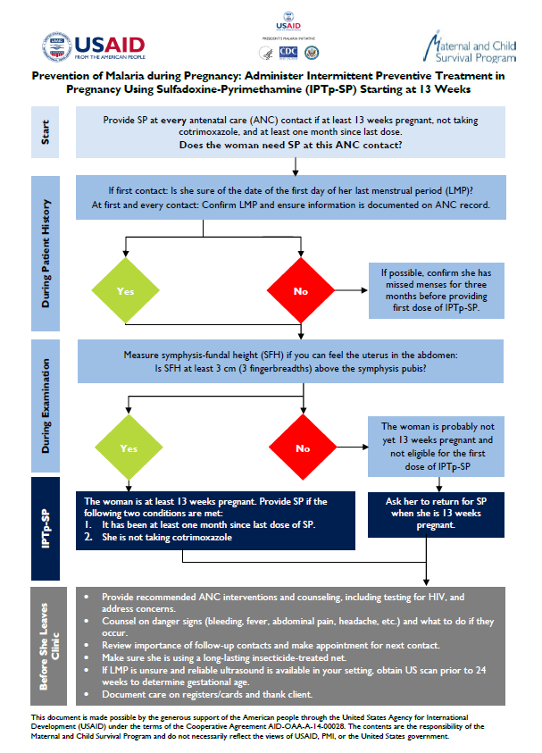

Appendix C: Technical Brief: Implementing Malaria in Pregnancy Programs in the Context of WHO Recommendations on Antenatal Care for a Positive Pregnancy Experience
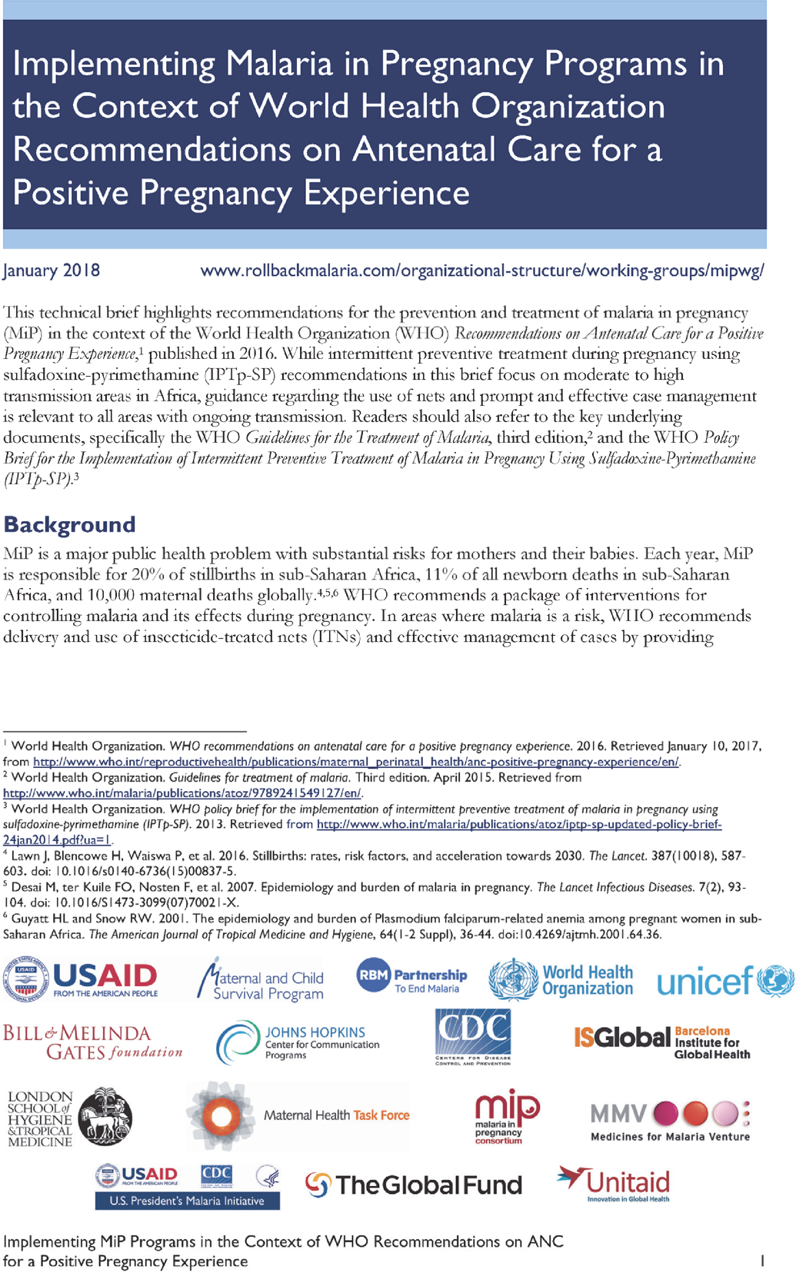

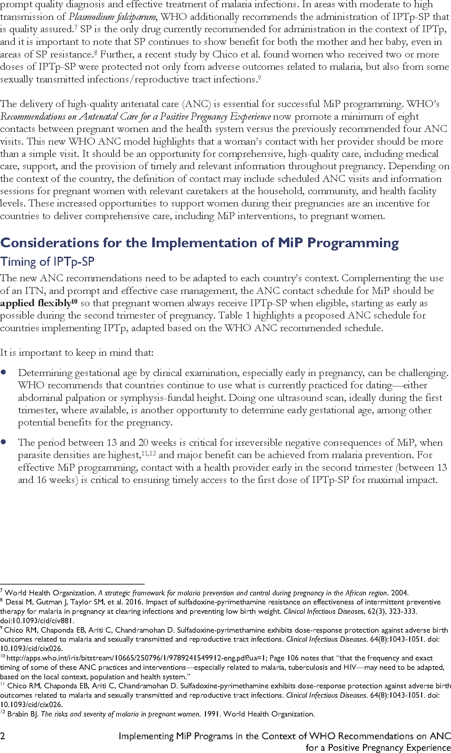

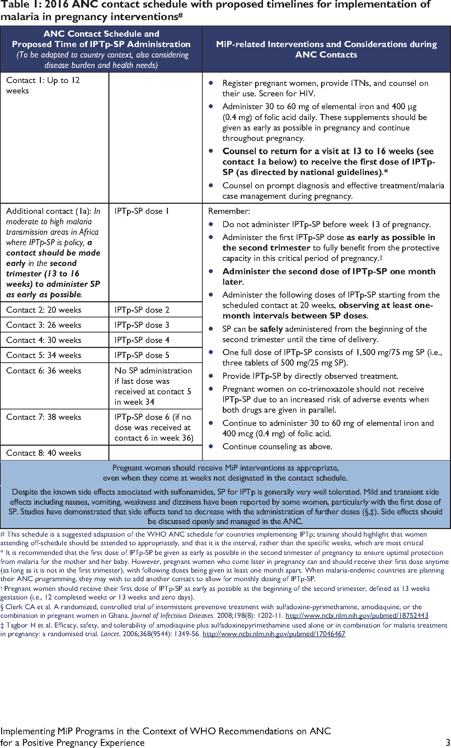

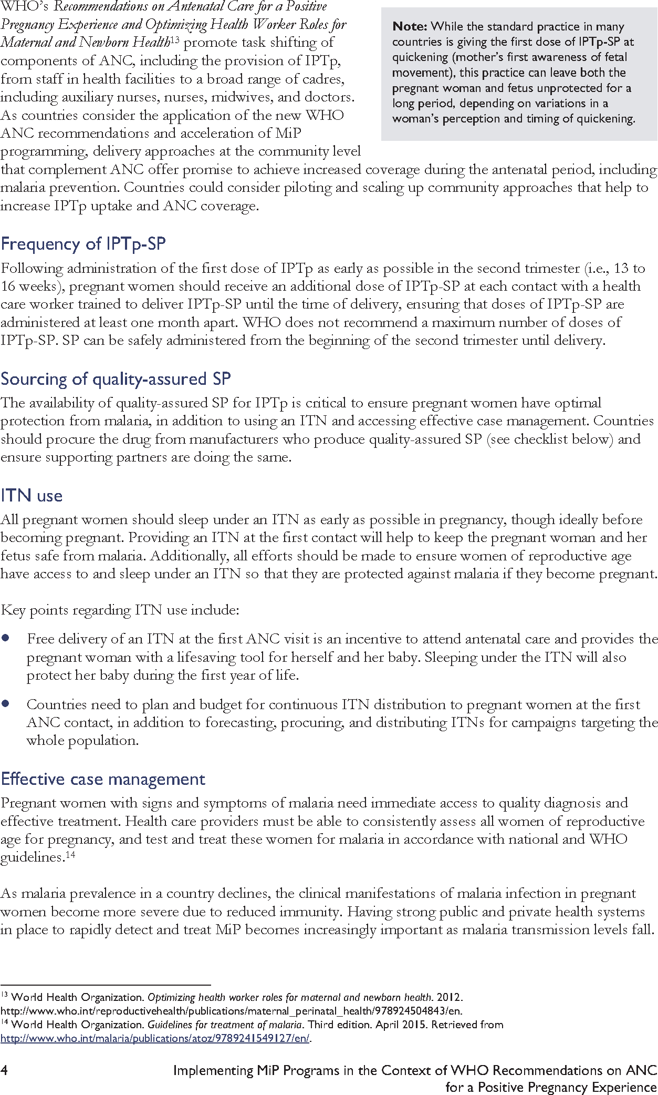

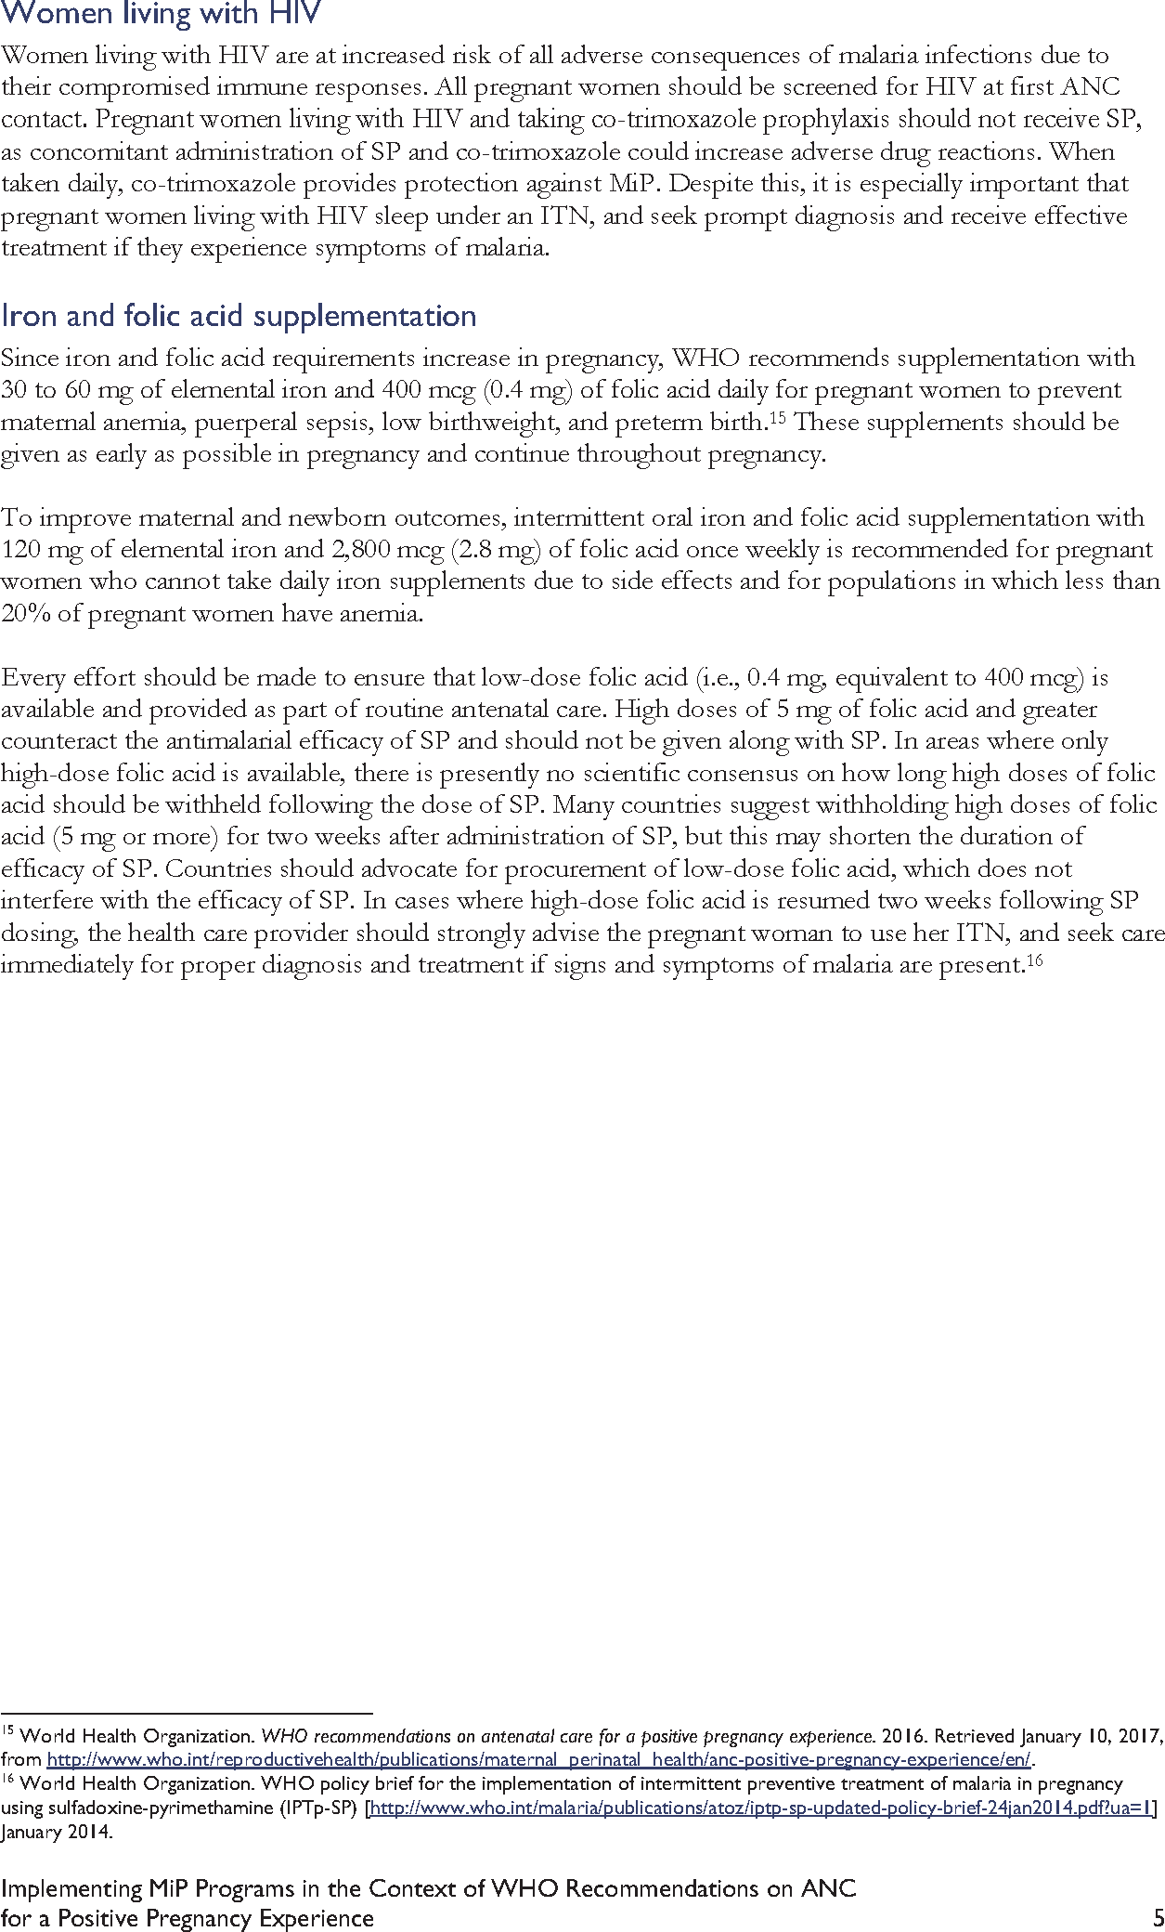

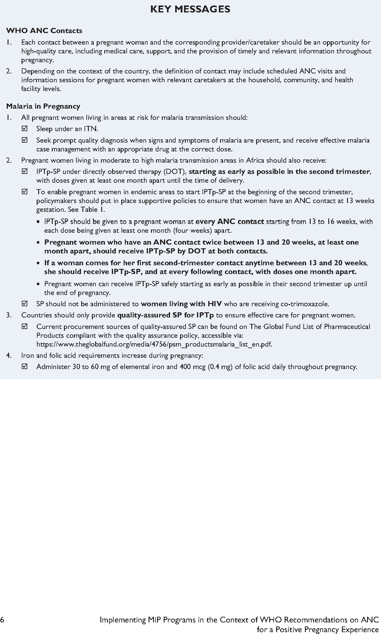

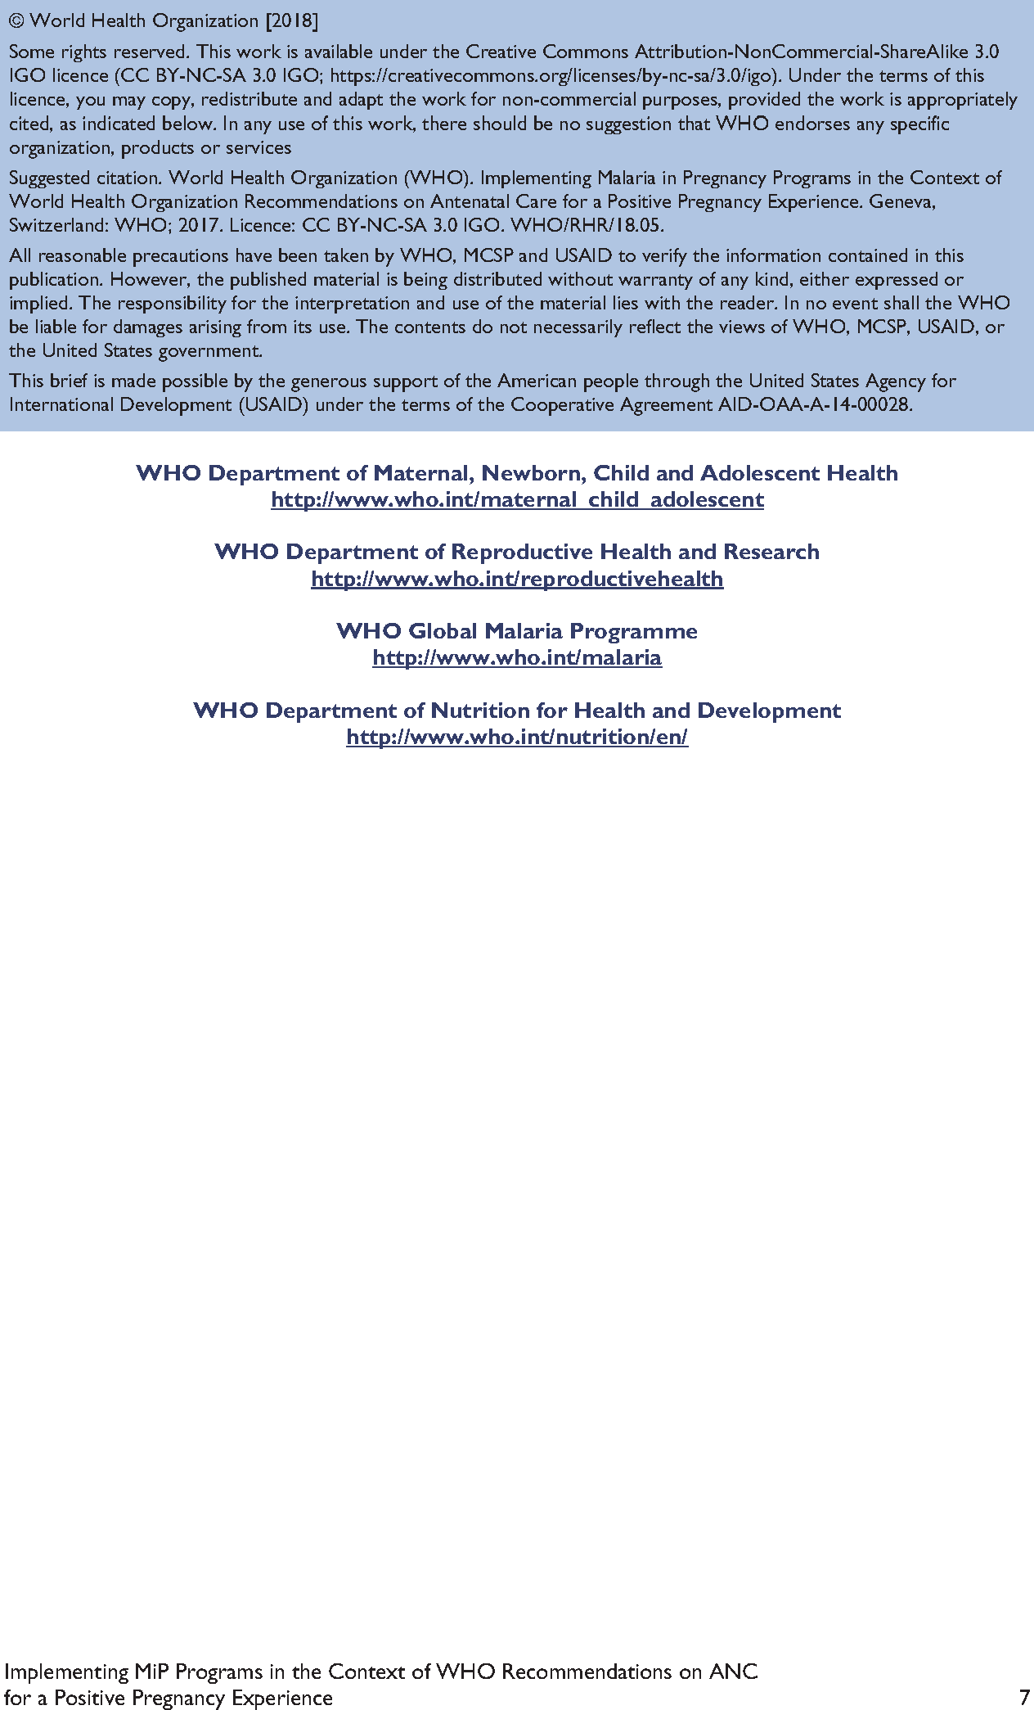

Appendix D: RBM Call to Action Infographic, 2019
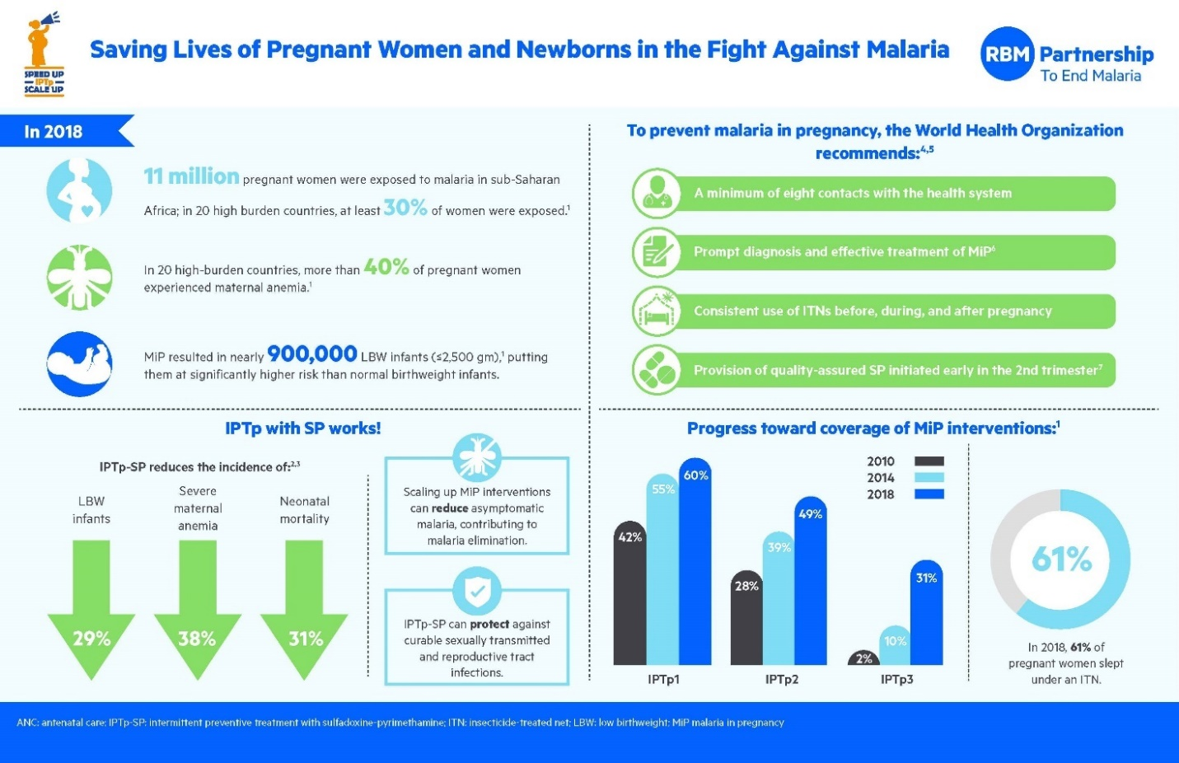
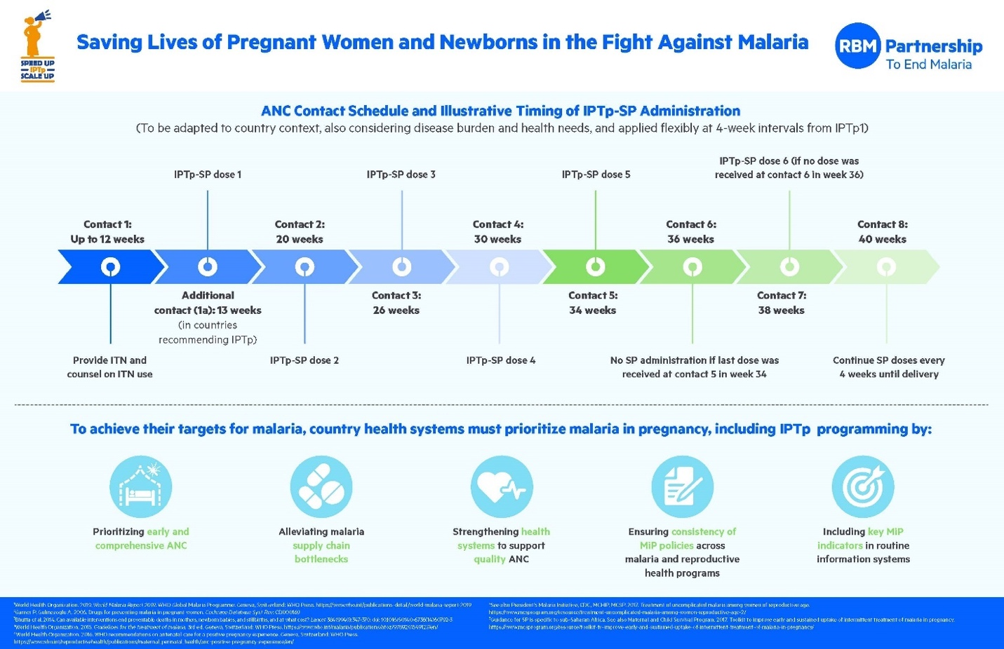
Source: https://endmalaria.org/about-us
References
Anglaret X, Chêne G, Attia A, et al. 1999. Early chemoprophylaxis with trimethoprim- sulphamethoxazole for HIV-1-infected adults in Abidjan, Côte d’Ivoire: A randomised trial. Cotimo-CI Study Group. Lancet. 353(9163):1463–8. doi: 10.1016/S0140-6736(98)07399-1.
Bowser D, Hill K. 2010. Exploring Evidence for Disrespect and Abuse in Facility-Based Childbirth. Harvard School of Public Health, University Research Co.
Breman JG, Alilio MS, White NJ. 2007. Defining and defeating the intolerable burden of malaria III: progress and perspectives. Am J Trop Med Hyg. 77(Suppl 6): vi–xi. doi: 10.4269/ajtmh.2007.77.vi.
Centers for Disease Control and Prevention (CDC). 2010a. About Malaria - Disease. CDC website. http://www.cdc.gov/malaria/about/disease.html. [October 7, 2015]. Accessed September 18, 2014.
CDC. 2010b. Malaria Treatment (United States). CDC website. http://www.cdc.gov/malaria/diagnosis_treatment/treatment.html. [2010. February 28, 2017.] Accessed August 20, 2014.
CDC. 2012. Intermittent Preventive Treatment of Malaria for Pregnant Women (IPTp). CDC website. http://www.cdc.gov/malaria/malaria_worldwide/reduction/iptp.html. [June 10, 2015.] Accessed August 20, 2014.
CDC. 2013. Treatment of Malaria: Guidelines for Clinicians (United States). Part 3: Alternatives for Pregnant Women and Treatment of Severe Malaria. CDC website. http://www.cdc.gov/malaria/diagnosis_treatment/clinicians3.html. [July 15, 2013.] Accessed August 20, 2014.
CDC. 2015. Sickle Cell Disease and Pregnancy. CDC website. https://www.cdc.gov/ncbddd/sicklecell/pregnancy.html. [September 14, 2015. August 31, 2016.]
CDC. 2016. Impact of Malaria. CDC website. https://www.cdc.gov/malaria/malaria_worldwide/impact.html. [2016. April 15, 2016.] Accessed July 11, 2017.
Chico RM, Chaponda EB, Ariti C, Chandramohan D. 2017. Sulfadoxine-pyrimethamine exhibits dose-response protection against adverse birth outcomes related to malaria and sexually transmitted and reproductive tract infections. Clin Infect Dis. 64(8):1043–1051. doi: 10.1093/cid/cix026.
Coleman PG, Morel C, Shillcutt S, Goodman C, Mills AJ. 2004. A threshold analysis of the cost- effectiveness of artemisinin-based combination therapies in sub-Saharan Africa. Am J Trop Med Hyg. 71(2 Suppl):196–204. doi: 10.4269/ajtmh.2004.71.196.
Dellicour S, Tatem AJ, Guerra CA, Snow RW, ter Kuile FO. 2010. Quantifying the number of pregnancies at risk of malaria in 2007: a demographic study. PLoS Med. 7(1):e1000221. doi: 10.1371/journal.pmed.1000221.
Denis MB, Tsuyuoka R, Poravuth Y, et al. 2006. Surveillance of the efficacy of artesunate and mefloquine combination for the treatment of uncomplicated falciparum malaria in Cambodia. Trop Med Int Health. 11(9):1360–1366. doi: 10.1111/j.1365-3156.2006.01690.x.
Desai M, ter Kuile FO, Nosten F, et al. 2007. Epidemiology and burden of malaria in pregnancy.
Lancet Inf Dis. 7(2):93–104. doi: 10.1016/S1473-3099(07)70021-X.
Eisele TP, Larsen DA, Anglewicz PA, et al. 2012. Malaria prevention in pregnancy, birthweight, and neonatal mortality; a meta-analysis of 32 national cross-sectional datasets in Africa. Lancet Infect Dis. 12(12):942–9. doi: 10.1016/S1473-3099(12)70222-0.
Falade CO, Tongo OO, Ogunkunle OO, Orimadegun AE. 2010. Effects of malaria in pregnancy on newborn anthropometry. J Infect Dev Ctries. 4(7):448–453. doi: 10.3855/jidc.329.
Fanello CI, Karema C, van Doren W, Rwagacondo CE, D’Alessandro U. 2006. Tolerability of amodiaquine and sulphadoxine-pyrimethamine, alone or in combination for the treatment of uncomplicated Plasmodium falciparum malaria in Rwandan adults. Trop Med Int Health. 11(5):589– 596. doi: 10.1111/j.1365-3156.2006.01610.x.
Finlayson K, Downe S. 2013. Why do women not use antenatal services in low- and middle-income countries? A meta-synthesis of qualitative studies. Plos Med. 10(1):e1001373. doi: 10.1371/journal.pmed.1001373.
Gething PW, Patil AP, Smith DL, et al. 2011. A new world malaria map: Plasmodium falciparum
endemicity in 2010. Malaria Journal. 10(378). doi: 10.1186/1475-2875-10-378
Guyatt HL, Snow RW. 2001. Malaria in pregnancy as an indirect cause of infant mortality in sub- Saharan Africa. Trans R Soc Trop Med Hyg. 95(6):569–76. doi: 10.1016/S0035-9203(01)90082-3.
Jhpiego. 2020. Operational Guidance for Continuity of Essential Services Impacted by COVID-19: A practical guide for program implementation and adaptation. Baltimore, MD: Jhpiego.
Jima D, Tesfaye G, Medhin A, Kebede A, Argaw D, Babaniyi O. 2005. Safety and efficacy of artemether-lumefantrine in the treatment of uncomplicated falciparum malaria in Ethiopia. East Afr Med J. 82(8):387–390. doi: 10.4314/eamj.v82i8.9321.
Kinney MV, Kerber KJ, Black RE, et al. 2010. Sub-Saharan Africa’s mothers, newborns, and children: where and why do they die? PLoS Med. 7(6):e1000294. doi: 10.1371/journal.pmed.1000294.
Kyabayinze DJ, Zongo I, Cunningham J, et al. 2016. HRP2 and pLDH-based rapid diagnostic tests, expert microscopy, and PCR for detection of malaria infection during pregnancy and at delivery in areas of varied transmission: a prospective cohort study in Burkina Faso and Uganda. PLoS One. 11(7):e0156954. doi: 10.1371/journal.pone.0156954.
Lalloo DG, Olukoya P, Olliaro P. 2006. Malaria in adolescence: burden of disease, consequences, and opportunities for intervention. Lancet Infect Dis. 6(12):780–93. doi: 10.1016/S1473- 3099(06)70655-7.
Lawn JE, Blencowe H, Waiswa P, et al. 2016. Stillbirths: rates, risk factors, and acceleration towards 2030. Lancet. 387(10018):587–603. doi: 10.1016/S0140-6736(15)00837-5.
Laufer MK, Plowe CV. 2006. Cotrimoxazole prophylaxis and malaria in Africa: have the important questions been answered? Am J Trop Med Hyg. 75(3):373–374. doi: 10.4269/ajtmh.2006.75.373.
Lindsay S, Ansell J, Selman C, Cox V, Hamilton K, Walraven G. 2000. Effect of pregnancy on exposure to malaria mosquitoes. Lancet. 355(9219):1972. doi: 10.1016/S0140-6736(00)02334-5.
Lindsay SW, Snow RW, Armstrong JR, Greenwood BM. 1989. Permethrin-impregnated bednets reduce nuisance arthropods in Gambian houses. Med Vet Entomol. 3(4):377–83. doi: 10.1111/j.1365- 2915.1989.tb00244.x.
Liverpool School of Tropical Medicine (LSTM). 2014. Introducing rapid diagnostic tests for malaria in rural Africa can reduce wastage of antimalarial drugs but may not improve patient health outcomes. LSTM website. https://lstmed.ac.uk/news-events/news/introducing-rapid-diagnostic- tests-for-malaria-in-rural-africa-can-reduce-wastage. [April 17, 2014.] Accessed August 26, 2014.
Malamba SS, Mermin J, Reingold A, et al. 2006. Effect of cotrimoxazole prophylaxis taken by human immunodeficiency virus (HIV)-infected persons on the selection of sulfadoxine- pyrimethamine-resistant malaria parasites among HIV-uninfected household members. Am J Trop Med Hyg. 75(3):375–80. doi: 10.4269/ajtmh.2006.75.375.
Malaria Atlas Project (MAP). 2007. The clinical burden of Plasmodium falciparum map in 2007 globally. MAP website. Accessed August 26, 2014.
Maternal and Child Survival Program (MCSP). 2018. Implementing Malaria in Pregnancy Programs in the Context of WHO Recommendations on Antenatal Care for a Positive Pregnancy Experience. Washington, DC: MCSP.
Menéndez C, Bardaji A, Sigauque B, at al. 2010. Malaria prevention with IPTp during pregnancy reduces neonatal mortality. PLoS One. 5(2):e9438. doi: 10.1371/journal.pone.0009438.
Mohamed AO, Eltaib EH, Ahmed OA, Elamin SB, Malik EM. 2006. The efficacies of artesunate- sulfadoxine-pyrimethamine and artemether-lumefantrine in the treatment of uncomplicated, Plasmodium falciparum malaria, in an area of low transmission in central Sudan. Ann Trop Med Parasitol. 100(1):5–10. doi: 10.1179/136485906X86239.
Moore KA, Simpson JA, Scoullar MJL, McGready R, and Fowkes FJI. Quantification of the association between malaria in pregnancy and stillbirth: a systematic review and meta-analysis. Lancet Glob Health 2017; 5: e1101–12.
Ouma P, Parise ME, Hamel MJ, et al. 2006. A randomized controlled trial of folate supplementation when treating malaria in pregnancy with sulfadoxine-pyrimethamine. PLoS Clin Trials. 1(6):e28. doi: 10.1371/journal.pctr.0010028.
President’s Malaria Initiative (PMI), CDC, Maternal and Child Health Integrated Program (MCHIP), MCSP. 2017. Treatment of Uncomplicated Malaria among Women of Reproductive Age. Washington, DC: MCSP.
Rogerson SJ, Mwapasa V, Meshnick SR. 2007. Malaria in pregnancy: linking immunity and pathogenesis to prevention. Am J Trop Med Hyg. 77(Suppl 6):14–22.
Roll Back Malaria – Malaria in Pregnancy Working Group. 2017. Implementing Malaria in Pregnancy Programs in the Context of World Health Organization Recommendations on Antenatal Care for a Positive Pregnancy Experience. Baltimore, MD: Jhpiego Corporation.
Roll Back Malaria Partnership (RBMP). 2005. Global Strategic Plan: Roll Back Malaria 2005–2015. Geneva: World Health Organization (WHO).
RBMP. 2008. The Global Malaria Action Plan for a Malaria-Free World. Geneva: WHO.
RBMP. 2014. The Contribution of Malaria Control to Maternal and Newborn Health. Geneva: WHO.
RBMP. 2015a. Action and Investment to Defeat Malaria 2016–2030: For a Malaria-Free World. London: WHO.
RBMP. 2015b. Global Call to Action to Increase National Coverage of Intermittent Preventive Treatment of Malaria in Pregnancy for Immediate Impact. Geneva: WHO.
RBM. 2020a. RBM Partnership to End Malaria Strategic Plan 2021 - 2025. UNOPS 2020.
RBM. 2020b. RBM Partnership to End Malaria: Practical Guidance for Delivery of Malaria in Pregnancy Interventions through Antenatal Care during the COVID-19 Pandemic. RBM, April 15 2020.
Schantz-Dunn J, Nour NM. 2009. Malaria and pregnancy: a global health perspective. Rev Obstet Gynecol. 2(3):186–92.
Sicuri E, Bardaji A, Nhampossa T, et al. 2010. Cost-effectiveness of intermittent preventive treatment of malaria in pregnancy in southern Mozambique. PLoS One. 5(10):e13407. doi: 10.1371/journal.pone.0013407.
Suthar AB, Granich R, Mermin J, Van Rie A. 2012. Effect of cotrimoxazole on mortality in HIV- infected adults on antiretroviral therapy: a systematic review and meta-analysis. Bull World Health Organ. 90(2):128–38C. doi: 10.2471/BLT.11.093260.
Tagbor H, Bruce J, Browne E, Randal A, Greenwood B, Chandramohan D. 2006. Efficacy, safety, and tolerability of amodiaquine plus sulphadoxine-pyrimethamine used alone or in combination for malaria treatment in pregnancy: a randomised trial. Lancet. 368(9544):1349–56. doi: 10.1016/S0140- 6736(06)69559-7.
ter Kuile FO, Parise ME, Verhoeff FH, et al. 2004. The burden of co-infection with human immunodeficiency virus type 1 and malaria in pregnant women in sub-Saharan Africa. Am J Trop Med Hyg. 71(2, Suppl):41–54.
TIPTOP. 2020. Delivery of Community Intermittent Preventive Treatment in Pregnancy in the Context of COVID-19.
Uneke CJ. 2011. Congenital malaria: an overview. Tanzanian Journal of Health Research 13(3):
United Nations Children’s Fund (UNICEF). 2005. Statistics: Malawi. UNICEF website. http://www.unicef.org/infobycountry/malawi_statistics.html#29. [2005. December 27, 2013.] Accessed May 15, 2014.
UNICEF. 2007. Malaria Diagnosis: A Guide for Selecting Rapid Diagnostic Test (RDT) Kits. New York City: UNICEF.
UNICEF. 2017. Antenatal Care: Current Status + Progress. UNICEF website. https://data.unicef.org/topic/maternal-health/antenatal-care/. [April 2017.]
United States Agency for International Development (USAID) and MCHIP. 2013. World Malaria Day 2013: Working tirelessly to prevent malaria in pregnancy in Kenya. MCHIP website. http://www.mchip.net/node/1765. [April 19, 2013.] Accessed May 15, 2015.
USAID and MCSP. 2017. Toolkit to Improve Early and Sustained Intermittent Preventive Treatment in Pregnancy (IPTp) Uptake.
van Eijk AM, Hill J, Alegana VA, et al. 2011. Coverage of malaria protection in pregnant women in sub-Saharan Africa: a synthesis and analysis of national survey data. Lancet Infect Dis. 11(3):190–207. doi: 10.1016/S1473-3099(10)70295-4.
Villar et al. 2021. Maternal and Neonatal Morbidity and Mortality Among Pregnant Women With and Without COVID-19 Infection: The INTERCOVID Multinational Cohort Study); JAMA Pediatr. doi:10.1001/jamapediatrics.2021.1050, published online April 22, 2021.
Vogel JP, Habib NA, Souza JP, et al. 2013. Antenatal care packages with reduced visits and perinatal mortality: a secondary analysis of the WHO antenatal care trial. Reprod Health. 10:19. doi: 10.1186/1742-4755-10-19.
Walker PGT, ter Kuile FO, Garske T, Menendez C, Ghani AC. 2014. Estimated risk of placental infection and low birthweight attributable to Plasmodium falciparum malaria in Africa in 2010: a modelling study. Lancet Glob Health. 2(8):e460–67. doi: 10.1016/S2214-109X(14)70256-6.
Williams JE, Cairns M, Njie F, et al. 2016. The performance of a rapid diagnostic test in detecting malaria infection in pregnant women and the impact of missed infections. Clin Infec Dis. 62(7):837- 844. doi: 10.1093/cid/civ1198.
World Health Assembly. 2006. Sickle-Cell Anaemia: Report by the Secretariat. Geneva: WHO.
WHO. 2002. WHO Antenatal Care Randomized Trial: Manual for the Implementation of the New Model. Geneva: WHO.
WHO. 2003. Global Strategy for Infant and Young Child Feeding. Geneva: WHO.
WHO. 2004a. Malaria and HIV/AIDS Interactions and Implications: Conclusions of a Technical Consultation Convened by WHO, 23–25 June, 2004. Geneva: WHO.
WHO. 2004b. Malaria and HIV Interactions and Their Implications for Public Health Policy. Geneva: WHO.
WHO. 2004c. A Strategic Framework for Malaria Prevention and Control during Pregnancy in the Africa Region. Brazzaville: WHO/Regional Office for Africa.
WHO. 2004d. The Use of Malaria Rapid Diagnostic Tests. WHO: Geneva.
WHO. 2004e. What Are the Options? Using Formative Research to Adapt Global Recommendations on HIV and Infant Feeding to the Local Context. Geneva: WHO.
WHO. 2005. The World Health Report 2005: Making Every Mother and Child Count. Geneva: WHO.
WHO. 2007. Insecticide-Treated Mosquito Nets: A WHO Position Statement.
WHO. 2008. World Malaria Report 2008. Geneva: WHO.
WHO. 2009. Malaria Case Management Operations Manual. Geneva: WHO.
WHO. 2010a. Guidelines for the Treatment of Malaria. 2nd ed. Geneva: WHO.
WHO. 2010b. Guidelines on HIV and Infant Feeding: Principles and Recommendations for Infant Feeding in the Context of HIV and a Summary of Evidence. Geneva: WHO.
WHO. 2011a. Malaria, Countries or Areas at Risk of Transmission, 2010. WHO website. http://gamapserver.who.int/mapLibrary/Files/Maps/Global_Malaria_ITHRiskMap.JPG?ua=1. Accessed October 1, 2014.
WHO. 2011b. WHO Universal Access to Malaria Diagnostic Testing: An Operational Manual. Geneva: WHO.
WHO. 2012a. Disease Surveillance for Malaria Control: An Operational Manual. Geneva: WHO.
WHO. 2012b. WHO Guidelines on HIV and Infant Feeding 2010: An Updated Framework for Priority Action. Geneva: WHO.
WHO. 2013a. Epidemiological Approach for Malaria Control (Guide for Tutors). Geneva: WHO. WHO. 2013b. Factsheet on the World Malaria Report 2013.
WHO. 2013c. Indoor Residual Spraying: An Operational Manual for Indoor Residual Spraying (IRS) for Malaria Transmission, Control and Elimination. Geneva: WHO.
WHO. 2013d. Management of Severe Malaria: A Practical Handbook. 3rd ed. Geneva: WHO.
WHO. 2013e. WHO Guidance Note for Estimating the Longevity of Long-Lasting Insecticidal Nets in Malaria Control. Geneva: WHO.
WHO. 2013f. WHO Policy Brief for the Implementation of Intermittent Preventive Treatment of Malaria in Pregnancy Using Sulfadoxine-Pyrimethamine (IPTp-SP). Geneva: WHO.
WHO. 2013g. WHO Recommended Long-Lasting Insecticidal Nets.
WHO. 2014. International Travel and Health. Chapter 7. Malaria. Geneva: WHO.
WHO. 2015a. Global Technical Strategy for Malaria 2016–2030. Geneva: WHO.
WHO. 2015b. Guidelines for the Treatment of Malaria. 3rd ed. Geneva: WHO.
WHO. 2015c. Malaria fact sheet. WHO website. http://www.who.int/mediacentre/factsheets/fs094/en/. [2015. April 2017]. Accessed March 9, 2016.
WHO. 2015d. Recommendations on Health Promotion Intervention for Maternal and Newborn Health 2015. Geneva: WHO.
WHO. 2016a. Consolidated Guidelines on the Use of Antiretroviral Drugs for Treating and Preventing HIV Infection: Recommendations for a Public Health Approach. 2nd ed. Geneva: WHO.
WHO. 2016b. Guideline: Updates on HIV and Infant Feeding: The Duration of Breastfeeding and Support from Health Services to Improve Feeding Practices among Mothers Living with HIV. Geneva: WHO.
WHO. 2016c. WHO Recommendations on Antenatal Care for a Positive Pregnancy Experience. Geneva: WHO.
WHO. 2016d. World Malaria Report 2016. Geneva: WHO.
WHO. 2017. Managing Complications in Pregnancy and Childbirth: A Guide for Midwives and Doctors. 2nd ed. Geneva: WHO.
WHO. 2017a. World Malaria Report 2017. Geneva: WHO.
WHO. 2020a. World malaria report 2020: 20 years of global progress and challenges. Geneva: WHO.
WHO. 2020b. Clinical Management of Covid-19. Interim guidance: 27 May 27 2020. Geneva: WHO.
WHO. 2020c. Maintaining essential health services: operational guidance for the COVID-19 context. Interim guidance: 1 June 2020. Geneva: WHO.
WHO. 2020d. Pulse survey on continuity of essential health services during the COVID-19 pandemic: interim report, 27 August 2020. Geneva: WHO.
WHO. 2021. COVID-19 Clinical Management. Living guidance: 25 January 2020. Geneva: WHO.
WHO, UNICEF. 2007. Guidance on the Global Scale-Up of the Prevention of Mother-to-Child Transmission of HIV. Geneva: WHO.
White Ribbon Alliance (WRA). 2011. Respectful Maternity Care: The Universal Rights of Childbearing Women. Washington, DC: WRA.
WHO Western Pacific Regional Office (WPRO). 2005. Malaria Rapid Diagnostic Tests: Purchasing and Using RDTs. WPRO website. http://www.wpro.who.int/sites/rdt/using_rdts. Accessed August 20, 2014.

According to WHO, the term “skilled attendant” refers to “an accredited health professional—such as a midwife, doctor or nurse—who has been educated and trained to proficiency in the skills needed to manage normal (uncomplicated) pregnancies, childbirth, and the immediate postnatal period, and in the identification, management and referral of complications in women and newborns” (WHO 2010a).
Though the ultimate goal of all ANC contacts is a healthy outcome for the woman and her newborn, ANC attendance and compliance with care may not result in a positive outcome; women should not be made to feel at fault if this occurs.
Please refer to Appendix B: WHO/USAID/MCSP, 2017: Implementing Malaria in Pregnancy Programs in the Context of WHO Recommendations on Antenatal Care for a Positive Pregnancy Experience.
WHO recommends that, in areas of moderate to high malaria transmission in Africa, IPTp-SP should be given to all pregnant women at each scheduled ANC contact, starting as early as possible in the second trimester, provided that the doses of SP are given at least 1 month apart. WHO recommends a package of interventions for preventing MIP, which includes promotion of ITNs and IPTp-SP. To ensure that pregnant women in endemic areas start IPTp-SP as early as possible in the second trimester, policymakers should ensure health system contact with women at 13 weeks gestation.
For further information on quality improvement, please refer to WHO’s Standards for Improving Quality of Maternal and Newborn Care in Health Facilities.
Rarely, congenital malaria can occur due to vertical transmission during pregnancy or labor. (Uneke 2011).
The Asembo Bay Cohort Project in western Kenya, in collaboration with the Kenya Medical Research Institute, investigated this issue in depth.
Because some studies have shown that LLINs may not have the expected life of 3 to 5 years, WHO recommends that each country conduct its own study to assess net attrition and physical integrity to better plan campaigns to resupply nets (WHO 2013e).
In some settings, mass screening and treatment programs are carried out using polymerase chain reaction tests to detect and treat those who are asymptomatic and have parasite density too low to be detected with microscopy or RDTs. Another situation that may require the use of polymerase chain reaction is identification of morphologically similar species (WHO 2011b).

